Design and Development of Office Student Affairs (OSA) Management System with QR Code and Geotagging System for Student Activity and Attendance

Bachelor of Science in Information Technology
St. Rita’s College of Balingasag



In Partial Fulfillment of the Requirements for the Degree Bachelor of Science in Information Technology

Hannah Felexabeth G. Abao
Maricar T. Bahala
Ishi Trixie Loraine G. Regodon
Joshua Angelo Arquita

October 2026

CHAPTER 1

1.1 Background and Rationale
Technology plays an important role in strengthening governance and improving educational quality by improving information access and streamlining institutional processes. Higher education institutions increasingly use digital systems to organize records, monitor student participation, and support data-driven decision-making (Al-Fedaghi, 2019; Chen & Martinez, 2024). QR-code-based attendance enables fast verification and real-time data capture, while geotagging uses Global Positioning System (GPS) services to verify users’ locations. By confirming whether students are within an authorized location, geotagging can help reduce proxy attendance, improve accountability, and strengthen attendance record reliability (Kessler, 2021; Kamarainen et al., 2018; Davies et al., 2023). Combining QR codes and geotagging provides a more secure and efficient approach to attendance monitoring.
At St. Rita’s College of Balingasag (SRCB), the Office of Student Affairs (OSA) manages student activity attendance, evaluation forms, admission slip requests, and participation records using manual documents and separate digital platforms. Based on interviews and observations with OSA personnel, attendance is recorded through paper sheets and later encoded into digital files, while activity evaluations are handled through separate Google Forms. Retrieving attendance and student records may take one to three days due to manual record handling. The current process also lacks a mechanism for verifying students’ physical presence at the designated activity venue. Because these processes are handled separately, attendance, evaluation results, and participation records are difficult to consolidate, increasing administrative workload and delaying report preparation.
These challenges affect the efficiency of the OSA and its ability to provide timely and accurate student services. To address these concerns, the researchers propose the Design and Development of Office Student Affairs (OSA) Management System with QR Code and Geotagging System for Student Activity and Attendance. The proposed web-based system provides QR-code attendance, geotagging validation, digital activity evaluations, OSA-approved admission slip requests, late attendance monitoring, student case record management, automated e-certificate generation, and analytics in one platform.

1.2 Statement of the Problem
The Office of Student Affairs (OSA) of St. Rita’s College of Balingasag (SRCB) manages student activity attendance, evaluation forms, admission slip requests, and participation records. However, these processes rely on manual records and separate digital platforms. Attendance is recorded through paper sheets and later encoded into digital files, while activity evaluations are managed separately through Google Forms. The OSA also has no mechanism to verify whether students are physically present at the designated activity venue, and related records are not maintained in a single repository. During the interview conducted by the researchers with the OSA administrator, the client stated that retrieving attendance and student records may take one to three days due to manual record handling. The client also identified difficulties in consolidating attendance, evaluation results, and participation records because these are handled separately. These conditions delay report preparation, make it difficult to monitor late attendance and verify physical presence, and increase the administrative workload of OSA personnel. The existing processes do not adequately address these problems because attendance, evaluations, and participation records are handled independently rather than as a coordinated process. Paper-based attendance requires additional encoding and manual handling, while separate digital platforms do not provide a common repository for related OSA records. Consequently, the current process remains fragmented and requires additional effort to retrieve, verify, organize, and report student activity information.

1.3 Objectives

General Objective
The general objective of this study is to design and develop a Office Student Affairs (OSA) Management System with QR Code and Geotagging System for Student Activity and Attendance for the Office of Student Affairs (OSA) of St. Rita's College of Balingasag.

Specific Objectives
Specifically, the study aims to:
- Gather Data by conducting system requirement gathering through interviews, observations, and stakeholder consultations to identify operational needs, analyze existing processes, and define the initial Product Backlog using Agile requirement documentation techniques and stakeholder analysis tools.
- Planning and Designing by designing the system interface and workflow using Figma, developing and prioritizing the Product Backlog through Agile Scrum methodology using project management tools and organizing system features including QR-based attendance, geotagging validation, evaluation forms, admission slip processing, student case record management, e-certificate generation, analytics dashboard, and role-based access control.
- Development by implementing iterative system development through the Agile Scrum framework using structured 1–4 week sprints, conducting daily Scrum meetings, and developing the system using PHP, Laravel, HTML, CSS, React, and MySQL.
- Continuous Integration by integrating completed system modules throughout each sprint, conducting sprint reviews and stakeholder demonstrations to validate implemented features, gathering feedback for Product Backlog refinement, performing sprint retrospectives to improve succeeding iterations, and managing source code using Git and GitHub.
- Testing by performing continuous Functional Testing, Integration Testing, Usability Testing, and Security Testing using manual testing techniques and Laravel built-in testing tools, and deploying validated system increments through Apache using XAMPP and/or cloud hosting until the QR Code and Geotagging System for Monitoring OSA and Student Activity, Attendance, and Evaluation is fully operational.

1.4 Scope and Limitation
This study focuses on the development of the Office Student Affairs (OSA) Management System with QR Code and Geotagging System for Student Activity and Attendance within the St. Rita's College of Balingasag Higher Education Department. The system is intended for use by the Office of Student Affairs (OSA) Personnel, Academic Personnel (Program Heads, Department Instructors, and Academic Office Staff), Student Leaders (CSG Officers), and Students.
It provides functionalities such as QR code-based attendance monitoring, geotagging validation for attendance within the school premises, late attendance tracking, student evaluation management, OSA-approved admission slip processing, student violation and case record management, and automated e-certificate generation. The system also provides an analytics dashboard that supports real-time monitoring, report generation, and data-driven decision-making. The system is developed as a web-based application and will be accessible online through desktop computers, laptops, tablets, and smartphones using supported web browsers.
The proposed system is limited to OSA-related services and does not cover academic grading systems, enrollment systems, or learning management systems. It does not integrate with existing institutional databases; instead, the system maintains its own database and stores only records created after deployment. Each student is assigned one unique QR code that serves as the official identifier for attendance monitoring and authorized system transactions. Existing paper-based records are not automatically migrated and require manual encoding into the system. The minimum hardware requirements include desktop or laptop computers with at least an Intel Core i3 (or equivalent dual-core processor), 8 GB RAM, and Windows 10 or later, or macOS 11 (Big Sur) or later, while smartphones should support modern web browsers and have access to a QR code scanner for attendance transactions. The recommended hardware requirements include computers with an Intel Core i5 (or higher), 16 GB RAM, and a solid-state drive (SSD) for improved system performance, together with dedicated 2D QR code scanners for faster and more reliable attendance processing during large-scale activities. The system is best accessed using updated web browsers such as Google Chrome version 120 or later, Mozilla Firefox version 120 or later, Microsoft Edge version 120 or later, or Safari version 17 or later.

1.5 Significance of the Study
The proposed Development of Office Student Affairs (OSA) Management System with QR Code and Geotagging System for Student Activity and Attendance aims to improve the management of student affairs by integrating attendance monitoring, geotagging validation, evaluation processing, admission slip management, and record management into a single web-based platform. The system is expected to enhance the efficiency, accuracy, and reliability of administrative processes while reducing manual work, minimizing human errors, and improving record accessibility. Through real-time monitoring and automated reporting, the proposed system supports a more organized, transparent, and technology-driven approach to managing student activities and services.
This study is significant to the following:
- Office of student affairs (OSA)
The system will benefit the Office of Student Affairs (OSA) by providing centralized student records, real-time attendance monitoring, admission slip management, evaluation management, student case management, analytics, and automated report generation.
- Academic Personnel
The system will benefit the Academic Personnel, including Program Heads, Department Instructors, and designated Academic Office Staff by providing real-time access to student attendance, participation records, case records, evaluation results, and program-based monitoring reports.

- Central Student Government (CSG) Officers
The system will benefit the Central Student Government (CSG) Officers by providing QR code attendance monitoring, event participation tracking, and efficient activity management.

- Students
The system will benefit students by providing faster attendance verification, digital admission slip requests, activity evaluations, access to participation records, and automated e-certificates.
- The Institution (St. Rita’s College of Balingasag)
St. Rita’s College of Balingasag, particularly the Office of Student Affairs (OSA) Office and the Higher Education Department, by providing a centralized student affairs management system, improved record management, real-time monitoring, and data-driven administrative reporting.
- Future Researchers
The study will benefit future researchers by serving as a reference for developing and improving student affairs management systems, QR code attendance systems, geotagging applications, digital evaluation systems, admission slip processing, and e-certificate generation.

1.6 Definition of Terms
This section defines the technical and operational terms used in this study to provide clarity and ensure a common understanding of the concepts discussed. These terms will be used throughout the development and evaluation of the proposed design and development of Office Student Affairs (OSA) Management System with QR Code and Geotagging System for Student Activity and Attendance.

- Agile Scrum Methodology – An iterative software development framework used in this study to manage system development through short development cycles called sprints, allowing continuous improvement and stakeholder feedback.
- Application Programming Interface (API) – A set of rules and protocols that enables communication and data exchange between different software applications and system components.
- Geotagging – The process of capturing and recording a user's geographic location using GPS technology. In this study, geotagging is used to verify that students are physically present within the authorized school premises during attendance checking.
- Global Positioning System (GPS) – A satellite-based navigation system that determines the geographic location of a device. It is used in the proposed system to support geotagging and location validation.
- Hypertext Markup Language (HTML) – The standard markup language used to create and structure web pages displayed through web browsers.
- Laravel – An open-source PHP framework used for developing the backend components of the proposed system. It provides tools for database management, authentication, routing, and application security.
- CSS - A utility-first CSS framework used for designing responsive and mobile-compatible user interfaces. Tailwind enables consistent styling across all system pages with minimal custom CSS code.
- SQL – A relational database management system used to store, manage, and retrieve data related to student attendance, evaluations, admission slips, and activity records.
- Product Backlog – A prioritized list of system requirements, features, enhancements, and tasks that guide the development process throughout Agile Scrum implementation.
- PHP (Hypertext Preprocessor) – A server-side scripting language used to develop dynamic web applications and process backend functions of the proposed system.
- QR Code (Quick Response Code) – A two-dimensional barcode that stores encoded information and can be scanned electronically. In this study, QR codes are used for fast and accurate student attendance verification.
- React – An open-source JavaScript library used to develop dynamic and interactive user interfaces for the proposed web application through reusable components.
- Role-Based Access Control (RBAC) – A security mechanism that restricts system access based on assigned user roles such as OSA Administrator, Academic Personnel, Student Leader, and Student.
- Sprint – A time-boxed development period, typically lasting one to four weeks, during which specific system features are designed, developed, tested, and reviewed.
- School / Academic Personnel – Refers to authorized institutional staff, including Academic Program Heads, Department Instructors, and designated Campus Office personnel, who oversee student academic status, monitor event attendance, review clearance, and track student violations within their respective departments.

References
Adebayo, O., & Oke, A. (2022). Digital attendance management systems in educational institutions. International Journal of Educational Technology, 15(2), 45–58.
Al-Fedaghi, S. (2019). Information technology and educational administration: Enhancing governance and efficiency. International Journal of Advanced Computer Science and Applications, 10(8), 320–327.
Ally, M., & Tsinakos, A. (2014). Increasing access through mobile learning. Commonwealth of Learning.
Astin, A. W. (1999). Student involvement: A developmental theory for higher education. Journal of College Student Development, 40(5), 518–529.
Chen, Y., & Martinez, R. (2024). Digital transformation in student affairs management: Improving efficiency and data integrity. Journal of Educational Administration and Technology, 18(1), 55–71.
Denso Wave Incorporated. (2024).
Few, S. (2013). Information dashboard design: Displaying data for at-a-glance monitoring (2nd ed.). Analytics Press.
Johnson, T., & Smith, P. (2023). Student affairs administration and institutional effectiveness in higher education. Higher Education Management Review, 12(3), 88–102.
Kessler, F. C. (2021). Geotagging and location-based information systems. In The International Encyclopedia of Geography. Wiley.
Komives, S. R., & Woodard, D. B. (2003). Student services: A handbook for the profession (4th ed.). Jossey-Bass.
Ministry of Education. (2024). Student affairs and support services framework. Government Education Publications.
Schwaber, K., & Sutherland, J. (2020). The Scrum Guide: The definitive guide to Scrum: The rules of the game. Scrum.org.
Stauffer, M. (2019). Laravel: Up and running (2nd ed.). O'Reilly Media.
Stufflebeam, D. L., & Zhang, G. (2017). The CIPP evaluation model: How to evaluate for improvement and accountability. Guilford Press.

CHAPTER 2
Review of Related Literatures
This chapter presents the related literature and studies that provide the foundation for the development of the Office Student Affairs (OSA) Management System with QR Code and Geotagging System for Student Activity and Attendance. The review covers concepts, technologies, and previous research relevant to QR code-based attendance systems, geotagging technologies, student activity monitoring, digital evaluation systems, and integrated student management platforms. These studies and literature help establish the significance of the proposed system and identify existing gaps that the study aims to address. The chapter also discusses the theoretical framework and usability principles that guide the design and development of the proposed system.
2.2 Theoretical Framework
The Technology Acceptance Model (TAM), developed by Davis (1989), explains that users are more likely to adopt a new information system when they perceive it as useful and easy to use. Perceived usefulness refers to the extent to which users believe that a system enhances their performance, while perceived ease of use refers to how effortless the system is to operate. In this study, TAM supports the development of the Office Student Affairs (OSA) Management System with QR Code and Geotagging System for Student Activity and Attendance because it is designed to simplify attendance monitoring, admission slip processing, evaluation management, and student record management. By automating these processes and providing an intuitive interface, the system increases efficiency, reduces manual work, and encourages acceptance among OSA Personnel/System Administrators, Academic Personnel, Student Leaders (CSG Officers), and Students.
The Unified Theory of Acceptance and Use of Technology (UTAUT), proposed by Venkatesh et al. (2003), extends technology acceptance by identifying four key factors that influence user adoption: performance expectancy, effort expectancy, social influence, and facilitating conditions. Performance expectancy refers to the belief that the system will improve job performance, effort expectancy refers to ease of use, social influence reflects the encouragement of important individuals or organizations, and facilitating conditions involve the availability of resources and technical support. In the proposed study, UTAUT explains how the integrated OSA Management System is expected to be accepted because it improves administrative efficiency, is simple to use, is supported by the institution, and provides the necessary infrastructure for implementation. These factors increase users' intention to adopt and continuously use the system in managing student affairs.
Location-Based Services (LBS) is a technological framework that utilizes Global Positioning System (GPS) and other location technologies to determine a user's geographical position and provide context-aware services. In educational environments, LBS enhances attendance authenticity by verifying whether students are physically present within authorized activity locations before recording their attendance. This study applies the LBS concept through geotagging functionality integrated with QR code attendance, ensuring that attendance is only validated when students are within the designated school premises or event venue. The integration of LBS minimizes proxy attendance, improves the reliability of participation records, strengthens accountability, and supports more accurate monitoring of student activities.
The Integrated Information Systems (IIS) concept emphasizes combining related organizational processes into a single centralized platform to improve efficiency, data consistency, and decision-making. Instead of maintaining separate applications for attendance, evaluations, admission slips, student case records, and reports, an integrated information system consolidates these functions into one database and interface. In this study, the proposed Office Student Affairs (OSA) Management System follows this principle by integrating QR code attendance, geotagging validation, digital evaluations, admission slip processing, student case management, automated e-certificate generation, and analytics into a unified web-based platform. This integration minimizes duplicated records, reduces administrative workload, provides real-time access to information, and supports faster, more informed decision-making within the Office of Student Affairs.
The International Organization for Standardization (2023) states that ISO/IEC 25010:2023 provides a quality framework for evaluating software systems. In this study, the standard is used to evaluate the developed OSA Management System with QR Code and Geotagging System for Student Activity and Attendance. It assesses functional suitability, performance efficiency, compatibility, interaction capability, reliability, security, maintainability, flexibility, and safety. These quality characteristics help determine whether the proposed system can effectively support QR-code attendance, geotagging validation, activity evaluation, student case records, analytics, and e-certificate generation. ISO/IEC 25010:2023 complements TAM, UTAUT, MVA, and SUS by providing a structured basis for evaluating the quality of the proposed system.
2.2.1 10 Heuristics and 5 Laws of UX
The reviewed literature demonstrates that usability principles are essential in developing effective, efficient, and user-friendly information systems. Nielsen's Ten Usability Heuristics emphasize interface design practices that improve system feedback, consistency, error prevention, user control, and overall usability, while the Laws of User Experience explain how users perceive, process, and interact with digital interfaces based on established psychological principles. Collectively, these frameworks highlight the importance of designing systems that are intuitive, easy to learn, and capable of reducing cognitive effort while enhancing user satisfaction. Based on the synthesis of these usability principles, the researchers adopted Nielsen's Ten Usability Heuristics and the five selected Laws of UX as the foundation for designing the Office Student Affairs (OSA) Management System with QR Code and Geotagging System for Student Activity and Attendance. Their integration supports the development of a user-centered platform that promotes efficient task completion, improves usability, enhances the overall user experience, and encourages greater technology acceptance among OSA Personnel/System Administrators, Academic Personnel, Student Leaders (CSG Officers), and Students.
10 Heuristics
- Visibility of System Status – Real-time monitoring portal displaying live updates for Total Scans, Present, and Late counts with pulse animations, status badges with visual indicators (upcoming, ongoing, completed) in Event List tables, and immediate visual feedback during QR scanning operations ensure that the system always keeps users informed about what is going on through appropriate and timely feedback ([Nielsen, 1994](https://www.nngroup.com/articles/ten-usability-heuristics/)).
- Match Between System and the Real World – Familiar school-oriented terminology such as "Admission Slip," "QR Scanner," “Evaluation,” and “Certificates" to help users understand system functions and interface flows that mirror actual school attendance processes ensure that the system speaks the users' language with words, phrases, and concepts familiar to school administrators and staff rather than system-oriented jargon([Nielsen,1994](https://www.nngroup.com/articles/ten-usability-heuristics/)).
- User Control and Freedom – Clear "Close" and "X" buttons on modals and dialogs such as ViewStudentDialog and EvaluationFormDialog, "Pause/Resume" toggle controls for real-time scanning sessions, and cancel options in form submissions provide users with a clearly marked "emergency exit" to leave unwanted states without having to go through extended processes ([Nielsen, 1994](https://www.nngroup.com/articles/ten-usability-heuristics/)).
- Consistency and Standards – A unified AttendanceTable ensuring that the Program Head sees the exact same layout, icons, and table structure as the Admin, consistent use of the Shadcn UI library for standardized inputs, select menus, and buttons, and uniform component patterns applied across the entire platform ensure that users do not have to wonder whether different words, situations, or actions mean the same thing, following platform and industry conventions ([Nielsen, 1994](https://www.nngroup.com/articles/ten-usability-heuristics/)).
- Error Prevention – Scanner portal rules that disable the "Start" button when the portal is manually deactivated or when 30+ minutes have passed the registration end time, SweetAlert confirmation popups before permanently archiving or deleting an event, and input validation on attendance forms eliminate error-prone conditions or present users with a confirmation option before they commit to an action, reducing the likelihood of operational mistakes in attendance data management ([Nielsen, 1994](https://www.nngroup.com/articles/ten-usability-heuristics/)).
- Recognition Rather Than Recall – Table search bars allowing searching by both student Name and ID instead of requiring memorization, filter dropdowns displaying available options such as Year Level (1st Year, 2nd Year) rather than requiring manual text entry, and visible quick-action icons in table rows minimize the user's memory load by making elements, actions, and options visible so that school staff do not have to remember information from one part of the system to another ([Nielsen, 1994](https://www.nngroup.com/articles/ten-usability-heuristics/)).
- Flexibility and Efficiency of Use – Quick-action icon buttons for Scanner, Real-time, Edit, Print, and Archive placed directly in table rows for advanced Admin users, shortcut workflows that eliminate the need to navigate to separate "Event Details" pages, and role-based access providing streamlined views for different user levels provide accelerators that speed up interaction for experienced administrators while remaining unobtrusive to novice users, catering to both user groups ([Nielsen, 1994](https://www.nngroup.com/articles/ten-usability-heuristics/)).
- Aesthetic and Minimalist Design – A clean blue gradient banner (bg-[#0b2d66] to-[#1e40af]) for the dashboard header, ample whitespace with subtle border shadows (shadow-sm), and complex information grouped into clean, readable cards ensure that dialogues do not contain irrelevant or rarely needed information, since every extra unit of information competes with relevant information and diminishes its relative visibility ([Nielsen,1994](https://www.nngroup.com/articles/ten-usability-heuristics/)).
- Help Users Recognize, Diagnose, and Recover from Errors – SweetAlert notifications providing explicit feedback when QR scans fail (e.g., "Invalid QR"), clear status indicators when a student is marked as "Late," and field validation errors on forms that highlight exactly what is wrong ensure that error messages are expressed in plain language, precisely indicate the problem, and help users recover from errors efficiently.([Nielsen,1994](https://www.nngroup.com/articles/ten-usability-heuristics/)).
- Help and Documentation – Contextual microcopy such as "Scan a QR code to begin" displayed when the scanner is idle, tooltips and descriptions like "Live scans update automatically while enabled" explaining features in context, and inline help text guiding users through system operations ensure that even though it is better if the system can be used without documentation, it may be necessary to provide help and documentation that is easy to search, focused on the user's task, and concise ([Nielsen, 1994](https://www.nngroup.com/articles/ten-usability-heuristics/)).
Laws of UX
- Jakob's Law – A standard left-side navigation sidebar, top-right profile dropdowns, and recognizable pagination at the bottom of data tables leverage users' pre-existing mental models from other web applications, ensuring that users transfer expectations from familiar sites to the Office Student Affairs (OSA) Management System with QR Code and Geotagging System for Student Activity and Attendance without requiring a tutorial or onboarding process ([Yablonski, 2020](https://lawsofux.com/jakobs-law/)).
- Fitts's Law – Primary action buttons such as the large green "Start Scanner" and "Create Event" button designed with prominent size and generous padding for easy clickability, and destructive actions like Archive rendered smaller and positioned to the right side of table rows, ensure that the most important interactive targets are efficiently acquired while reducing the risk of accidental activation of irreversible operations ([Fitts, 1954](https://doi.org/10.1037/h0055392)).
- Hick's Law – Complex forms such as incident reporting broken down into clean modal popups, and the Dashboard utilizing distinct Stats Cards that divide overall metrics into Total Events and Total Attendees, reduce the number of simultaneous choices presented to users, thereby decreasing decision time and preventing cognitive overload when interacting with the system ([Hick, 1952](https://doi.org/10.1080/17470215208416600)).
- Law of Proximity – Student data in the ViewStudentDialog conceptually grouped into neatly bordered cards labeled "Student Information," "Academic Background," and "Family Background," and related action buttons clustered together in table rows, ensure that spatially adjacent elements are perceived as functionally related, enabling users to quickly locate and process relevant information ([Wertheimer, 1923](https://doi.org/10.1007/BF00410640)).
- Miller's Law – Pagination limiting data tables to 15 items per page instead of rendering hundreds of students in a massive list, and filter controls that allow users to narrow down results to small, relevant subsets, ensure that information is chunked into manageable units that do not exceed the average person's working memory capacity of 7 (± 2) items ([Miller, 1956](https://doi.org/10.1037/h0043158)).

2.3 Review of Related Studies

2.3.1 QR Code Attendance Systems
QR code technology has become one of the most widely adopted solutions for automating attendance management in educational institutions because it provides a faster and more accurate method of recording attendance compared to traditional manual systems. According to Goyal and Bhushan (2021), QR code technology enables rapid data capture while minimizing human intervention during attendance recording. Similarly, Ng Sam Kee (2021) explained that mobile-based QR attendance systems improve the convenience of attendance verification by allowing students to scan personalized QR codes using their mobile devices. The results of these studies showed that QR code implementation significantly reduced attendance processing time, minimized manual recording errors, and improved the accessibility of attendance records. The findings further demonstrated that institutions were able to generate attendance reports more efficiently while reducing administrative workload. These results indicate that QR code technology is an effective solution for improving attendance management in educational environments. Furthermore, QR code attendance systems improve institutional efficiency by reducing paperwork and allowing attendance information to be stored digitally. Agripa and Astillero (2022) developed a QR code attendance management system for Sorsogon State University and reported that the system successfully automated attendance recording while improving record accuracy and retrieval efficiency. Likewise, Garrido et al. (2024) emphasized that QR code automation enhances attendance monitoring by providing real-time validation and reducing opportunities for duplicate or fraudulent attendance entries. The researchers found that automated attendance systems improved monitoring accuracy, strengthened attendance verification, and simplified report generation for administrators. These findings support the adoption of QR code technology as an effective attendance solution, although most existing systems remain focused only on attendance recording without integrating additional student affairs services.
Research Gaps: Although existing studies successfully improve attendance management through QR codes, most focus solely on attendance recording and verification. These systems generally lack location validation mechanisms that can confirm whether students are physically present within the authorized activity venue. Furthermore, previous studies rarely integrate attendance monitoring with student activity management, evaluation requirements, admission slip processing, and automated certificate generation. Most implementations operate as standalone attendance solutions, resulting in fragmented student records and limited administrative functionality. The proposed system addresses these limitations by combining QR code attendance verification, geotagging validation, activity monitoring, evaluation management, admission slip processing, and e-certificate generation within a single integrated platform.

2.3.2 Centralized Student Management Systems
Educational institutions have increasingly adopted centralized digital platforms to improve the management of student affairs and administrative services by consolidating related functions into a single system. According to Al-Fedaghi (2024), centralized information systems strengthen institutional governance by improving information accessibility, record management, and administrative coordination. The results of the study showed that organizations using centralized platforms experienced faster retrieval of records, improved data consistency, and more efficient administrative workflows because information was managed within a unified environment. These findings suggest that consolidating related administrative functions into one platform can reduce redundant processes and improve the efficiency of daily operations. Similarly, the Organisation for Economic Co-operation and Development (OECD, 2021) reported that centralized digital systems improve organizational performance by supporting efficient information sharing and evidence-based decision-making. The study found that institutions implementing centralized digital platforms achieved better monitoring of student services, reduced duplication of records, and enhanced reporting capabilities through the availability of organized and accessible data. The researchers concluded that centralized systems enable educational institutions to manage administrative processes more effectively while supporting timely and informed decision-making. Likewise, Daffodil International University (2024) examined the implementation of real-time analytics in centralized student management platforms. The results revealed that centralized dashboards enabled administrators to monitor student participation more efficiently, generate reports more quickly, and identify trends in student engagement using real-time data. The study also reported improvements in administrative productivity because decision-makers could access multiple student-related records through a single platform rather than using separate applications. These findings demonstrate that centralized management systems enhance administrative efficiency by providing a unified environment for monitoring and reporting student-related activities.
Research Gaps: Existing centralized student management systems primarily focus on enrollment, grading, academic records, and other institutional services. Although these systems successfully centralize academic and administrative functions, they provide limited support for Office of Student Affairs (OSA) operations such as QR code attendance monitoring, geotagging validation, admission slip processing, activity evaluation management, student case records, and automated e-certificate generation. Moreover, many existing solutions are designed to centralize institutional information or operate alongside other campus systems. In contrast, the proposed Office Student Affairs (OSA) Management System with QR Code and Geotagging System for Student Activity and Attendance is not intended to integrate with external institutional systems. Instead, it centralizes multiple OSA-related functions—including attendance monitoring, geotagging validation, activity management, evaluation, admission slip processing, student case records, analytics, and e-certificate generation—within a single standalone platform specifically designed for OSA operations.

2.3.3 Geotagging and Location-Based Attendance Systems
Geotagging and location-based technologies have become increasingly important in educational systems because they allow applications to use a user's physical location to provide location-specific functions. Kamarainen et al. (2018) demonstrated the use of mobile location-based technology in education, where GPS-enabled devices were used to activate information when users reached designated locations. More recent studies have applied similar location-based technologies specifically to student attendance. Taju et al. (2024) developed a student attendance system that combined QR codes and geolocation technologies, using geolocation to verify whether students were attending classes at the appropriate location. The study demonstrated that combining QR codes with geolocation can improve the verification and accuracy of attendance records. Similarly, Dawat and Casquejo (2025) developed a QR-based attendance tracking system that integrated GPS-based geofencing and automated notifications. Their system used geofencing to verify the student's location and combined it with QR-based attendance recording, demonstrating the continued development of location-aware attendance systems. These studies show that geolocation and geofencing have progressed from simply providing location information to becoming part of attendance verification and automated monitoring mechanisms.
Research Gaps: Recent studies have demonstrated the use of geolocation and geofencing to verify students' physical presence during attendance. Taju et al. (2024) combined QR codes with geolocation, while Dawat and Casquejo (2025) integrated QR-based attendance with GPS-based geofencing and automated notifications. These studies establish that location-based technologies can support attendance verification; therefore, the use of geotagging for attendance is not new by itself. However, the reviewed systems primarily combine location verification with QR-code scanning or geofencing-based attendance mechanisms. Limited attention is given to a simpler location-based check-in process in which students authenticate through their accounts, enable their device location, and select a “Check In” function for the system to capture and validate their current location. The proposed system addresses this gap by implementing geotagging as a direct check-in mechanism within the Office Student Affairs (OSA) Management System. After logging in, students can check in only when their device location is enabled, allowing the system to capture their location and determine whether they are within the authorized school premises or activity venue. This approach provides a straightforward location-based attendance process and integrates the captured attendance and location information with the broader student activity monitoring functions of the proposed OSA system.

2.3.4 Digital Evaluation Systems
Digital evaluation systems have transformed how educational institutions collect feedback and assess student participation in academic and co-curricular activities. According to Waight and Neumann (2020), technology-supported evaluation platforms improve the efficiency of feedback collection while increasing accessibility and participation among students. The results showed that digital evaluation platforms significantly increased response rates, reduced paper-based processing, and allowed administrators to collect feedback more efficiently. The researchers concluded that digital systems improve the quality and accessibility of institutional evaluation data. Modern educational institutions increasingly utilize online evaluation systems to gather feedback that supports continuous improvement in programs, services, and student activities. Digital evaluation platforms reduce administrative workload, improve response accuracy, and provide immediate access to evaluation results. The reviewed studies found that digital evaluation systems generated faster reports, improved data accuracy, and supported evidence-based decision-making through automated data analysis. These findings demonstrate the effectiveness of digital evaluation platforms in improving institutional assessment processes, although most systems remain independent from attendance management platforms.
Research Gaps: Existing digital evaluation systems are frequently implemented as standalone applications separate from attendance monitoring systems. As a result, institutions often experience fragmented records and inconsistent evaluation participation. Most current systems do not require students to complete evaluations before participating in future activities. The proposed system addresses this limitation by integrating evaluation management directly with attendance monitoring and activity participation records.

2.3.5 Digital Admission Slip Processing Systems
Educational institutions are increasingly adopting digital document processing systems to improve administrative efficiency, reduce paperwork, and streamline student services. According to Alotaibi et al. (2022), digital administrative systems reduce processing time and improve document accessibility. Likewise, Alshammari and Alenezi (2023) found that electronic approval workflows enhance transparency and accountability in educational institutions. Kumar et al. (2024) further emphasized that digital document management systems improve organizational productivity through centralized record keeping. The results of these studies consistently demonstrated that digital workflow systems reduced administrative delays, improved transaction monitoring, and increased the efficiency of document processing. These findings indicate that electronic document management systems provide faster and more reliable administrative services than traditional paper-based processes. Digital admission slip processing systems provide students with a convenient method of requesting approvals while enabling administrators to review, track, and manage requests through a centralized platform. Hassan et al. (2021), Nguyen et al. (2023), and Ahmed and Rahman (2025) reported improvements in request management, service delivery, and administrative efficiency through digital approval systems. The findings revealed that automated request processing increased user satisfaction, reduced paperwork, minimized approval delays, and improved record accuracy. These results demonstrate that digital admission slip systems effectively streamline administrative services, although they are rarely integrated with attendance monitoring and student participation management.
Research Gaps: Existing student information systems primarily focus on enrollment, grading, and academic records while providing limited support for admission slip processing within student affairs operations. Many institutions still rely on manual approval processes, resulting in delays, lost documents, and inefficient monitoring of requests. Although recent studies have demonstrated the effectiveness of digital workflow systems, few have integrated admission slip processing with attendance monitoring, activity management, and evaluation systems. The proposed QR Code and Geotagging System addresses this gap by incorporating a centralized digital admission slip module that supports automated processing, monitoring, and record management.

2.3.6 Electronic Certificate Generation Systems
Electronic certificate generation systems automate the creation, issuance, and distribution of certificates for educational activities, seminars, training, and institutional programs. Sharma et al. (2022) reported that automated certificate systems significantly reduce administrative effort and certificate preparation time. Ibrahim et al. (2023) likewise found that digital certificate generation minimizes human error while improving processing efficiency. The results of these studies showed that automated certificate generation accelerated certificate distribution, reduced repetitive manual tasks, and improved administrative productivity. The researchers concluded that digital certificate systems provide a faster and more efficient method of issuing academic and participation credentials. Modern institutions increasingly utilize electronic certificates because they offer greater convenience, security, and accessibility for both administrators and recipients. Patel et al. (2021), Santos and Reyes (2024), and Garcia et al. (2025) emphasized the benefits of digital credential management and secure verification mechanisms. The reviewed studies found that electronic certificate systems improved document security, simplified record retrieval, reduced operational costs, and increased participant satisfaction through faster certificate issuance. These findings support the implementation of automated e-certificate generation, although most existing systems are not directly integrated with attendance verification and evaluation completion processes.
Research Gaps: Existing attendance and activity management systems often require administrators to prepare certificates manually even after attendance and evaluation requirements have been completed. This process increases workload, delays certificate issuance, and creates inconsistencies in record management. Although recent studies have shown the benefits of automated credential systems, few solutions integrate certificate generation directly with attendance validation, activity monitoring, and evaluation completion. The proposed QR Code and Geotagging System addresses this limitation by automatically generating e-certificates after attendance and evaluation requirements have been successfully completed.

2.4 Research Gaps
The reviewed studies demonstrate that QR code attendance systems, integrated student management systems, geotagging technologies, digital evaluation platforms, admission slip processing systems, managed student case records, and electronic certificate generation systems have significantly improved administrative efficiency in educational institutions. However, these technologies are often implemented as separate and independent solutions. Existing QR code attendance systems primarily focus on attendance recording and verification but generally lack geotagging capabilities that can validate the actual location of students during attendance checking. As a result, issues such as proxy attendance and inaccurate participation records may still occur. Similarly, integrated student management systems are commonly designed to support enrollment, grading, and academic record management rather than the operational requirements of the Office of Student Affairs (OSA) office. Most existing systems provide limited functionality for monitoring student activities, validating attendance during institutional events, and managing participation records. Furthermore, while geotagging technologies improve attendance authenticity through location validation, they are rarely integrated with broader student affairs processes such as activity monitoring, evaluation management, and administrative services. The literature also reveals that digital evaluation systems, admission slip processing systems, and electronic certificate generation systems are frequently developed as standalone platforms. Because these systems operate independently, institutions often experience fragmented records, duplicated data entry, delayed processing, and difficulties in generating comprehensive reports. In addition, most evaluation systems do not enforce the completion of activity evaluations before allowing students to participate in succeeding institutional activities. Another significant gap identified in the literature is the absence of a centralized platform that combines attendance verification, location validation, evaluation management, admission slip processing, participation monitoring, analytics reporting, and automated certificate generation. Previous studies have addressed these functionalities individually; however, limited research has focused on integrating all these components into a single system specifically designed for student affairs management. Therefore, the proposed Office Student Affairs (OSA) Management System with QR Code and Geotagging System for Student Activity and Attendance seeks to address these gaps by providing a centralized platform that integrates QR code attendance verification, geotagging validation, activity monitoring, digital evaluation management, admission slip processing, analytics reporting, case records, and automated e-certificate generation. Through this integration, the system aims to improve administrative efficiency, strengthen attendance authenticity, enhance record management, and support data-driven decision-making within the Office of Student Affairs Office.

2.5 Summary
This chapter reviewed the related literature and studies that support the development of the Office Student Affairs (OSA) Management System with QR Code and Geotagging System for Student Activity and Attendance. The review highlighted the growing importance of QR code technology in improving attendance monitoring, integrated student management systems in enhancing administrative efficiency, geotagging technologies in validating attendance authenticity, digital evaluation systems in collecting and analyzing feedback, digital admission slip processing systems in streamlining administrative transactions, and electronic certificate generation systems in automating certificate issuance. The chapter also discussed the theoretical foundations of the study, including the Technology Acceptance Model (TAM), Unified Theory of Acceptance and Use of Technology (UTAUT), and Location-Based Services (LBS), which explain user acceptance, technology adoption, and location validation mechanisms. Furthermore, Nielsen’s Ten Usability Heuristics and the Laws of User Experience (UX) were presented as guiding principles for ensuring that the proposed system is user-friendly, efficient, and accessible to administrators, program heads, student leaders, and students. The reviewed literature revealed that while existing technologies provide valuable solutions for attendance management, evaluation collection, administrative processing, and participation monitoring, most systems operate independently and do not fully address the integrated operational needs of the Office of Student Affairs Office. The identified research gaps highlight the need for a centralized platform capable of combining attendance verification, geotagging validation, activity monitoring, evaluation management, admission slip processing, analytics reporting, and automated e-certificate generation. Based on these findings, the proposed Office Student Affairs (OSA) Management System with QR Code and Geotagging System for Student Activity and Attendance is justified as a comprehensive solution that integrates multiple student affairs functions into a single platform. The reviewed studies and theories provide the conceptual and technological foundation for the design, development, and evaluation of the proposed system.

References
Agripa, D. J. B., & Astillero, S. F. (2022). Development of employee attendance and management system using Quick Response (QR) code in Sorsogon State University, Castilla Campus, Philippines. European Journal of Education Studies, 9(11).
Al-Fedaghi, S. (2024). Information systems in higher education: Strengthening governance and information access. International Journal of Enterprise Information Systems, 18(1), 1–20.
Bazine, I. (2025). Exploring the development of the Technology Acceptance Model (TAM): A chronological overview. Global Journal of Computer Science and Technology, 25(1), 45–58.
Camacho, D. J., & Legare, J. M. (2016). Opportunities to create active learning techniques in the classroom: Competency-based assessment and personalized learning evaluation. Journal of Instructional Research, 5, 40–46.
Daffodil International University. (2024). Implementation of real-time analytics for student participation tracking. Journal of Computing and Educational Research, 10(1), 12–29.
Davies, P., Smith, J., & Brown, R. (2023). Digital identity and location-based data privacy considerations. Journal of Information Privacy and Security, 19(2), 101–118.
Davis, F. D. (1989). Perceived usefulness, perceived ease of use, and user acceptance of information technology. MIS Quarterly, 13(3), 319–340.
Fitts, P. M. (1954). The information capacity of the human motor system in controlling the amplitude of movement. Journal of Experimental Psychology, 47(6), 381–391.
Garrido, C. R., Dela Cruz, J. P., & Santos, M. A. (2024). QR code automated daily attendance monitoring system for Grade 12 learners. DLSU Research Congress Proceedings, 1–12.
Goyal, S., & Bhushan, B. (2021). QR code technology and applications in education. International Journal of Advanced Research in Computer Science, 12(3), 45–52.
Hick, W. E. (1952). On the rate of gain of information. Quarterly Journal of Experimental Psychology, 4(1), 11–26.
International Organization for Standardization. (2015). Information technology—Automatic identification and data capture techniques—QR code bar code symbology specification (ISO/IEC 18004:2015).
Kamarainen, A. M., Metcalf, S., Grotzer, T., Browne, A., Mazzuca, D., Tutwiler, M. S., & Dede, C. (2018). Mobile location-based systems for educational applications and GPS-enabled learning environments. Educational Technology Research and Development, 66(2), 295–315.
Ng Sam Kee. (2021). Student attendance system based on QR code with mobile devices. International Journal of Research in Industrial Application Sciences, 6(2), 34–42.
Nielsen, J. (1994). 10 usability heuristics for user interface design. Nielsen Norman Group.
Organisation for Economic Co-operation and Development. (2021). Digital transformation in education and skills development. OECD Publishing.
Savenye, W. C. (2004). Alternatives for assessing learning in web-based courses and digital evaluation methods. Educational Technology Research and Development, 52(3), 75–89.
Southard, S., & Mooney, M. (2015). Distance education quality assurance standards and evaluation frameworks. Online Journal of Distance Learning Administration, 18(4), 1–15.
Thompson, K. (2023). Geolocation-integrated QR systems for attendance verification. Journal of Educational Informatics, 15(3), 301–315.
Venkatesh, V., Morris, M. G., Davis, G. B., & Davis, F. D. (2003). User acceptance of information technology: Toward a unified view. MIS Quarterly, 27(3), 425–478.
Waight, N., & Neumann, K. (2020). Technology integration challenges and digital platform implementation in educational institutions. Educational Technology & Society, 23(4), 90–104.
Wertheimer, M. (1923). Untersuchungen zur Lehre von der Gestalt II [Investigations in Gestalt theory II]. Psychologische Forschung, 4(1), 301–350.
Yablonski, J. (2020). Laws of UX: Using psychology to design better products and services. O'Reilly Media.
International Organization for Standardization. (2023). ISO/IEC 25010:2023: Systems and software engineering—Systems and software Quality Requirements and Evaluation (SQuaRE)—Product quality model. ISO.

CHAPTER 3
RESEARCH METHODOLOGY
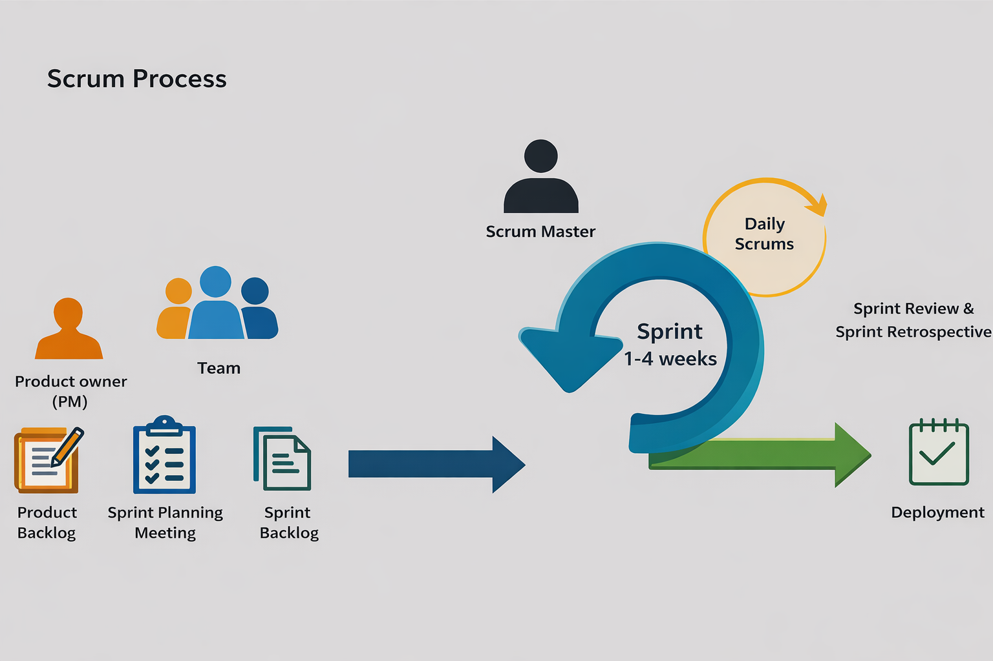
This chapter presents the methodology followed in the design and development of Office Student Affairs (OSA) Management System with QR Code and Geotagging System for Student Activity and Attendance, focusing on how the system is systematically planned, designed, developed, and evaluated. A clear and structured methodology is essential in software development because it guides the project team in organizing tasks, managing risks, and ensuring that the resulting system addresses the real needs of its users. In this study, the researchers adopt the Agile-Scrum methodology as the primary software development approach, since it supports iterative development, continuous testing, and close collaboration with stakeholders such as the OSA Personnel/System Administrators, Academic Personnel, Student Leaders (CSG Officers), and Students. This chapter explains how Agile–Scrum is applied to the proposed project from requirement gathering and sprint planning up to development, testing, and deployment together with the tools, diagrams, roles, and technologies that support the entire process.

Figure 3.1: Agile Methodology – Scrum Model Process by Ken Schwaber
and Jeff Sutherland
As shown in Figure 3.1, the researchers have chosen the Scrum-Agile model for the project because it supports an adaptive and collaborative development approach. Working in short, iterative sprints allows for continuous feedback and improvement, reducing risks and ensuring steady progress. This approach also offers a flexible structure that future teams can use when developing dynamic and user-centered systems.
The project, “Office Student Affairs (OSA) Management System with QR Code and Geotagging System for Student Activity and Attendance” adopts the Scrum Agile model illustrated in Figure 1. This methodology organizes development into short, focused work sessions called sprints, enabling step-by-step system development. Scrum follows distinct phases, including Product Backlog Creation, Sprint Planning, Sprint Backlog, Sprint Review, and Sprint Retrospective, ensuring that all requirements are regularly reviewed and adjusted to meet evolving needs.

3.1 Overview of the Methodology
The development of the Office Student Affairs (OSA) Management System with QR Code and Geotagging System for Student Activity and Attendance adopts the Agile Software Development Methodology, specifically the Scrum Framework, to ensure the systematic design, implementation, testing, and continuous improvement of the proposed system. Agile Scrum is an iterative and incremental software development methodology that emphasizes flexibility, collaboration, stakeholder involvement, and the rapid delivery of functional software increments (Schwaber & Sutherland, 2020). Unlike traditional software development models such as the Waterfall Model, which follows a rigid sequential process, Agile Scrum enables the development team to divide the project into smaller iterations called sprints. Each sprint delivers a functional increment of the system that can be reviewed, tested, and evaluated by stakeholders before proceeding to the next development cycle. This iterative approach allows the researchers to identify technical issues early, accommodate changing user requirements, and continuously improve the system based on stakeholder feedback.
The Scrum Framework also promotes close collaboration among the development team, Product Owner, and stakeholders throughout the software development lifecycle. Continuous sprint planning, daily Scrum meetings, sprint reviews, and sprint retrospectives enable the researchers to monitor project progress, resolve issues efficiently, and ensure that every system feature satisfies the operational requirements of the Office of Student Affairs.
The researchers selected Agile Scrum because the proposed system consists of multiple integrated modules including QR code attendance monitoring, geotagging validation, admission slip processing, student case record management, activity evaluation, analytics, and automated e-certificate generation which require iterative development, continuous integration, and regular stakeholder validation. Through Agile Scrum, the researchers can progressively deliver working software, refine system functionalities, and maintain software quality while ensuring that the final system effectively addresses the needs of the Office of Student Affairs of St. Rita's College of Balingasag.

3.2 Research Design
This study employs a Developmental-Applied Research Design integrated with a Descriptive-Quantitative Research Method to address the operational challenges encountered by the Office of Student Affairs (OSA) of St. Rita's College of Balingasag in managing student activities, attendance monitoring, admission slip processing, evaluation management, student case records, and report generation. The developmental-applied component focuses on the systematic design, development, implementation, and testing of the Office Student Affairs (OSA) Management System with QR Code and Geotagging System for Student Activity and Attendance. The software development process follows the Agile Scrum Methodology, allowing the researchers to perform iterative planning, requirement analysis, system design, software development, continuous integration, testing, and stakeholder validation through structured sprint cycles. This approach supports incremental software delivery, accommodates changing user requirements, and promotes continuous improvement based on stakeholder feedback throughout the development process (Richey & Klein, 2007; Schwaber & Sutherland, 2020).
The descriptive-quantitative component focuses on evaluating the quality, usability, functionality, and overall acceptability of the developed system. Quantitative data will be collected through User Acceptance Testing (UAT) involving the target users, including the Office of Student Affairs personnel, Program Heads, Central Student Government (CSG) Officers, and students. The system will also be evaluated by Information Technology experts using the ISO/IEC 25010 Software Quality Model, while system usability will be measured using the System Usability Scale (SUS). The collected data will be analyzed using descriptive statistical methods, such as frequency counts, percentages, weighted mean, and interpretation scales, to determine the overall performance and user acceptance of the proposed system. The Developmental-Applied Research Design is appropriate for this study because its primary objective is to produce a functional technological solution while simultaneously evaluating its effectiveness, usability, and software quality within an actual institutional environment. This design enables the researchers to develop an innovative student affairs management system that responds to identified operational problems while providing empirical evidence regarding its quality and user acceptance.

3.3 Agile Scrum Framework
The development of the Office Student Affairs (OSA) Management System with QR Code and Geotagging System for Student Activity and Attendance follows the Agile Scrum Framework to organize software development into iterative and incremental cycles. Scrum enables the researchers to develop the system through a series of short development periods called sprints, allowing continuous planning, development, testing, evaluation, and stakeholder feedback throughout the project. This framework promotes collaboration, flexibility, and continuous improvement, ensuring that each completed sprint delivers a functional system increment that contributes to the final product (Schwaber & Sutherland, 2020).
The Scrum Framework implemented in this study consists of Scrum Roles, Scrum Artifacts, Scrum Events, and Sprint Cycles, which collectively guide the systematic development of the proposed system.
3.3.1 Scrum Roles
The Scrum team for this study consists of the Product Owner, Scrum Master, Development Team, and Stakeholders. Each role has specific responsibilities to ensure the successful development of the proposed system.
Scrum Role | Assigned Personnel | Responsibilities
Product Owner | Office of Student Affairs (OSA) Representative | Defines system requirements, prioritizes the Product Backlog, validates completed features, and provides feedback during Sprint Reviews.
Scrum Master | Project Manager (Researcher) | Facilitates Scrum activities, monitors sprint progress, removes development obstacles, and ensures proper implementation of Agile Scrum practices.
Development Team | Researchers/ Developers | Designs, develops, tests, integrates, and documents the system throughout every sprint.
Stakeholders | Office of Student Affairs (OSA) Personnel, Academic Personnel (Program Heads, Department Instructors, and Academic Office Staff), Student Leaders (CSG Officers), and Students. | Evaluate developed features, provide feedback, participate in User Acceptance Testing, and validate system requirements.

3.3.2 Scrum Artifacts
Product Backlog
The Product Backlog contains all system requirements gathered during interviews, observations, and stakeholder consultations. It serves as the master list of system features that will be prioritized and implemented throughout the project.
The Product Backlog of this study includes:
- User Authentication
- User Management
- QR Code Attendance
- Geotagging Validation
- Admission Slip Processing
- Student Case Records
- Activity Evaluation
- Analytics Dashboard
- Report Generation
- E-Certificate Generation
- Role-Based Access Control
- Activity Log Monitoring
- Archive Management
Sprint Backlog
The Sprint Backlog contains selected Product Backlog items that will be completed during a specific sprint. Each Sprint Backlog includes development tasks, testing activities, and expected deliverables. Before each sprint begins, the development team conducts Sprint Planning to determine the features to be implemented based on project priorities and stakeholder requirements.
Working System Increment
At the end of every sprint, a functional version of the system is produced. This working increment undergoes Sprint Review, stakeholder evaluation, and testing before proceeding to the next sprint. Feedback gathered during Sprint Review is incorporated into the succeeding sprint to continuously improve the system.
3.3.3 Scrum Events
The Scrum Framework follows several recurring activities throughout the development process.
- Sprint Planning – determines sprint goals and identifies Product Backlog items to be completed.
- Daily Scrum – short meetings to monitor progress, discuss completed tasks, identify obstacles, and plan daily activities.
- Sprint Review – demonstrates completed features to stakeholders and gathers recommendations.
- Sprint Retrospective – evaluates the sprint process and identifies improvements for future iterations.
3.3.4 Sprint Cycles
The researchers divided the development of the Office of Student Affairs Management System (OSAMS) into four (4) sprint cycles using the Agile Scrum framework. The development was conducted from June 5 to September 30, 2026, with each sprint lasting approximately four (4) weeks. Each sprint focused on specific system modules and functionalities, allowing the researchers to plan, develop, test, integrate, and improve the system incrementally. Daily Scrum meetings were conducted to monitor progress, discuss completed and upcoming tasks, and identify challenges encountered during development. The four sprint cycles covered system administration, student services and attendance, personnel management and record monitoring, and system integration, testing, and finalization.
Sprint | Duration | Major Deliverables
Sprint 1 | June 5–June 30, 2026 (4 weeks) | Admin Module, User Authentication, User Management, Dashboard, Role-Based Access Control, and Event Management
Sprint 2 | July 1–July 31, 2026 (4 weeks) | Student Module, QR Code Attendance, Geotagging Validation, Admission Slip Requests, and Activity Evaluation
Sprint 3 | August 1–August 31, 2026 (4 weeks) | Academic Personnel Module, Department Roster, Event and Attendance Management, and Student Disciplinary Records
Sprint 4 | September 1–September 30, 2026 (4 weeks) | Analytics Dashboard, Report Generation, E-Certificate Generation, System Integration, Final Testing, Error Correction, and Deployment Preparation
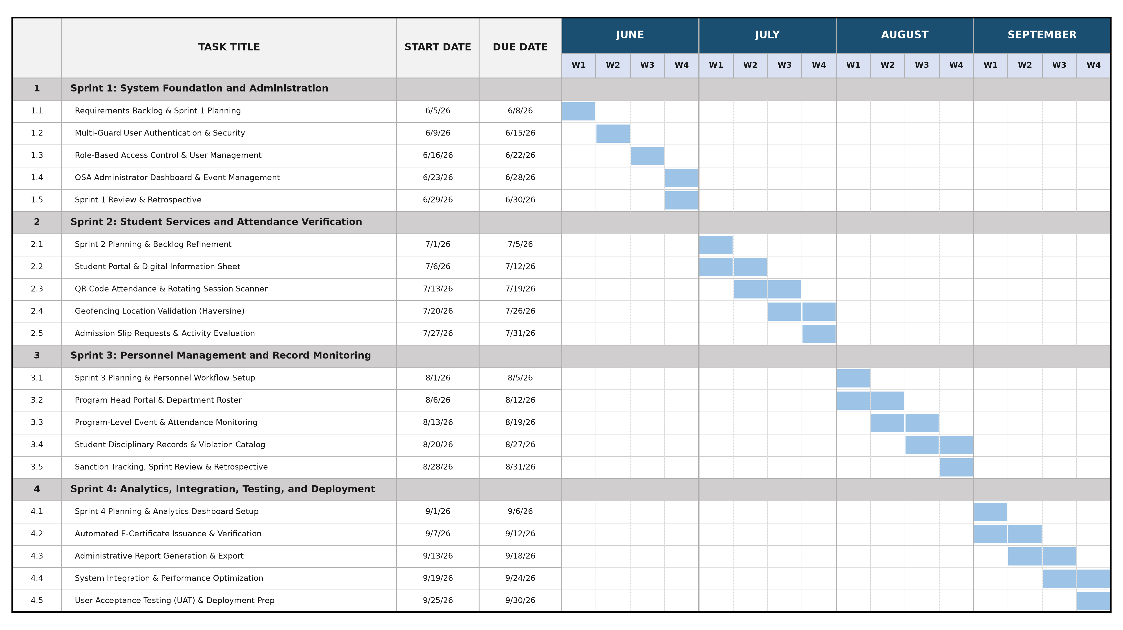
3.3.5 Gantt Chart

Figure 3.2: Project Gantt Chart
The Gantt Chart presented in Figure 3.2 illustrates the overall project schedule and timeline adopted by the researchers across the four (4) Agile Scrum sprint cycles from June 5 to September 30, 2026. As detailed in Section 4.1.1 and Table 4.1, the development timeline is systematically organized into four sequential four-week sprints:
• Sprint 1 (June 5 – June 30, 2026): Focuses on system foundation and administrative functions, encompassing requirements backlog refinement, multi-guard user authentication, role-based access control (RBAC), the OSA administrator dashboard, and campus event management.
• Sprint 2 (July 1 – July 31, 2026): Concentrates on student services and attendance verification, including student self-registration, digital information sheet completion, QR code session scanning, geotagging validation using the Haversine distance algorithm, admission slip requests, and activity evaluation surveys.
• Sprint 3 (August 1 – August 31, 2026): Covers academic personnel management and student disciplinary monitoring, featuring the dedicated Program Head portal, departmental student rosters, program-level event attendance monitoring, student violation catalogs, incident reporting, and disciplinary sanction management.
• Sprint 4 (September 1 – September 30, 2026): Encompasses administrative reporting, analytics, automated e-certificate issuance, system-wide integration, performance optimization, and final User Acceptance Testing (UAT) and deployment preparation.
Each sprint incorporates sprint planning, iterative feature development, continuous testing, review demonstrations, and retrospective evaluations, ensuring that every increment is verified and refined before proceeding to the subsequent phase.

3.4 System Design and Modeling
System design and modeling provide the structural and functional blueprint of the proposed system. The diagrams presented in this section illustrate the architecture, data movement, business processes, database structure, user interfaces, and testing procedures used during the development of the Office Student Affairs (OSA) Management System with QR Code and Geotagging System for Student Activity and Attendance. These models enable the researchers to visualize system components, define interactions among users and processes, and ensure that the system satisfies the identified functional and non-functional requirements.

3.4.1 System Architecture Diagram
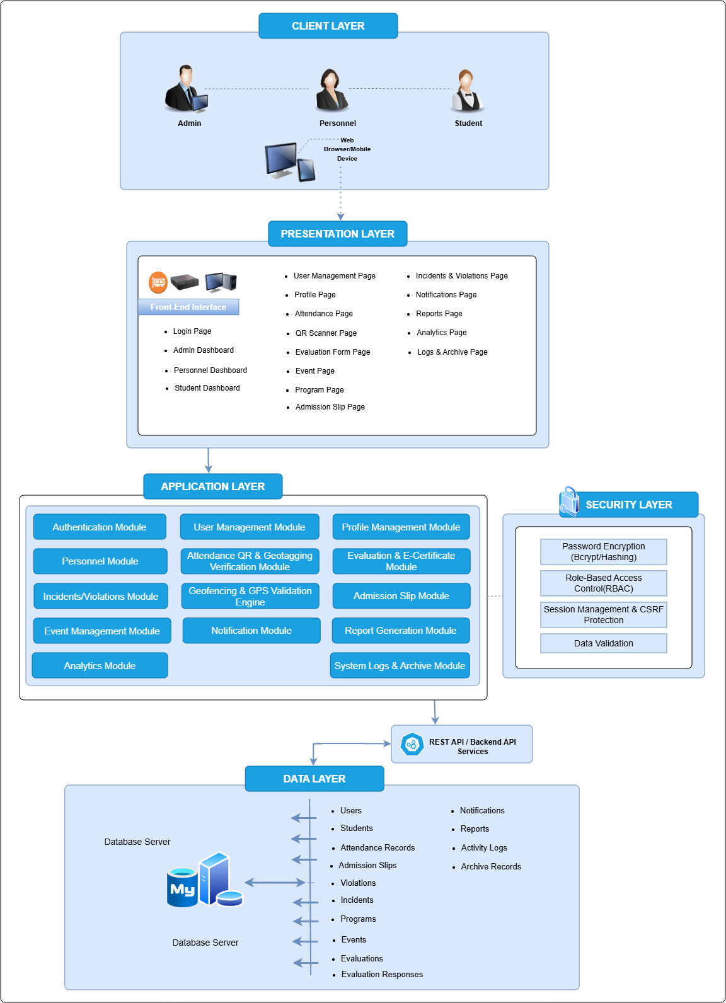
This section presents the system modeling and design artifacts that describe how the proposed system operates, how data flows through its components, and how users interact with its features. These diagrams are created using draw.io and related tools and serve as visual documentation of the system’s processes, architecture, and data structures.

Figure 3.3 : System Architecture
As shown in Figure 3.3, the System Architecture of the Office of Student Affairs Management System (OSAMS) is designed using a multi-layered architecture that supports scalability, security, maintainability, and efficient management of student affairs processes. At the Client Layer, the system is accessed by three main user groups: Admin, Personnel, and Student, using a web browser or mobile device. User requests are directed to the Presentation Layer, which serves as the front-end interface and includes the Login Page, Admin Dashboard, Personnel Dashboard, Student Dashboard, User Management, Profile, Attendance, QR Scanner, Evaluation Form, Event, Program, Admission Slip, Incidents and Violations, Notifications, Reports, Analytics, and Logs and Archive pages. This layer provides users with an accessible interface for performing functions according to their assigned roles.
The Application Layer serves as the main processing component of OSAMS, where the system's business logic and core functionalities are implemented. It consists of the Authentication, User Management, Profile Management, Personnel, Attendance QR & Geotagging Verification, Evaluation & E-Certificate, Incidents/Violations, Geofencing & GPS Validation, Admission Slip, Event Management, Notification, Report Generation, Analytics, and System Logs & Archive Modules. The Security Layer supports the application by providing password encryption through bcrypt/hashing, Role-Based Access Control (RBAC), session management and CSRF protection, and data validation. The REST API/Backend API Services facilitate communication between the application components and the database, allowing system information to be securely processed, retrieved, and updated.
At the Data Layer, OSAMS uses a MySQL database server to store and manage system information, including users, students, attendance records, admission slips, violations, incidents, programs, events, evaluations, evaluation responses, notifications, reports, activity logs, and archive records. The centralized database helps maintain data consistency, integrity, and availability across the system. Overall, the layered architecture provides a secure and organized framework that integrates event and activity management, QR and geotagging attendance, student verification, evaluations and e-certificates, admission slips, incidents and violations, notifications, reports, analytics, and record management into a single platform, supporting efficient student affairs operations and service delivery within the institution.

3.4.2 Data Flow Diagrams (DFD)
The Data Flow Diagram (DFD) illustrates how data moves within the system. It shows the sources of data, processes that transform the data, data storage, and outputs. This diagram helps in understanding how information such as attendance records, case details, and evaluation results are processed and stored within the system.
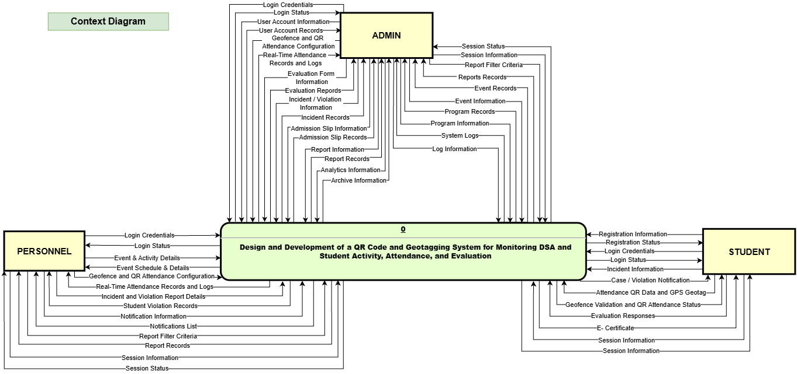
Figure 3.4 : Level 0 Context Diagram
The Context Diagram shown in Figure 3.4 illustrates the overall interaction between the proposed QR Code and Geotagging System for Monitoring DSA and Student Activity, Attendance, and Evaluation and its three external entities: Admin, Personnel, and Student. It presents the major data exchanged between the system and each user according to their respective roles. The Admin provides login credentials, user account information, geofence and QR attendance configuration, evaluation forms, incident and violation information, admission slip information, report criteria, and other management-related data, while receiving attendance records and logs, evaluation reports, incident records, admission slip records, reports, analytics, archive information, event and program records, and system logs. The Personnel provides login credentials, event and activity details, event schedules, geofence and QR attendance configuration, attendance information, incident and violation report details, report filter criteria, and session information, while receiving login status, event details, real-time attendance records and logs, student violation records, notifications, reports, and session status. The Student provides registration and login information, incident information, attendance QR data and GPS coordinates, evaluation responses, and session information, while receiving registration and login status, case or violation notifications, geofence validation and QR attendance status, e-certificates, and other relevant system information. Overall, the diagram provides a high-level view of the data flows between OSAMS and its external entities and establishes the system boundary for the more detailed data flows presented in the succeeding Data Flow Diagrams (DFDs).

Figure 3.5 : Level 1 Data Flow Diagram

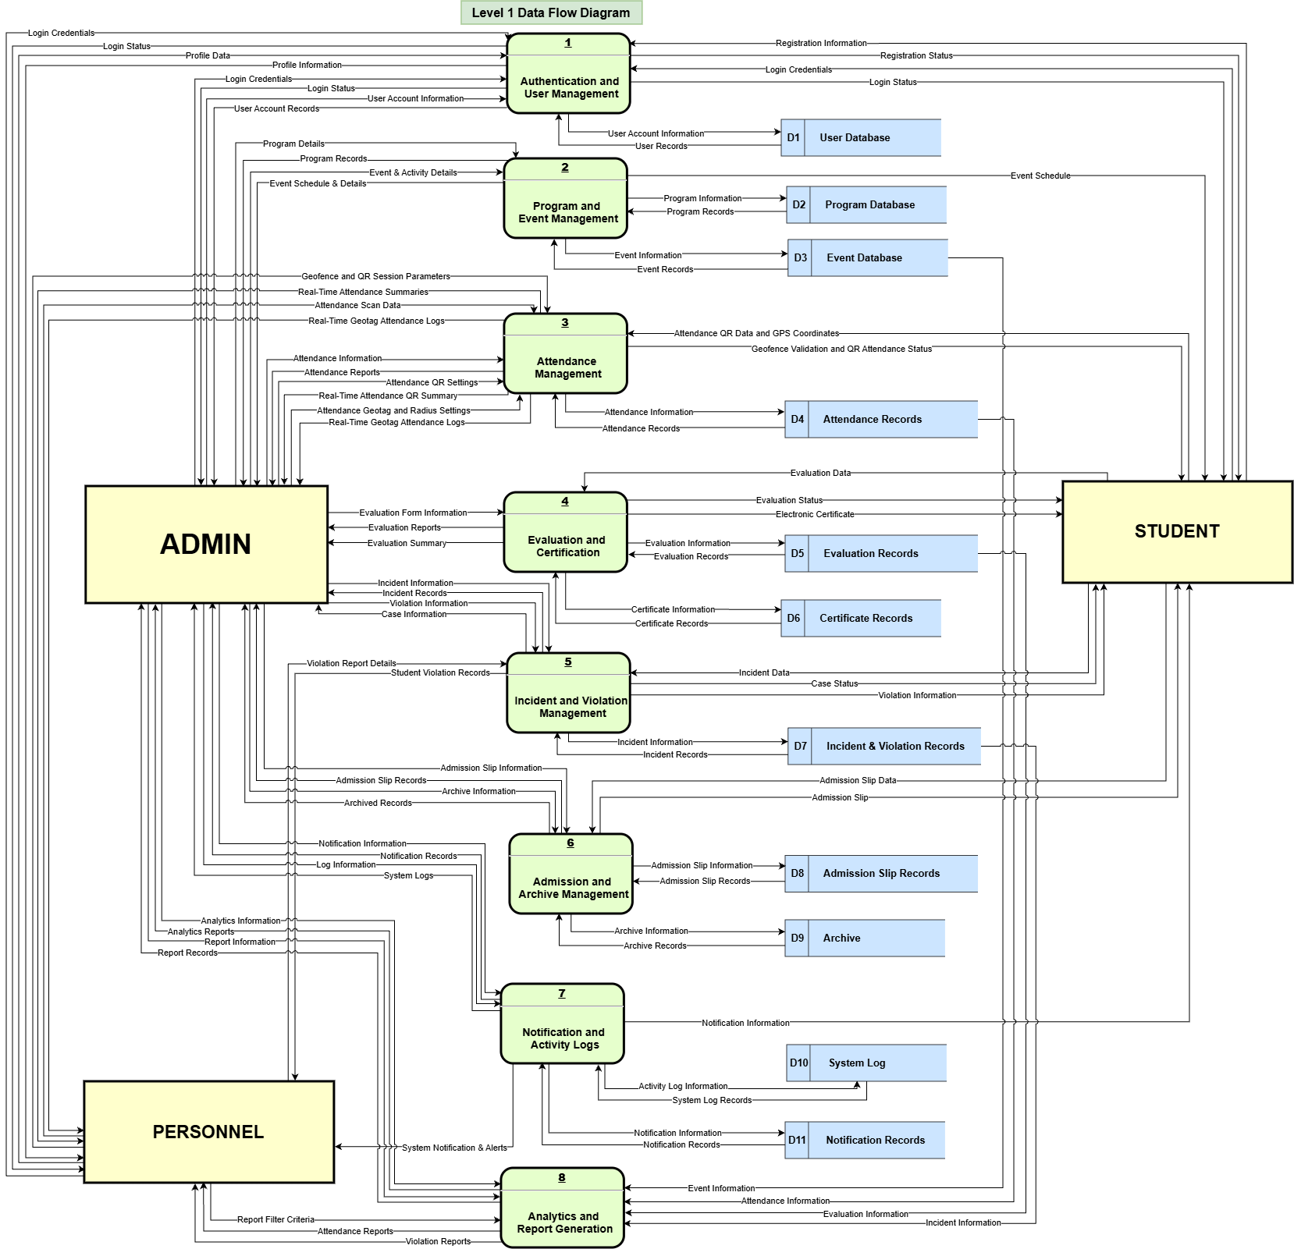
The Level 1 Data Flow Diagram shown in Figure 3.5 illustrates how data flows between the Admin, Personnel, Student, system processes, and data stores of the proposed system. The system begins with Authentication and User Management, which handles registration, login credentials, profile information, and user account records. It then processes the major functions of the system through Program and Event Management, Attendance Management, Evaluation and Certification, Incident and Violation Management, Admission and Archive Management, Notification and Activity Logs, and Analytics and Report Generation. Each process receives, processes, and transfers relevant information to the appropriate data stores, including the User Database, Program Database, Event Database, Attendance Records, Evaluation Records, Certificate Records, Incident and Violation Records, Admission Slip Records, Archive, System Log, and Notification Records. The Admin, Personnel, and Student interact with the system by providing and receiving information based on their respective roles and authorized activities, including event and program management, QR and geotagged attendance, evaluation and certification, incident and violation management, admission slips, notifications, analytics, and report generation. Overall, the diagram provides a detailed representation of how data is input, processed, stored, retrieved, and transferred among the system processes, external entities, and data stores of the proposed OSAMS.

3.4.3 Activity Diagrams
The Activity Diagrams illustrate the sequence of activities, actions, and interactions involved in the different processes of the Office of Student Affairs. They show how each process is currently performed and how it will be improved through the proposed system. The current activity diagrams present the existing procedures for student attendance, activity evaluation, admission slip requests, and the handling of incidents, violations, and complaints. These include paper-based and online-based activity evaluations, walk-in admission slip processing, and different procedures for minor and serious cases. Meanwhile, the proposed activity diagrams present the improved processes for student attendance, activity evaluation, admission slips, and the management of minor and serious incidents, violations, and complaints using the proposed system. These diagrams provide a clear comparison between the existing and proposed workflows and show how the system can improve the efficiency and management of these processes.

3.4.3.1 Current Activity Diagrams
The Current Activity Diagrams present the existing procedures followed by the students and the Office of Student Affairs (OSA) in carrying out different student-related activities. These diagrams show the current flow of student attendance, activity evaluation, admission slip requests, and incident, violation, and complaint handling. The processes include paper-based and online-based activity evaluations, walk-in admission slip requests, and separate procedures for minor cases based on complaints, being caught in the act, or witness reports, as well as serious cases or concerns that arise. These diagrams serve as a representation of the existing processes before the implementation of the proposed system.
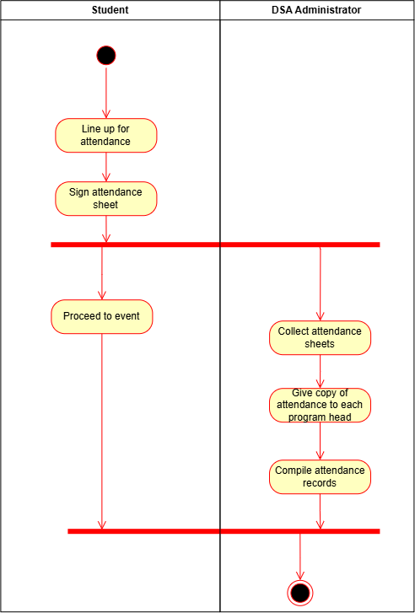

Figure 3.6: Current Student Attendance Activity Flow Diagram
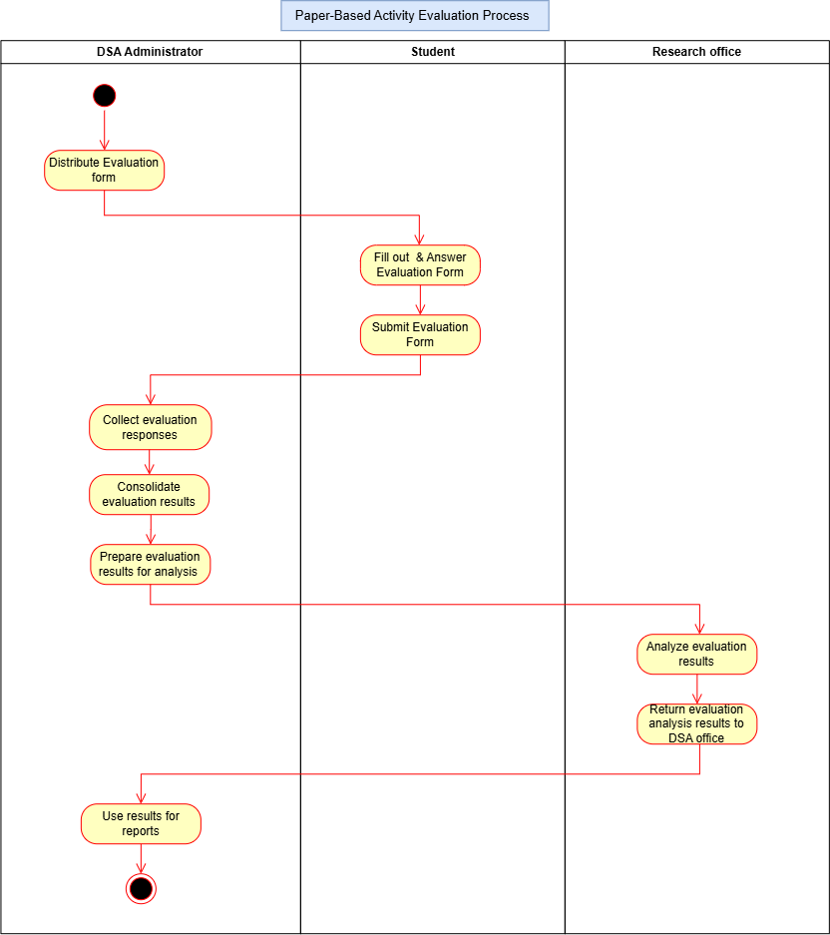
As shown in Figure 3.6, the current student attendance workflow in the Office of Student Affairs (OSA) Office process begins with students arriving at the venue and lining up for attendance. Each student then signs the attendance sheet to confirm their presence. After completing the sign-in process, students proceed to the event. On the administrative side, the OSA administrator collects all completed attendance sheets after the sign-in period. Copies of the attendance records are then distributed to each program head for reference and monitoring. Following this, the administrator compiles the attendance data into an organized record for documentation and reporting purposes. The workflow concludes once all attendance records have been properly compiled and finalized.

Figure 3.7: Current Paper-Based Evaluation Activity Flow Diagram
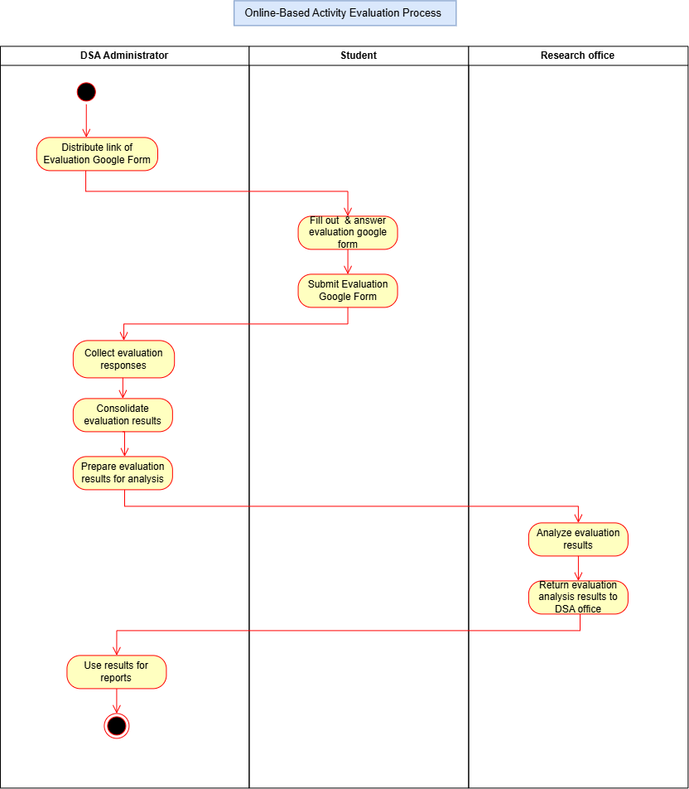
The current paper-based activity evaluation workflow that is shown in Figure 3.7, involving the OSA Administrator, students, and the research office. The process begins with the OSA administrator distributing evaluation forms to students. Upon receiving the forms, students fill out and answer the evaluation questions, then submit the completed forms back to the administrator. After collecting all evaluation responses, the OSA administrator consolidates the results and prepares them for further analysis. These prepared evaluation results are then forwarded to the research office, where they are carefully analyzed to extract meaningful insights. Once the analysis is complete, the research office returns the evaluation findings to the OSA office. Lastly, the OSA administrator utilizes the analyzed results to generate reports, concluding the evaluation process.

Figure 3.8: Current Online-Based Evaluation Activity Flow Diagram
The current online-based activity evaluation process shown in Figure 3.8 involves the DSA Administrator, Student, and Research Office. The process begins when the DSA Administrator distributes the evaluation Google Form link to the students. The students then fill out and answer the evaluation form and submit their responses through Google Forms. After submission, the DSA Administrator collects the evaluation responses, consolidates the results, and prepares the evaluation results for analysis. The Research Office then analyzes the evaluation results and returns the analysis results to the DSA Office. Finally, the DSA Administrator uses the evaluation results for reporting, which concludes the process.
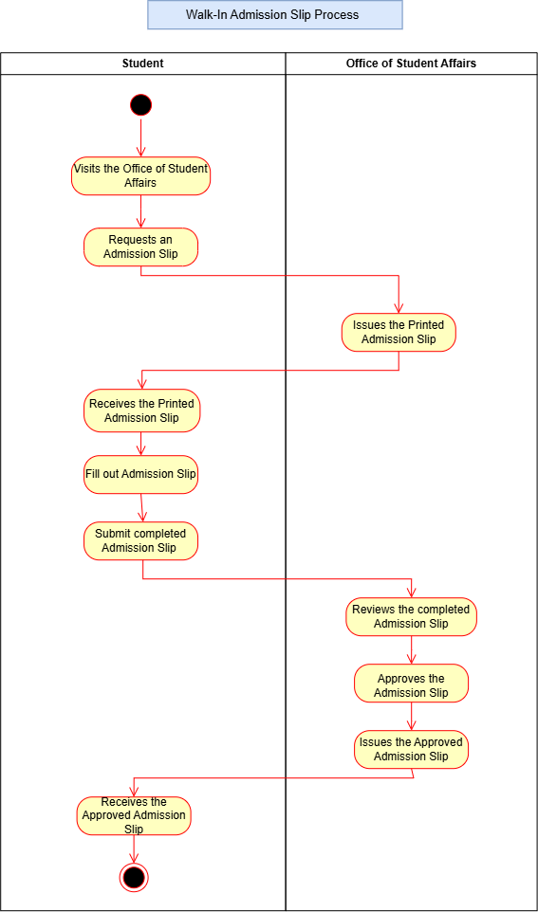

Figure 3.9: Current Walk-In Admission Slip Activity Flow Diagram
The current walk-in admission slip process shown in Figure 3.9 involves the student and the Office of Student Affairs (OSA). The process begins when the student visits the Office of Student Affairs to request an admission slip. The OSA then issues a printed admission slip to the student. After receiving the form, the student fills out the required information and submits the completed admission slip back to the OSA. The OSA reviews the submitted admission slip and, once the information is verified and approved, issues the approved admission slip to the student. The process concludes when the student receives the approved admission slip.
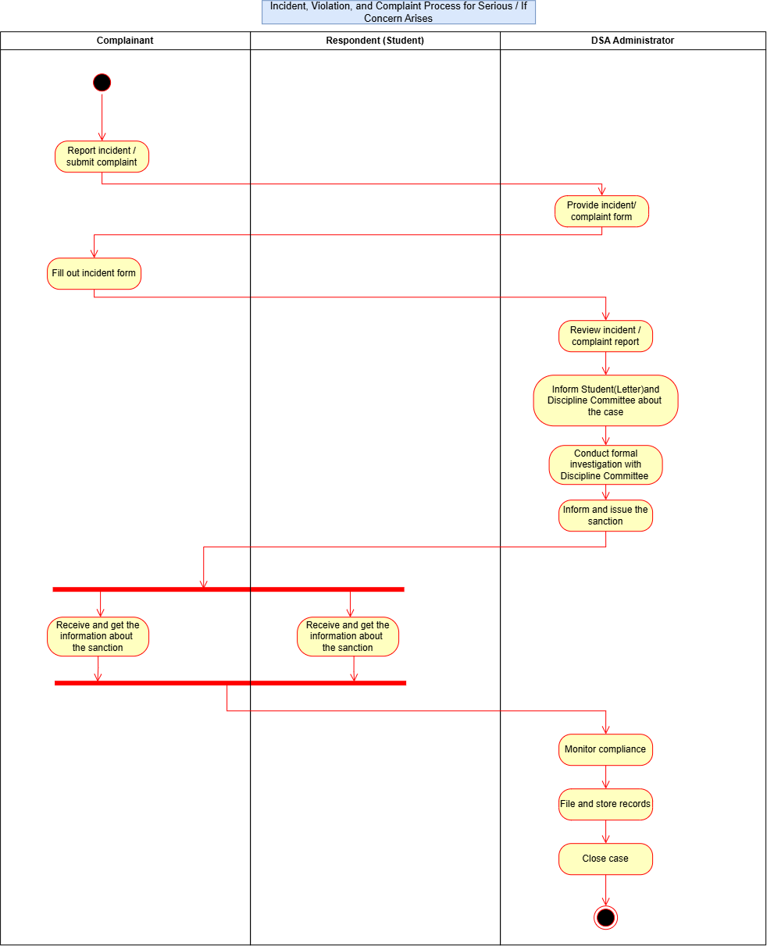

Figure 3.10: Current Incident, Violation, and Complaint Activity Flow Diagram
The current incident, violation, and complaint process shown in Figure 3.10, involves the complainant, the respondent (student), and the OSA Administrator. The process begins when the complainant reports an incident or submits a complaint to the OSA office. In response, the OSA Administrator provides the necessary incident or complaint form to formally document the concern. The complainant then fills out the incident form and submits it for review. Once the form is submitted, the OSA Administrator reviews the incident or complaint report to assess the situation. After evaluation, the administrator informs the concerned student (respondent) through a formal letter and coordinates with the Discipline Committee regarding the case. A formal investigation is then conducted in collaboration with the Discipline Committee to ensure that all details are properly examined. Based on the findings, the OSA Administrator makes a decision and issues the appropriate sanction.
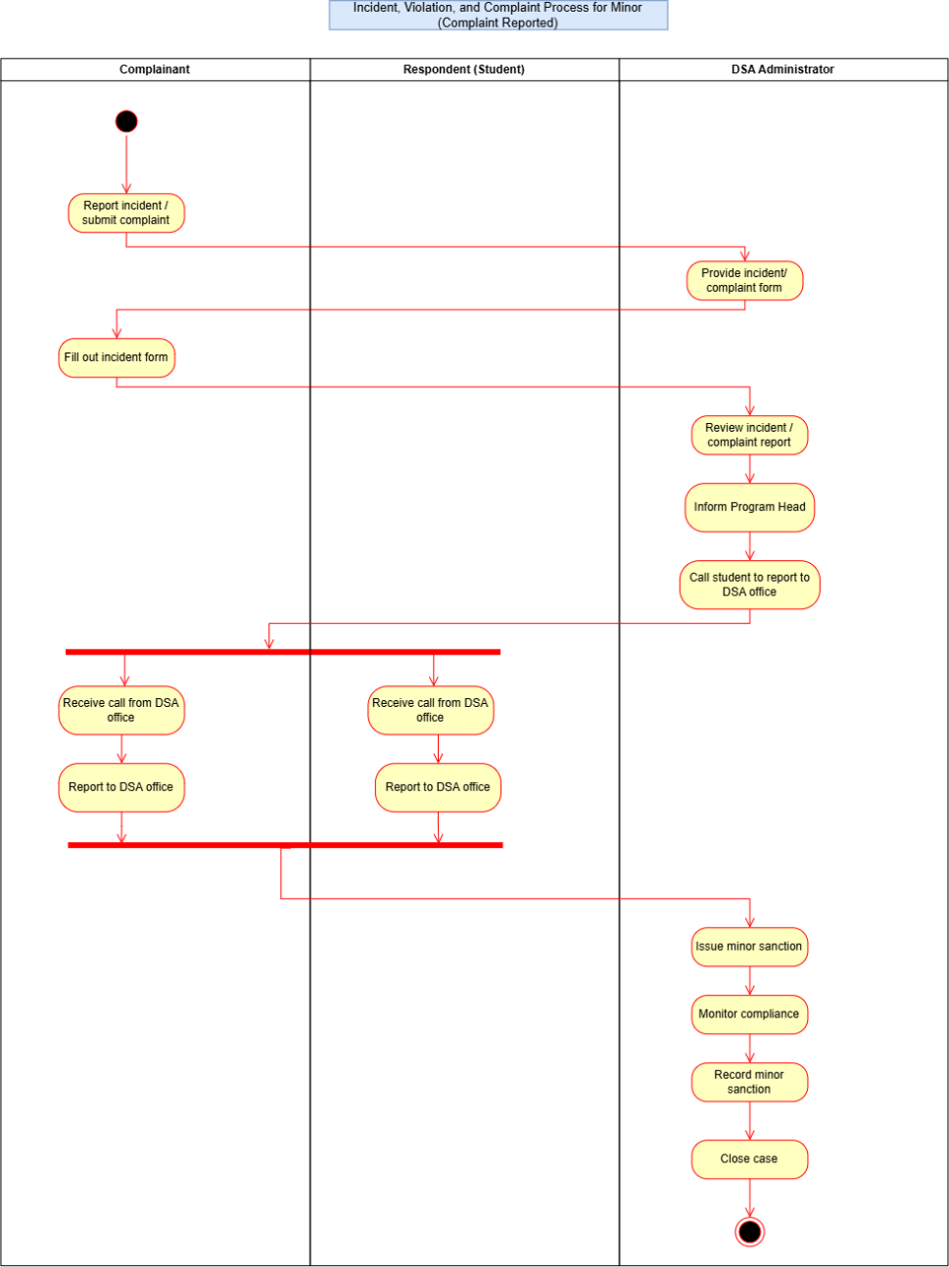

Figure 3.11: Current Incident, Violation, and Complaint (Minor) Activity Flow Diagram
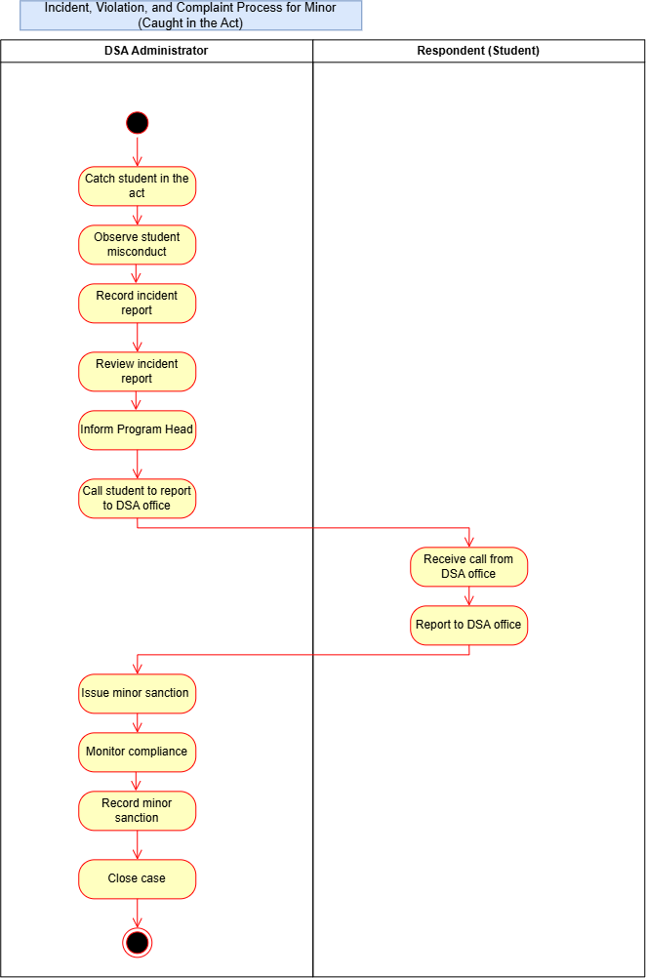
The current incident, violation, and complaint process for minor cases shown in Figure 3.11 involves the complainant, respondent (student), and OSA Administrator. The process begins when the complainant reports an incident or submits a complaint to the OSA office, after which the OSA Administrator provides the appropriate incident or complaint form for the complainant to complete and submit. The OSA Administrator then reviews the report and informs the program head about the case. After the initial coordination, the OSA office contacts both the complainant and respondent and requests them to report to the OSA office. Once both parties appear, the OSA Administrator proceeds with the resolution process by issuing an appropriate minor sanction based on the findings and monitoring compliance with the sanction. The imposed sanction is then recorded for documentation, and once all requirements have been fulfilled and properly documented, the case is formally closed, concluding the incident, violation, and complaint process.

Figure 3.12: Current Incident, Violation, and Complaint (Caught in Act) Activity Flow Diagram
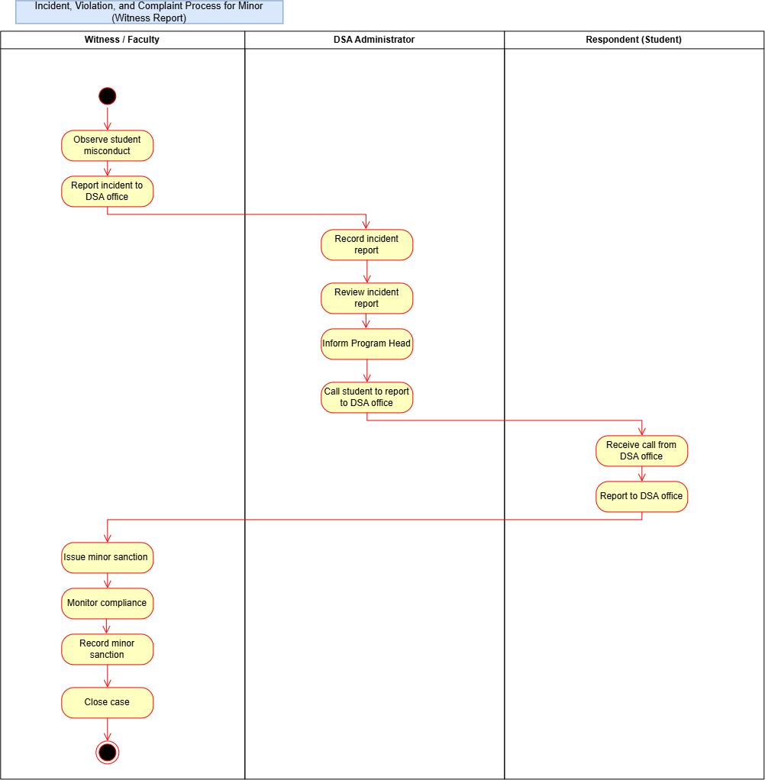
The current incident, violation, and complaint process for minor cases when a student is caught in the act, as shown in Figure 3.12, involves the OSA Administrator and the respondent (student). The process begins when the OSA Administrator catches the student committing a violation and observes the misconduct. The administrator then documents the incident by recording an incident report, reviews the report, and informs the program head about the violation. Afterward, the administrator contacts the student and instructs them to report to the OSA office. The student receives the instruction and reports to the office as directed. Once the student appears, the OSA Administrator proceeds with the resolution process by issuing an appropriate minor sanction, monitoring the student’s compliance, and recording the details for documentation. Finally, after all requirements have been fulfilled and properly documented, the case is officially closed, concluding the incident, violation, and complaint process.

Figure 3.13: Current Incident, Violation, and Complaint (Witness Report) Activity Flow Diagram
The current incident, violation, and complaint process for minor cases based on a witness report, as shown in Figure 3.13, involves the witness or faculty member, OSA Administrator, and respondent (student). The process begins when a witness or faculty member observes a student committing misconduct and reports the incident to the OSA office for proper action. Upon receiving the report, the OSA Administrator records the incident and prepares an official incident report, reviews the case, and informs the program head about the situation. The OSA office then contacts the student involved and instructs them to report to the office. After receiving the instruction, the student reports to the OSA office, where the OSA Administrator proceeds with the resolution by issuing an appropriate minor sanction. The administrator monitors the student’s compliance with the imposed sanction and records the details for documentation. Finally, after all requirements have been fulfilled and properly documented, the case is formally closed, concluding the incident, violation, and complaint process.

3.4.3.2 Proposed Activity Diagrams
The Proposed Activity Diagrams present the improved procedures that will be implemented through the proposed system. These diagrams show how the system will support and streamline the processes for student attendance, activity evaluation, admission slip requests, and the management of minor and serious incidents, violations, and complaints. The proposed workflows incorporate system-based processes such as recording information, sending notifications, updating statuses, and managing records to reduce manual work and improve the efficiency of OSA services. These diagrams demonstrate how the proposed system improves the existing procedures while providing a more organized and efficient process for both students and authorized OSA personnel.

Figure 3.14: Proposed Direct Geotagging Attendance (No Scanner) Diagram
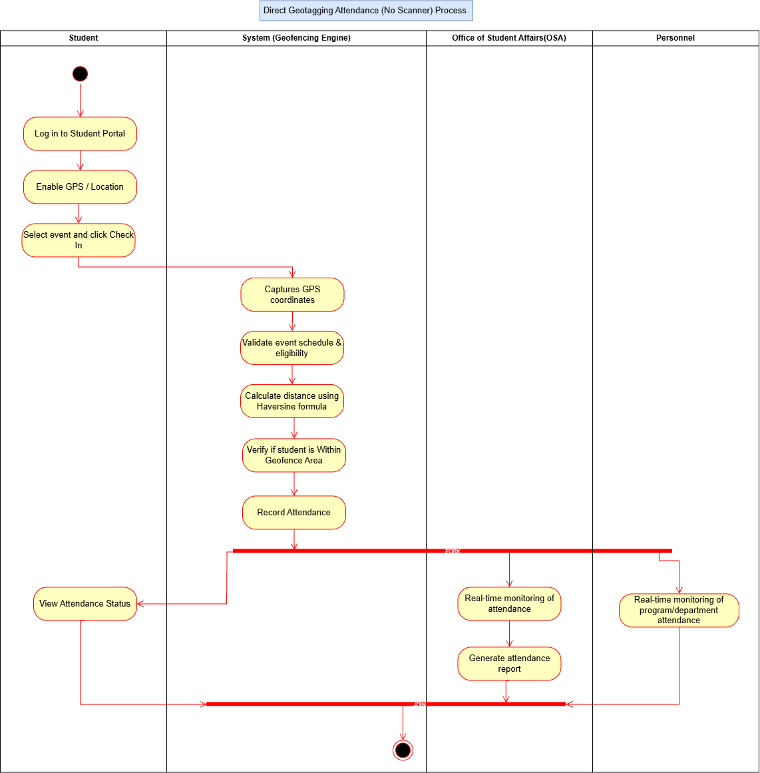
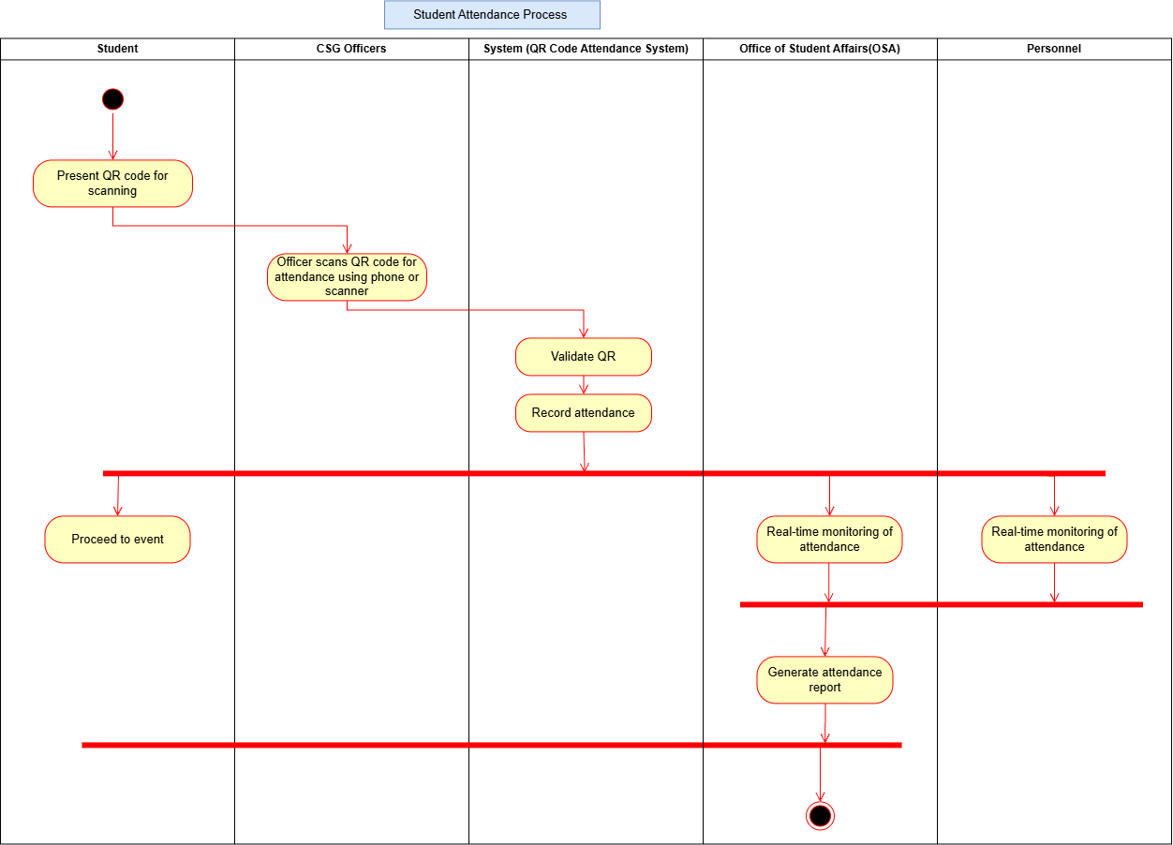
The Direct Geotagging Attendance Process shown in Figure 3.14 illustrates the process of recording student attendance using GPS-based geofencing without requiring a QR scanner. The process begins when the student logs in to the Student Portal, enables GPS or location services, selects the scheduled event, and clicks the Check In option. The system then captures the student's GPS coordinates, validates the event schedule and the student's eligibility, and calculates the distance between the student's current location and the designated event location using the Haversine formula. The system verifies whether the student is within the allowed geofence area and, if valid, records the student's attendance. The student can then view the attendance status through the Student Portal. At the same time, the OSA can monitor attendance in real time and generate an attendance report, while Personnel can monitor attendance for their assigned program or department. The process concludes after the attendance is recorded and the attendance information is made available for real-time monitoring and reporting.
Figure 3.15: Proposed QR Student Attendance Activity Flow Diagram
The proposed Student Attendance Process shown in Figure 3.15 involves the Student, CSG Officers, QR Code Attendance System, Office of Student Affairs (OSA), and Personnel. The process begins when the student presents their QR code for scanning upon arrival at the event. The CSG Officer then scans the student's QR code using a mobile phone or scanner device. Once scanned, the system validates the QR code and records the student's attendance. After the attendance is successfully recorded, the student proceeds to the event. At the same time, the OSA and Personnel can monitor the attendance in real time through the system, allowing them to track student participation during the event. The OSA can then generate an attendance report based on the recorded attendance data. The process concludes once the attendance has been monitored and the required attendance report has been generated.
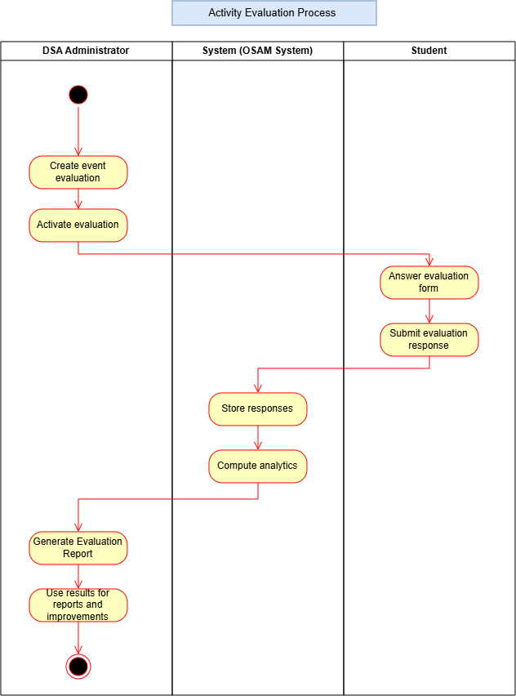

Figure 3.16: Proposed Activity Evaluation Flow Diagram
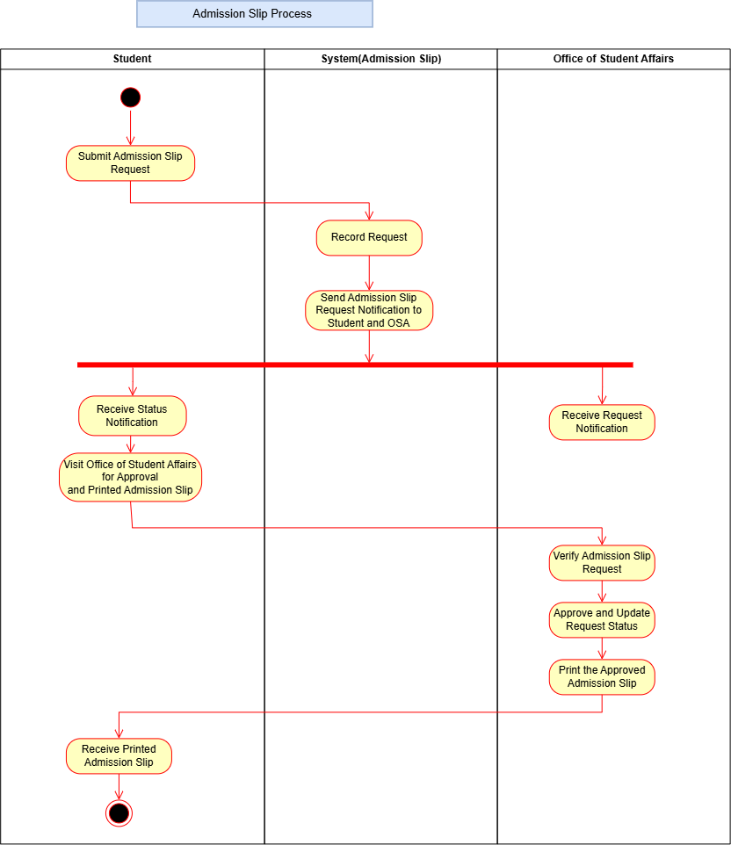
The proposed activity evaluation workflow shown in Figure 3.16 involves the OSA Administrator, the QR-Based Evaluation System, and the students. The process begins when the OSA Administrator creates an event evaluation and activates it within the system. Once the evaluation is activated, students can access the evaluation form, answer the required questions, and submit their responses electronically through the system. After submission, the system automatically stores the students’ responses and computes analytics to summarize the evaluation results. The processed data is then made available to the OSA Administrator, who generates the evaluation report and uses the results for reporting and continuous improvement of future activities and programs. The process concludes once the evaluation results have been reviewed and utilized for decision-making and activity enhancement.

Figure 3.17: Proposed Admission Slip Activity Flow Diagram
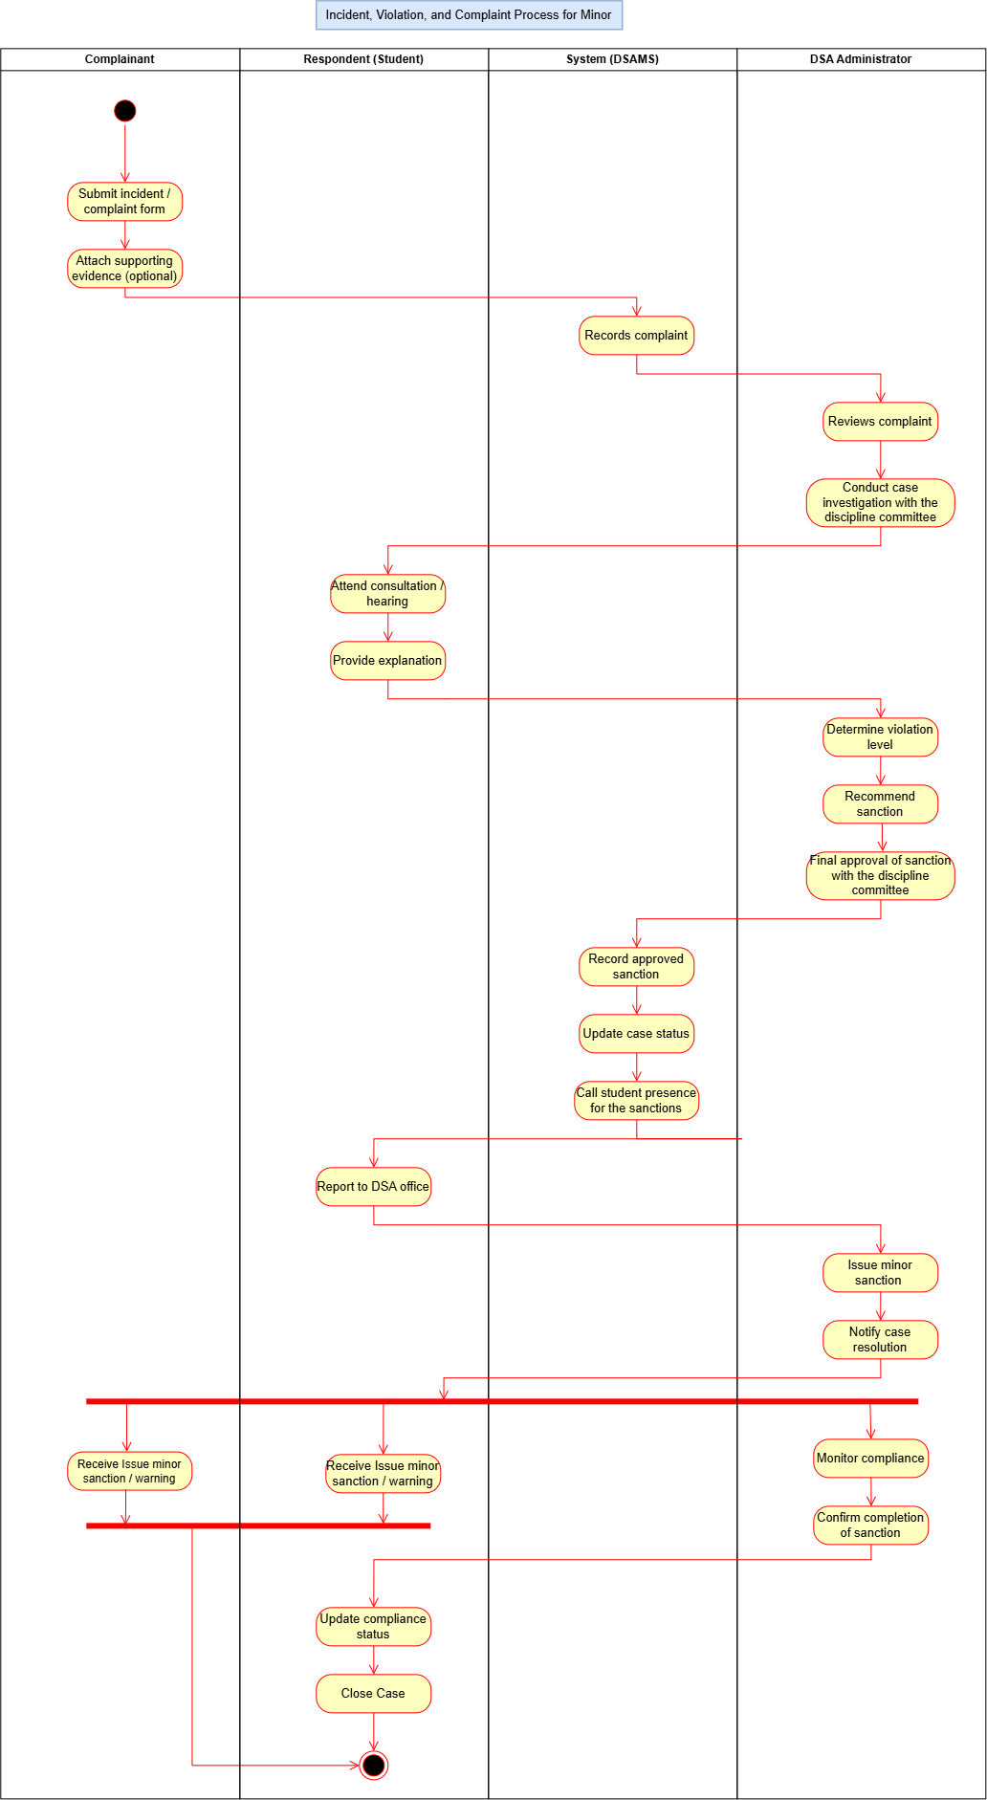
The proposed admission slip process shown in Figure 3.17 involves the student, the Admission Slip System, and the Office of Student Affairs (OSA). The process begins when the student submits an admission slip request through the system. The system records the request and sends a notification about the admission slip request to both the student and the OSA. The student receives the status notification and proceeds to the OSA for approval and the printing of the admission slip, while the OSA receives the request notification and verifies the admission slip request. After verification, the OSA approves the request and updates its status in the system. The approved admission slip is then printed by the OSA and provided to the student. The process concludes when the student receives the printed admission slip.

Figure 3.18: Proposed Incident, Violation, and Complaint (Minor) Activity Flow Diagram
The proposed incident, violation, and complaint process for minor cases shown in Figure 3.18 involves four key participants: the complainant, respondent (student), System (OSAMS), and the OSA Administrator. The process begins when the complainant submits an incident or complaint form and may optionally attach supporting evidence. The OSAMS records the complaint and forwards it to the OSA Administrator for review. The administrator then conducts a case investigation together with the discipline committee. During the investigation, the respondent is required to attend a consultation or hearing and provide an explanation regarding the reported incident. Based on the gathered information and findings, the OSA Administrator determines the violation level, recommends an appropriate sanction, and obtains final approval from the discipline committee. Once approved, the system records the sanction, updates the case status, and schedules the student’s presence for sanction implementation. The respondent reports to the OSA Office, where the minor sanction is formally issued, and both the complainant and respondent are notified of the case resolution. The OSA Administrator then monitors the respondent’s compliance and confirms the completion of the required sanction. Finally, the system updates the compliance status, closes the case, and marks the process as completed.

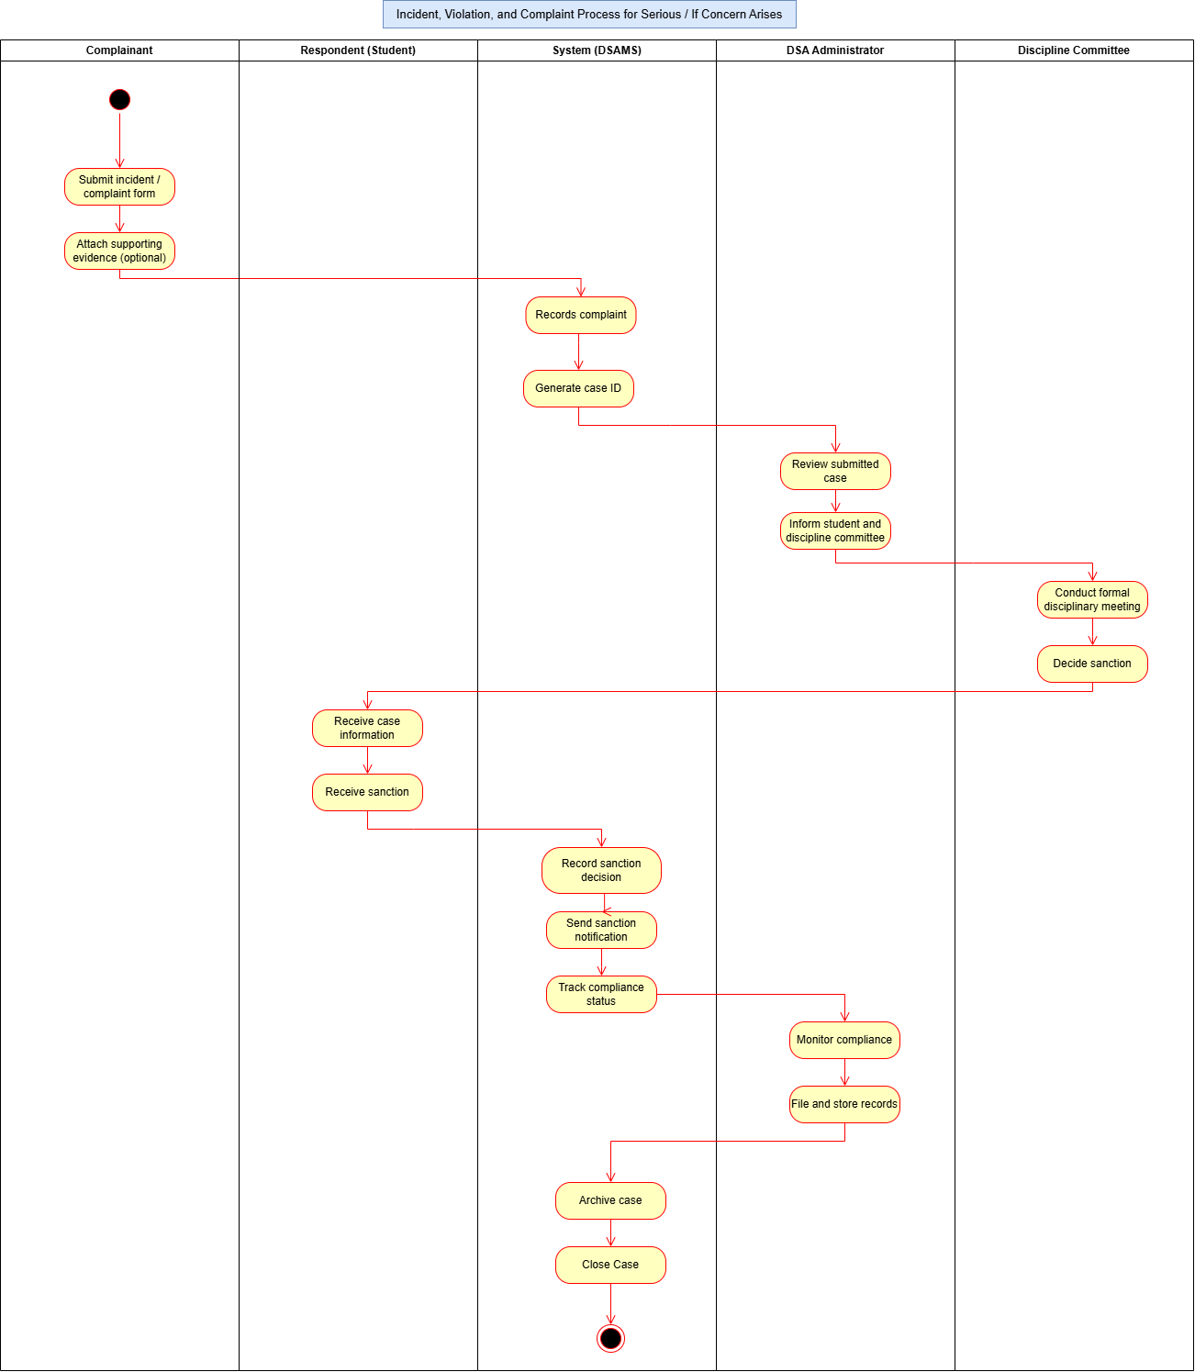

Figure 3.19: Proposed Incident, Violation, and Complaint Process for Serious Cases/ If Concern Arises Activity Flow Diagram
The proposed incident, violation, and complaint process for serious cases or situations where concerns arise, as shown in Figure 3.19, involves the complainant, respondent (student), System (OSAMS), OSA Administrator, and the Discipline Committee. The process begins when the complainant submits an incident or complaint form and may attach supporting evidence. The OSAMS records the complaint and automatically generates a case ID for proper tracking and documentation. The OSA Administrator then reviews the submitted case and informs both the respondent and the Discipline Committee about the reported incident. A formal disciplinary meeting is conducted by the Discipline Committee to investigate the case and evaluate the evidence presented. Based on the findings of the investigation, the committee decides on the appropriate sanction. The respondent receives the case information and is informed of the sanction imposed. The system records the sanction decision, sends sanction notifications, and tracks the respondent’s compliance status. The OSA Administrator continuously monitors compliance and files all relevant records for documentation purposes. Once all requirements and sanctions have been fulfilled, the system archives the case, formally closes it, and marks the process as completed.
3.4.4 Database Design (ERD & Data Dictionary)
The Database Design presents the structure and organization of the database for the proposed Office of Student Affairs Management System. It includes the Entity-Relationship Diagram (ERD) and Data Dictionary, which define how data are stored, organized, and related within the system. The ERD illustrates the entities, attributes, and relationships involved in the system, while the Data Dictionary provides detailed information about the fields in each database table, including their names, data types, descriptions, and keys. Together, these provide a clear representation of the database structure and serve as a guide for the proper organization, storage, and management of data within the proposed system.

3.4.4.1 Entity-Relationship Diagram (ERD)
The Entity-Relationship Diagram (ERD) illustrates the logical database structure of the system, defining the primary keys (PK), foreign keys (FK), attributes, and relationship cardinalities between entities.

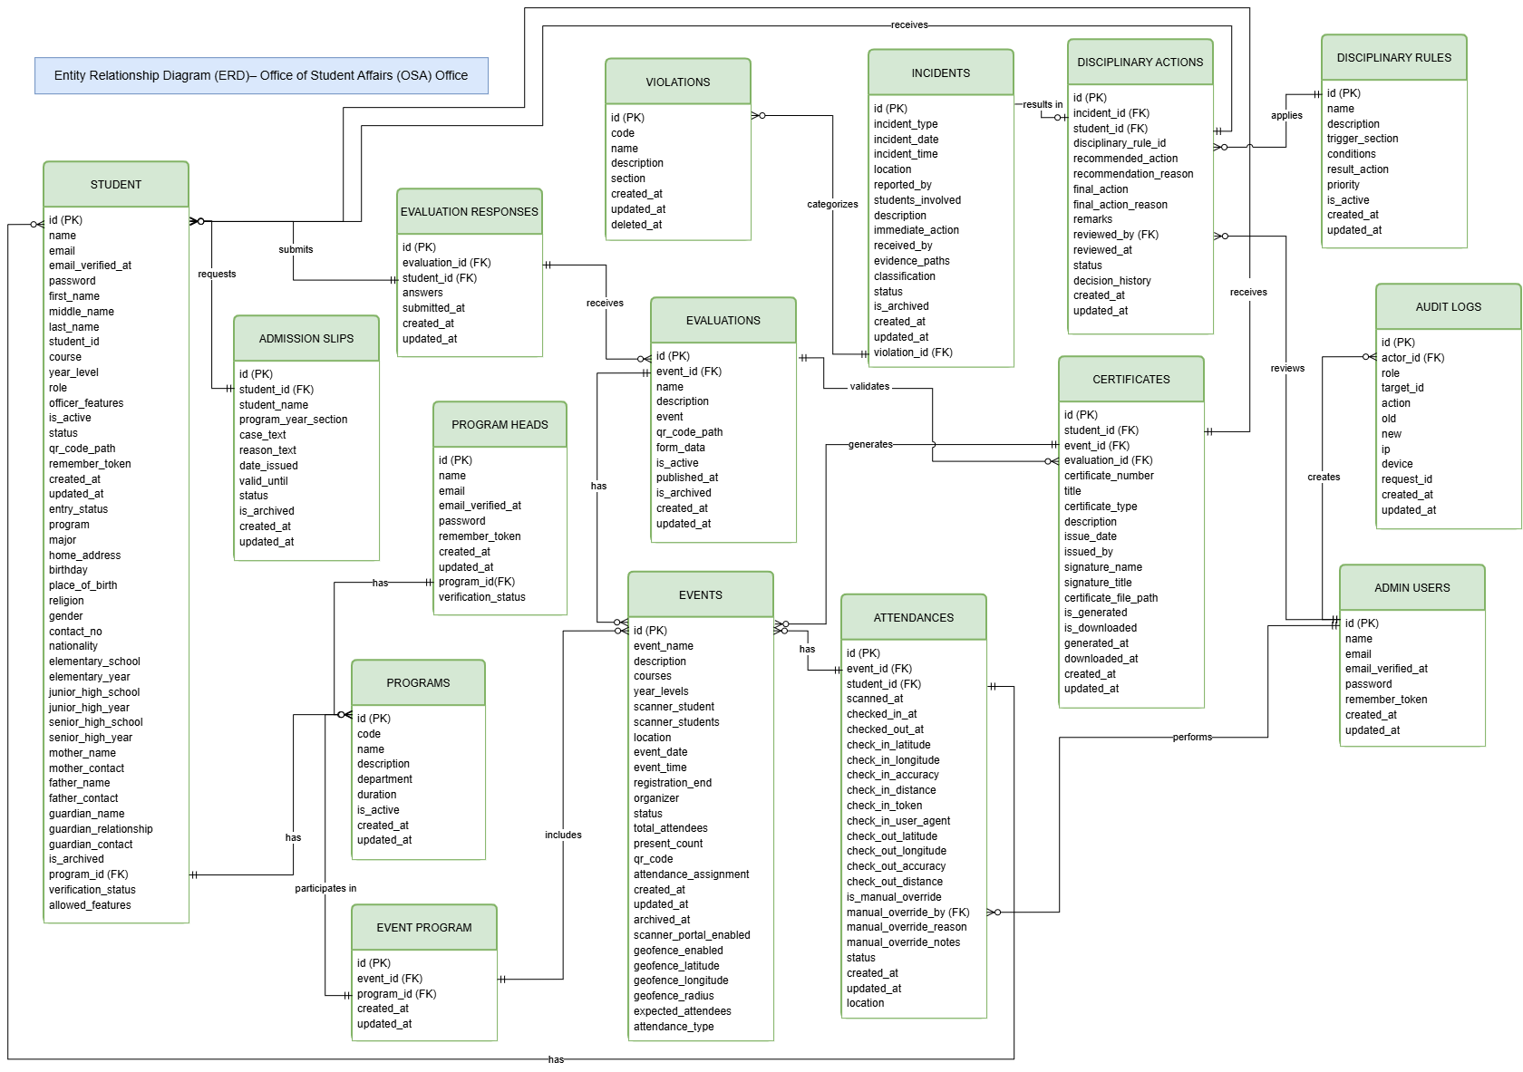
Figure 3.20: Entity-Relationship Diagram
The Entity-Relationship Diagram (ERD) of the proposed Office of Student Affairs Management System (OSAMS), as shown in Figure 3.20, presents the different entities, attributes, and relationships that make up the system’s database. The diagram includes the Student, Admission Slips, Evaluation Responses, Evaluations, Events, Attendances, Programs, Event Program, Program Heads, Incidents, Violations, Disciplinary Actions, Disciplinary Rules, Certificates, Admin Users, and Audit Logs entities. The Student entity stores student information and is connected to records such as admission slip requests, evaluation responses, attendance records, incidents, and certificates. The Events entity manages event information and is associated with programs, evaluations, and attendance records, while the Evaluations entity stores evaluation details and receives responses submitted by students. The Incidents and Violations entities support the recording and classification of reported cases, while Disciplinary Actions records the actions taken based on applicable Disciplinary Rules. The Admin Users and Program Heads support the management and review of system records, while Audit Logs record activities performed within the system for monitoring and accountability. Overall, Figure 19 shows how the different entities are connected through primary and foreign keys, providing an organized structure for storing, retrieving, and managing data within the proposed system.

3.4.4.2 Data Dictionary
The Data Dictionary provides a detailed description of the tables used in the Office of Student Affairs Management System (OSAMS). It identifies the fields, data types, lengths, constraints, and purpose of each attribute stored in the system's database.
Column Name | Data Type | Length | Constraints | Description
id | BIGINT UNSIGNED | 20 | PRIMARY KEY, AUTO_INCREMENT | Unique identifier for the administrator account.
name | VARCHAR | 255 | NOT NULL | Full name of the administrator.
email | VARCHAR | 255 | NOT NULL, UNIQUE | Official email address used for system login.
email_verified_at | TIMESTAMP | - | NULLABLE | Timestamp when the admin email was verified.
password | VARCHAR | 255 | NOT NULL | Bcrypt-hashed password.
handover_expires_at | TIMESTAMP | - | NULLABLE | Expiration date and time for temporary account access.
is_active | TINYINT(1) | 1 | DEFAULT 1 | Flag showing if the account is active or disabled.
created_by_admin_id | BIGINT UNSIGNED | 20 | NULLABLE | ID of the administrator who created this account.
two_factor_secret | TEXT | - | NULLABLE | Secret key used for two-factor authentication.
two_factor_recovery_codes | TEXT | - | NULLABLE | Emergency recovery codes for two-factor login.
two_factor_confirmed_at | TIMESTAMP | - | NULLABLE | Timestamp when two-factor setup was confirmed.
remember_token | VARCHAR | 100 | NULLABLE | Token for "Remember Me" persistent sessions.
created_at | TIMESTAMP | - | NULLABLE | Timestamp when the record was created.
updated_at | TIMESTAMP | - | NULLABLE | Timestamp when the record was last updated.
Table 3.1: Data Dictionary of admin_users
Table 3.1 presents the admin_users table, which stores the account information of system administrators and authorized Office of Student Affairs (OSA) personnel. It contains their personal and authentication details, including their name, email address, password, account verification status, and timestamps for account creation and updates.

Column Name | Data Type | Length | Constraints | Description
id | BIGINT UNSIGNED | 20 | PRIMARY KEY, AUTO_INCREMENT | Unique identifier for the program head account.
name | VARCHAR | 255 | NOT NULL | Full name of the program head.
email | VARCHAR | 255 | NOT NULL, UNIQUE | Institutional email address used for login.
email_verified_at | TIMESTAMP | - | NULLABLE | Timestamp when the email was verified.
password | VARCHAR | 255 | NOT NULL | Bcrypt-hashed password.
program | VARCHAR | 255 | NOT NULL | Academic degree program managed by the program head.
program_id | BIGINT UNSIGNED | 20 | NULLABLE | Foreign key linking to the programs table.
office | VARCHAR | 255 | NULLABLE | Campus office location of the department.
employee_id | VARCHAR | 255 | NULLABLE | Institutional employee ID number.
is_active | TINYINT(1) | 1 | DEFAULT 1 | Flag showing if the program head account is active.
two_factor_secret | TEXT | - | NULLABLE | Secret key used for two-factor authentication.
two_factor_recovery_codes | TEXT | - | NULLABLE | Emergency recovery codes for two-factor login.
two_factor_confirmed_at | TIMESTAMP | - | NULLABLE | Timestamp when two-factor setup was confirmed.
remember_token | VARCHAR | 100 | NULLABLE | Token for "Remember Me" persistent sessions.
created_at | TIMESTAMP | - | NULLABLE | Timestamp when the record was created.
updated_at | TIMESTAMP | - | NULLABLE | Timestamp when the record was last updated.
Table 3.2: Data Dictionary of program_heads
Table 3.2 presents the program_heads table, which stores the account information of academic program heads who are authorized to access the system. It contains their name, institutional email, password, assigned program, verification status, and account timestamps.
Column Name | Data Type | Length | Constraints | Description
id | BIGINT UNSIGNED | 20 | PRIMARY KEY, AUTO_INCREMENT | Unique identifier for the academic degree program.
code | VARCHAR | 255 | NOT NULL, UNIQUE | Short program code, such as BSIT or BSED.
name | VARCHAR | 255 | NOT NULL, UNIQUE | Full official name of the degree program.
department | VARCHAR | 255 | NULLABLE | College department offering the program.
duration_years | INT | 11 | DEFAULT 4 | Standard number of years required to finish the degree.
description | TEXT | - | NULLABLE | Brief description and objectives of the program.
is_active | TINYINT(1) | 1 | DEFAULT 1 | Flag showing if the program is currently offered.
created_at | TIMESTAMP | - | NULLABLE | Timestamp when the record was created.
updated_at | TIMESTAMP | - | NULLABLE | Timestamp when the record was last updated.
Table 3.3: Data Dictionary of programs
Table 3.3 presents the programs table, which stores information about the academic degree programs offered by the institution. It includes the program code, program name, department, duration, description, and active status used to identify and manage academic programs.
Column Name | Data Type | Length | Constraints | Description
id | BIGINT UNSIGNED | 20 | PRIMARY KEY, AUTO_INCREMENT | Unique internal identifier for the student.
student_id | VARCHAR | 255 | NOT NULL, UNIQUE | Official school student ID number.
name | VARCHAR | 255 | NOT NULL | Full name of the student.
first_name | VARCHAR | 255 | NULLABLE | Given first name of the student.
middle_name | VARCHAR | 255 | NULLABLE | Middle name of the student.
last_name | VARCHAR | 255 | NULLABLE | Family surname of the student.
email | VARCHAR | 255 | NULLABLE, UNIQUE | Institutional email address for student login.
email_verified_at | TIMESTAMP | - | NULLABLE | Timestamp when the student email was verified.
password | VARCHAR | 255 | NOT NULL | Bcrypt-hashed password.
course | VARCHAR | 255 | NOT NULL | Enrolled degree program code (e.g., BSIT).
year_level | VARCHAR | 255 | NOT NULL | Current year level of the student (1st to 4th Year).
entry_status | VARCHAR | 255 | NULLABLE | Admission status (e.g., New, Transferee, Regular).
program | VARCHAR | 255 | NULLABLE | Alternate full name of the student's program.
major | VARCHAR | 255 | NULLABLE | Academic field of specialization, if applicable.
program_id | BIGINT UNSIGNED | 20 | NULLABLE | Foreign key linking to the programs table.
role | VARCHAR | 255 | DEFAULT "student" | Role of the user, set to "student".
is_active | TINYINT(1) | 1 | DEFAULT 1 | Flag showing if the student account is active.
status | VARCHAR | 50 | DEFAULT "approved" | Account approval status (approved, pending, or inactive).
verification_status | VARCHAR | 50 | DEFAULT "approved" | Status of the student's identity verification.
qr_code_path | VARCHAR | 255 | NULLABLE | File storage path of the student's QR code image.
device_uuid | VARCHAR | 255 | NULLABLE | Unique device ID bound to the student's phone or computer.
device_name | VARCHAR | 255 | NULLABLE | Name and model of the student's registered device.
officer_features | JSON | - | NULLABLE | Special system tools allowed if the student is an officer.
allowed_features | JSON | - | NULLABLE | List of feature permissions assigned to the student.
academic_year_started | VARCHAR | 50 | NULLABLE | School year when the student first enrolled.
is_archived | TINYINT(1) | 1 | DEFAULT 0 | Flag showing if the student record is archived.
home_address | TEXT | - | NULLABLE | Complete residential address of the student.
birthday | DATE | - | NULLABLE | Date of birth of the student.
place_of_birth | VARCHAR | 255 | NULLABLE | City or town where the student was born.
religion | VARCHAR | 255 | NULLABLE | Religious affiliation of the student.
gender | VARCHAR | 50 | NULLABLE | Biological sex or gender of the student.
contact_no | VARCHAR | 50 | NULLABLE | Active mobile phone number of the student.
nationality | VARCHAR | 100 | NULLABLE | Citizenship or nationality of the student.
elementary_school | VARCHAR | 255 | NULLABLE | Name of the elementary school attended.
elementary_year_graduated | INT | 11 | NULLABLE | Year when elementary school was completed.
junior_high_school | VARCHAR | 255 | NULLABLE | Name of the junior high school attended.
junior_high_year_graduated | INT | 11 | NULLABLE | Year when junior high school was completed.
senior_high_school | VARCHAR | 255 | NULLABLE | Name of the senior high school attended.
senior_high_year_graduated | INT | 11 | NULLABLE | Year when senior high school was completed.
mother_name | VARCHAR | 255 | NULLABLE | Full name of the student's mother.
mother_contact | VARCHAR | 50 | NULLABLE | Mobile phone number of the mother.
father_name | VARCHAR | 255 | NULLABLE | Full name of the student's father.
father_contact | VARCHAR | 50 | NULLABLE | Mobile phone number of the father.
guardian_name | VARCHAR | 255 | NULLABLE | Full name of the student's emergency guardian.
guardian_relation | VARCHAR | 100 | NULLABLE | Relationship of the guardian to the student.
guardian_contact | VARCHAR | 50 | NULLABLE | Mobile phone number of the guardian.
remember_token | VARCHAR | 100 | NULLABLE | Token for "Remember Me" persistent sessions.
created_at | TIMESTAMP | - | NULLABLE | Timestamp when the record was created.
updated_at | TIMESTAMP | - | NULLABLE | Timestamp when the record was last updated.
Table 3.4: Data Dictionary of students
Table 3.4 presents the students table, which stores the personal, academic, authentication, and account information of students registered in the system. It includes the student's institutional ID, name, email, academic program, year level, role, account status, QR code information, contact details, and guardian information.

Column Name | Data Type | Length | Constraints | Description
id | BIGINT UNSIGNED | 20 | PRIMARY KEY, AUTO_INCREMENT | Unique identifier for the campus activity or event.
event_name | VARCHAR | 255 | NOT NULL | Title or name of the school event.
location | VARCHAR | 255 | NOT NULL | Official campus venue where the event is held.
event_date | DATE | - | NOT NULL | Calendar date scheduled for the event.
event_time | TIME | - | NOT NULL | Start time of the event.
registration_end_time | TIME | - | NULLABLE | Time when event check-in closes.
description | TEXT | - | NULLABLE | Details, objectives, and schedule of the event.
expected_attendees | INT | 11 | NULLABLE | Estimated number of student attendees.
total_attendees | INT | 11 | DEFAULT 0 | Total count of students who timed in.
present_count | INT | 11 | DEFAULT 0 | Total count of students marked as present.
status | ENUM | - | DEFAULT "upcoming" | Event stage (upcoming, ongoing, or completed).
courses | JSON | - | NULLABLE | List of college programs required to attend.
year_levels | JSON | - | NULLABLE | List of student year levels required to attend.
attendance_type | VARCHAR | 50 | DEFAULT "both" | Allowed scan mode (barcode, dynamic QR, or both).
scanner_portal_active | TINYINT(1) | 1 | DEFAULT 0 | Flag showing if the attendance portal is active.
scanner_student_ids | JSON | - | NULLABLE | List of student IDs authorized to scan for this event.
geofence_enabled | TINYINT(1) | 1 | DEFAULT 0 | Flag showing if location checking is turned on.
geofence_latitude | DECIMAL | 10,8 | NULLABLE | Venue GPS latitude coordinate.
geofence_longitude | DECIMAL | 11,8 | NULLABLE | Venue GPS longitude coordinate.
geofence_radius_m | INT | 11 | DEFAULT 50 | Allowed distance in meters from the venue.
approval_status | VARCHAR | 50 | DEFAULT "approved" | Event approval status by the OSA.
rejection_reason | TEXT | - | NULLABLE | Explanation if an event proposal was declined.
created_by_program_head_id | BIGINT UNSIGNED | 20 | NULLABLE | ID of the program head who organized the event.
archived_at | TIMESTAMP | - | NULLABLE | Timestamp when the event was archived.
created_at | TIMESTAMP | - | NULLABLE | Timestamp when the record was created.
updated_at | TIMESTAMP | - | NULLABLE | Timestamp when the record was last updated.
Table 3.5: Data Dictionary of events
Table 3.5 presents the events table, which stores information about institutional activities and events managed through the system. It contains event details such as the event name, location, date, time, organizer, eligible programs and year levels, attendance settings, QR code information, geofencing configuration, approval status, and attendance counts.
Column Name | Data Type | Length | Constraints | Description
id | BIGINT UNSIGNED | 20 | PRIMARY KEY, AUTO_INCREMENT | Unique identifier for the event-program link.
event_id | BIGINT UNSIGNED | 20 | FK -> events.id | Foreign key linking to the events table.
program_id | BIGINT UNSIGNED | 20 | FK -> programs.id | Foreign key linking to the programs table.
created_at | TIMESTAMP | - | NULLABLE | Timestamp when the record was created.
updated_at | TIMESTAMP | - | NULLABLE | Timestamp when the record was last updated.
Table 3.6: Data Dictionary of event_program
Table 3.6 presents the event_program table, which serves as a junction table connecting events with academic programs. It allows an event to be associated with one or more programs and identifies the programs eligible to participate in a particular event.
Column Name | Data Type | Length | Constraints | Description
id | BIGINT UNSIGNED | 20 | PRIMARY KEY, AUTO_INCREMENT | Unique identifier for the attendance record.
event_id | BIGINT UNSIGNED | 20 | FK -> events.id | Foreign key linking to the attended event.
student_id | BIGINT UNSIGNED | 20 | FK -> students.id | Foreign key linking to the attending student.
scanned_at | TIMESTAMP | - | NOT NULL | Timestamp when the attendance was first scanned.
status | VARCHAR | 50 | DEFAULT "present" | Attendance status (present, late, or excused).
checked_in_at | TIMESTAMP | - | NULLABLE | Timestamp when the student recorded Time-In.
checked_out_at | TIMESTAMP | - | NULLABLE | Timestamp when the student recorded Time-Out.
check_in_latitude | DECIMAL | 10,8 | NULLABLE | GPS latitude recorded at Time-In.
check_in_longitude | DECIMAL | 11,8 | NULLABLE | GPS longitude recorded at Time-In.
check_in_accuracy_m | DECIMAL | 8,2 | NULLABLE | GPS accuracy in meters during Time-In.
check_in_distance_m | DECIMAL | 8,2 | NULLABLE | Calculated distance from venue during Time-In.
check_in_token_id | VARCHAR | 64 | NULLABLE | Dynamic QR code token used for Time-In.
check_in_user_agent | TEXT | - | NULLABLE | Browser and device info used during Time-In.
check_out_latitude | DECIMAL | 10,8 | NULLABLE | GPS latitude recorded at Time-Out.
check_out_longitude | DECIMAL | 11,8 | NULLABLE | GPS longitude recorded at Time-Out.
check_out_accuracy_m | DECIMAL | 8,2 | NULLABLE | GPS accuracy in meters during Time-Out.
check_out_distance_m | DECIMAL | 8,2 | NULLABLE | Calculated distance from venue during Time-Out.
location | VARCHAR | 255 | NULLABLE | Text description of the location where scan happened.
is_manual_override | TINYINT(1) | 1 | DEFAULT 0 | Flag showing if attendance was edited manually by staff.
manual_override_by_admin_id | BIGINT UNSIGNED | 20 | NULLABLE | ID of the administrator who edited the record.
manual_override_reason | VARCHAR | 255 | NULLABLE | Reason why attendance was edited manually.
manual_override_notes | TEXT | - | NULLABLE | Additional notes regarding manual attendance change.
mid_session_verified_at | TIMESTAMP | - | NULLABLE | Timestamp when mid-event presence was verified.
is_flagged | TINYINT(1) | 1 | DEFAULT 0 | Flag showing if attendance has a violation or warning.
flagged_reason | VARCHAR | 255 | NULLABLE | Explanation why the attendance was flagged.
flag_cleared_by_admin_id | BIGINT UNSIGNED | 20 | NULLABLE | ID of the administrator who cleared the warning flag.
flag_cleared_at | TIMESTAMP | - | NULLABLE | Timestamp when the warning flag was removed.
created_at | TIMESTAMP | - | NULLABLE | Timestamp when the record was created.
updated_at | TIMESTAMP | - | NULLABLE | Timestamp when the record was last updated.
Table 3.7: Data Dictionary of attendances
Table 3.7 presents the attendances table, which stores student attendance records for institutional events. It records the associated event and student, check-in and check-out times, GPS coordinates, location accuracy, distance from the designated geofence, attendance status, and information about manual attendance adjustments.
Column Name | Data Type | Length | Constraints | Description
id | BIGINT UNSIGNED | 20 | PRIMARY KEY, AUTO_INCREMENT | Unique identifier for the evaluation form.
event_id | BIGINT UNSIGNED | 20 | FK -> events.id | Foreign key linking to the evaluated event.
name | VARCHAR | 255 | NOT NULL | Title of the evaluation form.
description | TEXT | - | NULLABLE | Instructions for students filling out the evaluation.
event | VARCHAR | 255 | NOT NULL | Name of the event being evaluated.
qr_code_path | VARCHAR | 255 | NULLABLE | File path of the evaluation QR code image.
form_data | JSON | - | NULLABLE | List of evaluation questions and rating choices.
is_active | TINYINT(1) | 1 | DEFAULT 1 | Flag showing if the evaluation is currently open.
published_at | TIMESTAMP | - | NULLABLE | Timestamp when the evaluation was made available.
is_archived | TINYINT(1) | 1 | DEFAULT 0 | Flag showing if the evaluation form is archived.
created_at | TIMESTAMP | - | NULLABLE | Timestamp when the record was created.
updated_at | TIMESTAMP | - | NULLABLE | Timestamp when the record was last updated.
Table 3.8: Data Dictionary of evaluations
Table 3.8 presents the evaluations table, which stores the evaluation forms used to collect student feedback regarding institutional activities and events. It contains information about the evaluation title, associated event, description, questions and criteria, QR code, publication status, and archive status.
Column Name | Data Type | Length | Constraints | Description
id | BIGINT UNSIGNED | 20 | PRIMARY KEY, AUTO_INCREMENT | Unique identifier for the submitted response.
evaluation_id | BIGINT UNSIGNED | 20 | FK -> evaluations.id | Foreign key linking to the evaluation form.
student_id | BIGINT UNSIGNED | 20 | FK -> students.id | Foreign key linking to the responding student.
answers | JSON | - | NOT NULL | Rating scores and written comments submitted by the student.
submitted_at | TIMESTAMP | - | NOT NULL | Timestamp when the student submitted the evaluation.
created_at | TIMESTAMP | - | NULLABLE | Timestamp when the record was created.
updated_at | TIMESTAMP | - | NULLABLE | Timestamp when the record was last updated.
Table 3.9: Data Dictionary of evaluation_responses
Table 3.9 presents the evaluation_responses table, which stores feedback submitted by students through activity evaluation forms. It links each response to the corresponding evaluation and student and stores the submitted answers along with the date and time of submission.
Column Name | Data Type | Length | Constraints | Description
id | BIGINT UNSIGNED | 20 | PRIMARY KEY, AUTO_INCREMENT | Unique identifier for the electronic certificate.
student_id | BIGINT UNSIGNED | 20 | FK -> students.id | Foreign key linking to the recipient student.
event_id | BIGINT UNSIGNED | 20 | FK -> events.id | Foreign key linking to the completed event.
evaluation_id | BIGINT UNSIGNED | 20 | FK -> evaluations.id | Foreign key linking to the submitted evaluation.
certificate_number | VARCHAR | 255 | NOT NULL, UNIQUE | Unique tracking code printed on the certificate.
certificate_type | VARCHAR | 40 | DEFAULT "participation" | Type of certificate issued (e.g., participation).
title | VARCHAR | 255 | NOT NULL | Main title displayed on the certificate.
description | TEXT | - | NULLABLE | Certificate body text honoring the student.
issue_date | DATE | - | NOT NULL | Date when the certificate was officially granted.
issued_by | VARCHAR | 255 | NOT NULL | Office or organization issuing the award.
signature_name | VARCHAR | 255 | NOT NULL | Name of the authorized school signatory.
signature_title | VARCHAR | 255 | NOT NULL | Position title of the authorized signatory.
certificate_file_path | VARCHAR | 255 | NULLABLE | Storage path of the generated PDF certificate.
is_generated | TINYINT(1) | 1 | DEFAULT 0 | Flag showing if the PDF certificate has been created.
is_downloaded | TINYINT(1) | 1 | DEFAULT 0 | Flag showing if the student downloaded the certificate.
generated_at | TIMESTAMP | - | NULLABLE | Timestamp when the PDF certificate was created.
downloaded_at | TIMESTAMP | - | NULLABLE | Timestamp when the student downloaded the file.
created_at | TIMESTAMP | - | NULLABLE | Timestamp when the record was created.
updated_at | TIMESTAMP | - | NULLABLE | Timestamp when the record was last updated.
Table 3.10: Data Dictionary of certificates
Table 3.10 presents the certificates table, which stores electronic certificates issued to students for their participation or completion of institutional events. It contains the recipient, associated event and evaluation, certificate number, certificate type, issuance details, signatory information, generated file path, and certificate status.
Column Name | Data Type | Length | Constraints | Description
id | BIGINT UNSIGNED | 20 | PRIMARY KEY, AUTO_INCREMENT | Unique identifier for the admission slip.
student_id | BIGINT UNSIGNED | 20 | NULLABLE | Foreign key linking to the requesting student.
student_name | VARCHAR | 255 | NOT NULL | Full name of the student requesting the slip.
program_year_level | VARCHAR | 255 | NOT NULL | Degree program and year level of the student.
date_issued | VARCHAR | 255 | NOT NULL | Date when the admission slip was issued.
case_text | VARCHAR | 255 | NOT NULL | Case number or subject of the absence.
reason_text | VARCHAR | 255 | NOT NULL | Reason for absence (e.g., Illness, Emergency).
valid_until | VARCHAR | 255 | NULLABLE | Expiration date of the admission slip.
status | VARCHAR | 50 | DEFAULT "PENDING" | Request status (PENDING, APPROVED, or REJECTED).
is_archived | TINYINT(1) | 1 | DEFAULT 0 | Flag showing if the slip has been archived.
created_at | TIMESTAMP | - | NULLABLE | Timestamp when the record was created.
updated_at | TIMESTAMP | - | NULLABLE | Timestamp when the record was last updated.
Table 3.11: Data Dictionary of admission_slips
Table 3.11 presents the admission_slips table, which stores student requests for admission slips and their corresponding approval information. It contains the requesting student's information, program and year level, reason for the request, issuance and validity dates, request status, archive status, and timestamps.
Column Name | Data Type | Length | Constraints | Description
id | BIGINT UNSIGNED | 20 | PRIMARY KEY, AUTO_INCREMENT | Unique identifier for the student offense rule.
code | VARCHAR | 255 | NOT NULL, UNIQUE | Official code of the violation (e.g., V-01).
name | VARCHAR | 255 | NOT NULL | Title or name of the school offense.
description | TEXT | - | NULLABLE | Detailed definition of the prohibited action.
section | ENUM | - | NOT NULL | Sanction level (Warning, Suspension, Exclusion, Expulsion).
deleted_at | TIMESTAMP | - | NULLABLE | Timestamp when the violation was soft-deleted.
created_at | TIMESTAMP | - | NULLABLE | Timestamp when the record was created.
updated_at | TIMESTAMP | - | NULLABLE | Timestamp when the record was last updated.

Table 3.12: Data Dictionary of violations
Table 3.12 presents the violations table, which stores the standardized student offenses defined by the institution's student handbook. It contains the violation code, offense name, disciplinary section, description, and record management timestamps.
Column Name | Data Type | Length | Constraints | Description
id | BIGINT UNSIGNED | 20 | PRIMARY KEY, AUTO_INCREMENT | Unique identifier for the disciplinary incident case.
violation_id | BIGINT UNSIGNED | 20 | FK -> violations.id | Foreign key linking to the violated rule.
incident_type | VARCHAR | 255 | NOT NULL | Category or title of the incident.
incident_date | DATE | - | NOT NULL | Date when the incident happened.
incident_time | TIME | - | NOT NULL | Time of day when the incident happened.
location | VARCHAR | 255 | NOT NULL | Campus place where the incident happened.
reported_by | VARCHAR | 255 | NULLABLE | Name of the person who reported the incident.
students_involved | JSON | - | NULLABLE | List of students involved in the case.
description | TEXT | - | NOT NULL | Detailed narrative of what happened.
immediate_action | TEXT | - | NULLABLE | First response taken by school staff.
evidence_paths | JSON | - | NULLABLE | File paths of photos or supporting documents.
classification | VARCHAR | 255 | DEFAULT "Minor" | Severity of the offense (Minor or Major).
status | VARCHAR | 255 | DEFAULT "Pending" | Case status (Pending, Ongoing, or Resolved).
calling_phase | VARCHAR | 50 | DEFAULT "Phase 1" | Current case stage (Notice, Hearing, or Resolution).
calling_phase_history | JSON | - | NULLABLE | Record of stage transitions and dates.
investigation_details | JSON | - | NULLABLE | Notes and findings from the investigation.
calling_notice_sent_at | TIMESTAMP | - | NULLABLE | Timestamp when summons notice was sent.
calling_notice_details | JSON | - | NULLABLE | Instructions and schedule for student hearing.
received_by | VARCHAR | 255 | NULLABLE | Staff member who received the incident report.
is_archived | TINYINT(1) | 1 | DEFAULT 0 | Flag showing if the incident case is archived.
created_at | TIMESTAMP | - | NULLABLE | Timestamp when the record was created.
updated_at | TIMESTAMP | - | NULLABLE | Timestamp when the record was last updated.
Table 3.13: Data Dictionary of incidents
Table 3.13 presents the incidents table, which stores reports and case information involving student incidents or violations. It records the incident type, date, time, location, persons involved, description, immediate actions, evidence, classification, investigation status, calling phase, investigation details, and archive status.
Column Name | Data Type | Length | Constraints | Description
id | BIGINT UNSIGNED | 20 | PRIMARY KEY, AUTO_INCREMENT | Unique identifier for the disciplinary action record.
incident_id | BIGINT UNSIGNED | 20 | FK -> incidents.id | Foreign key linking to the related incident case.
student_id | BIGINT UNSIGNED | 20 | FK -> students.id | Foreign key linking to the disciplined student.
recommended_action | ENUM | - | NOT NULL | Suggested sanction (Warning, Suspension, etc.).
recommendation_reason | TEXT | - | NULLABLE | Reason why this sanction was recommended.
final_action | ENUM | - | NULLABLE | Final approved sanction issued to the student.
final_action_reason | TEXT | - | NULLABLE | Official reason for the final decision.
remarks | TEXT | - | NULLABLE | Extra notes from the disciplinary committee.
reviewed_by | BIGINT UNSIGNED | 20 | NULLABLE | Administrator ID who reviewed the case.
reviewed_at | TIMESTAMP | - | NULLABLE | Timestamp when the review took place.
status | ENUM | - | DEFAULT "Pending" | Decision status (Pending, Approved, or Modified).
decision_history | JSON | - | NULLABLE | History of sanctions and status updates.
created_at | TIMESTAMP | - | NULLABLE | Timestamp when the record was created.
updated_at | TIMESTAMP | - | NULLABLE | Timestamp when the record was last updated.
Table 3.14: Data Dictionary of disciplinary_actions
Table 3.14 presents the disciplinary_actions table, which stores the recommended and final disciplinary actions associated with student incidents. It records the involved student and incident, recommended sanction, reasons, final decision, administrative remarks, reviewing administrator, decision status, and decision history.
Column Name | Data Type | Length | Constraints | Description
id | BIGINT UNSIGNED | 20 | PRIMARY KEY, AUTO_INCREMENT | Unique identifier for the automated disciplinary rule.
name | VARCHAR | 255 | NOT NULL | Name or title of the rule.
description | TEXT | - | NULLABLE | Explanation of how the rule works.
trigger_section | ENUM | - | NOT NULL | Offense section that triggers this rule.
conditions | JSON | - | NOT NULL | Criteria needed to activate the rule.
result_action | ENUM | - | NOT NULL | Automatic sanction resulting from this rule.
priority | INT | 11 | DEFAULT 0 | Execution order of the rule.
is_active | TINYINT(1) | 1 | DEFAULT 1 | Flag showing if the rule is currently active.
created_at | TIMESTAMP | - | NULLABLE | Timestamp when the record was created.
updated_at | TIMESTAMP | - | NULLABLE | Timestamp when the record was last updated.
Table 3.15: Data Dictionary of disciplinary_rules
Table 3.15 presents the disciplinary_rules table, which stores the rules used by the system to determine appropriate disciplinary actions based on defined conditions. It contains the rule name, description, applicable offense section, conditions, resulting action, priority, and active status.
Column Name | Data Type | Length | Constraints | Description
id | BIGINT UNSIGNED | 20 | PRIMARY KEY, AUTO_INCREMENT | Unique identifier for the audit log entry.
actor_id | BIGINT UNSIGNED | 20 | NULLABLE | ID of the user who performed the action.
role | VARCHAR | 255 | NULLABLE | Role of the user (admin, program_head, or student).
target_id | BIGINT UNSIGNED | 20 | NULLABLE | ID of the record that was affected.
action | VARCHAR | 255 | NOT NULL | Name of the action taken (e.g., create, update, delete).
old | JSON | - | NULLABLE | Values of the data before the change.
new | JSON | - | NULLABLE | Values of the data after the change.
ip | VARCHAR | 255 | NULLABLE | IP address of the user's computer or phone.
device | VARCHAR | 255 | NULLABLE | Web browser and device used by the user.
request_id | VARCHAR | 255 | NULLABLE | Unique tracking ID for the web request.
created_at | TIMESTAMP | - | NULLABLE | Timestamp when the action was recorded.
updated_at | TIMESTAMP | - | NULLABLE | Timestamp when the record was last updated.
Table 3.16: Data Dictionary of audit_logs
Table 3.16 presents the audit_logs table, which stores records of important activities and changes performed within the system. It helps track the user who performed an action, the affected record, previous and updated values, IP address, device information, and the date and time of the activity.

3.4.5 User Interface (UI/UX) Design & Wireframes
The User Interface (UI) and User Experience (UX) design of the Office of Student Affairs Management System (OSAMS) provide the overall layout, navigation, and visual structure of the system to ensure usability, consistency, and ease of access for its users.
A. Public-Facing and Landing Screens
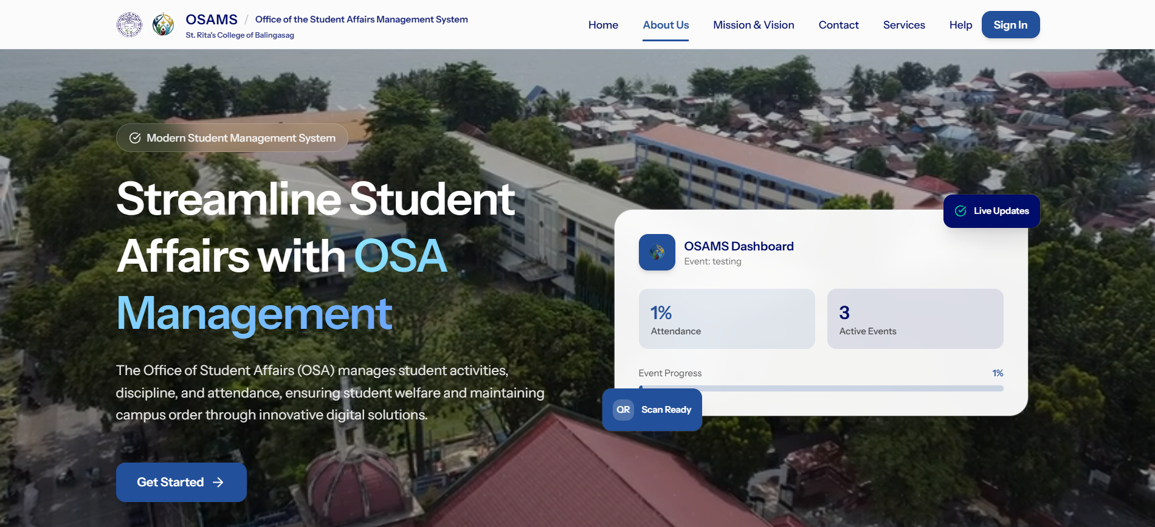
Figure 3.21: Landing Page
The proposed landing page shown in Figure 3.21 presents the initial interface of the Office of Student Affairs Management System (OSAMS). It provides an overview of the system and guides users to the appropriate access options.
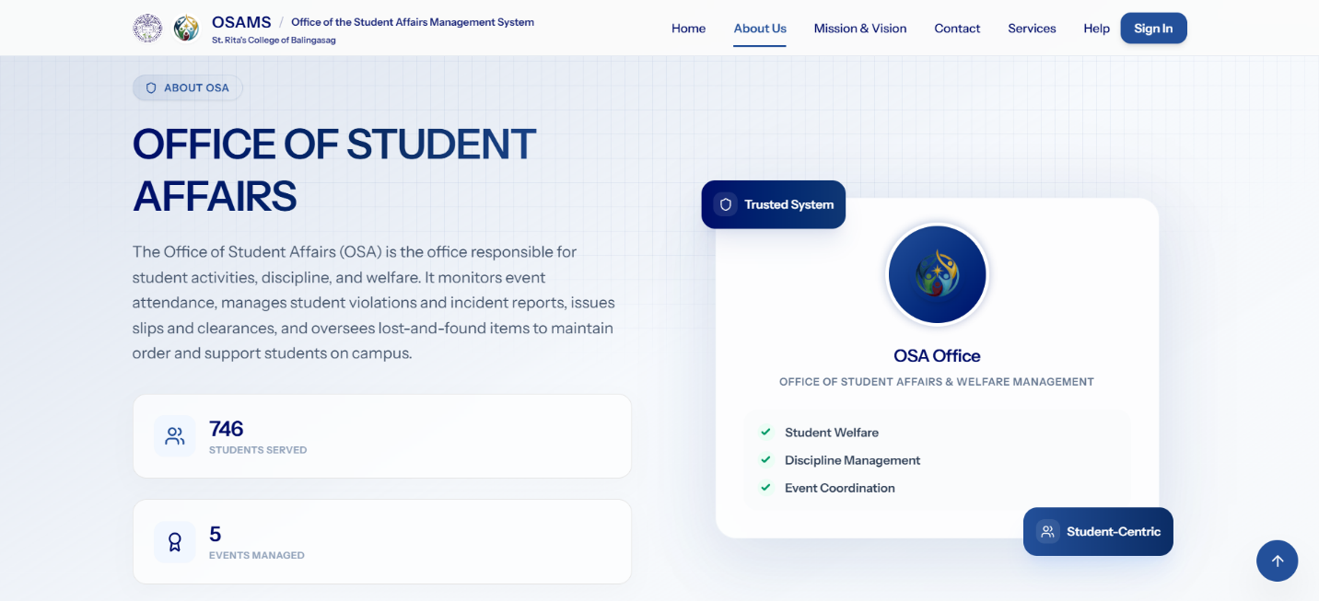
Figure 3.22: About Page
The proposed About page shown in Figure 3.22 provides background information about the Office of Student Affairs Management System (OSAMS), including its purpose and general information about the system.
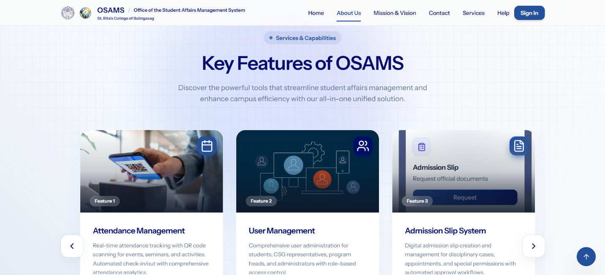
Figure 3.23: Features Page
The proposed Features page shown in Figure 3.23 presents the main features and functions of the Office of Student Affairs Management System (OSAMS). It allows users to understand the services and functions available in the system.
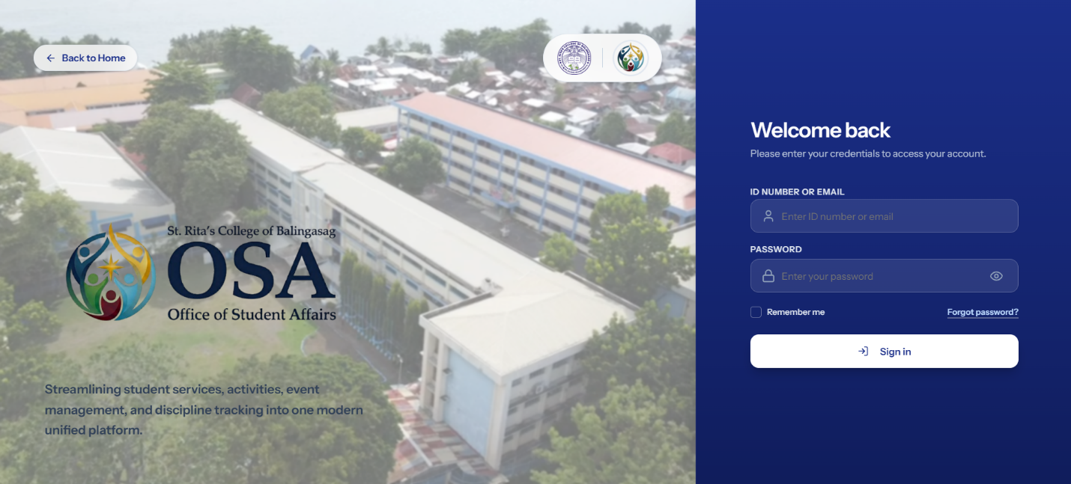
B. Authentication & Registration Screens
Figure 3.24: Login Page
The proposed login page shown in Figure 3.24 provides a single authentication interface for authorized users of the Office of Student Affairs Management System (OSAMS). It allows users to enter their login credentials and access the system according to their assigned role and permissions. The unified login design provides a simple and consistent authentication process for the system users.
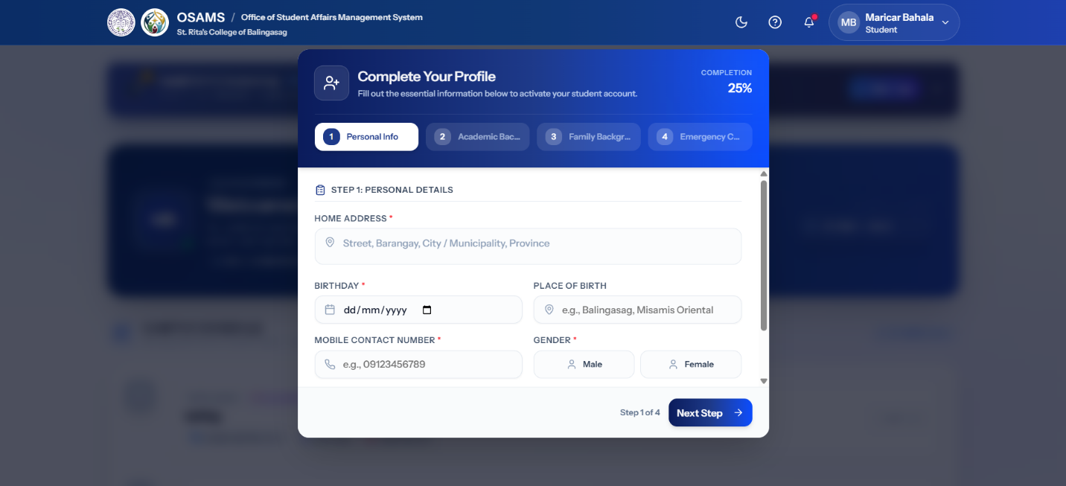
Figure 3.25: Student Registration Page
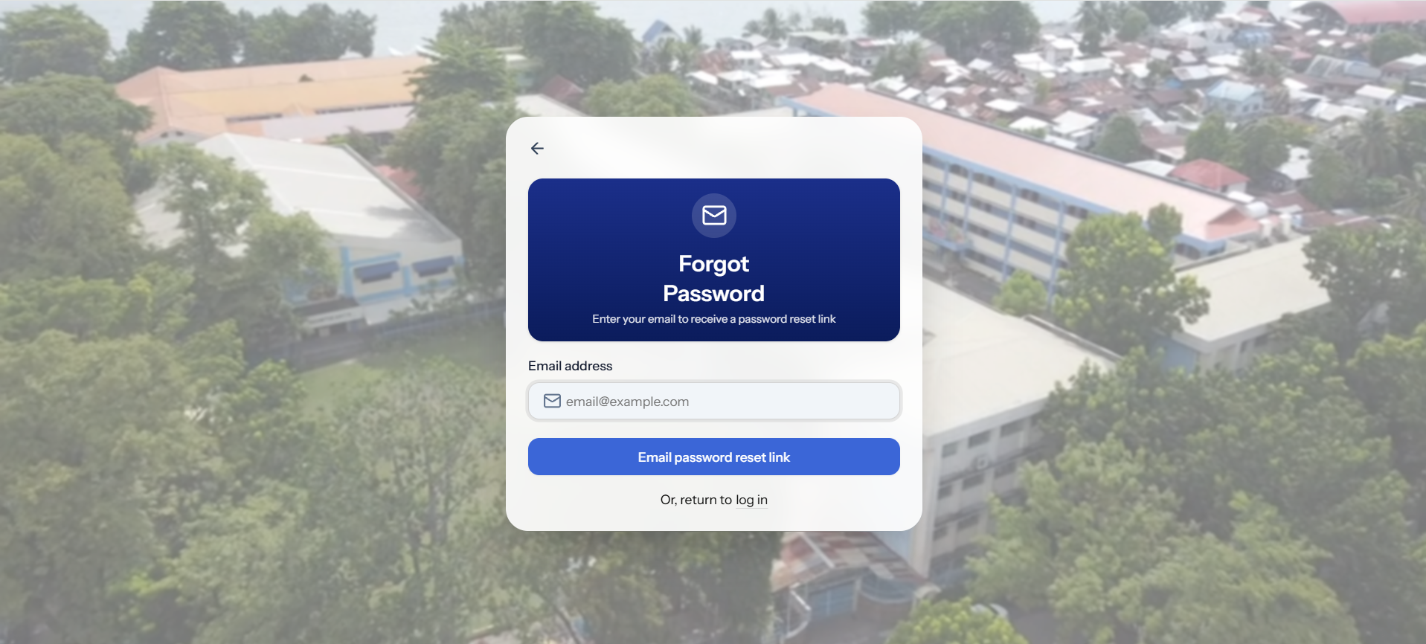
The proposed student registration page shown in Figure 3.25 allows students to provide the required personal, academic, and account information for registration. The information is organized in a clear and structured form to help students complete the registration process accurately. Input validation is used to ensure that the required information is properly provided before submission.

Figure 3.26: Forgot Password Page
The proposed Forgot Password page shown in Figure 3.26 allows users to request assistance in recovering access to their account. The page provides the necessary input for initiating the password recovery process and helps users regain access when they forget their password.
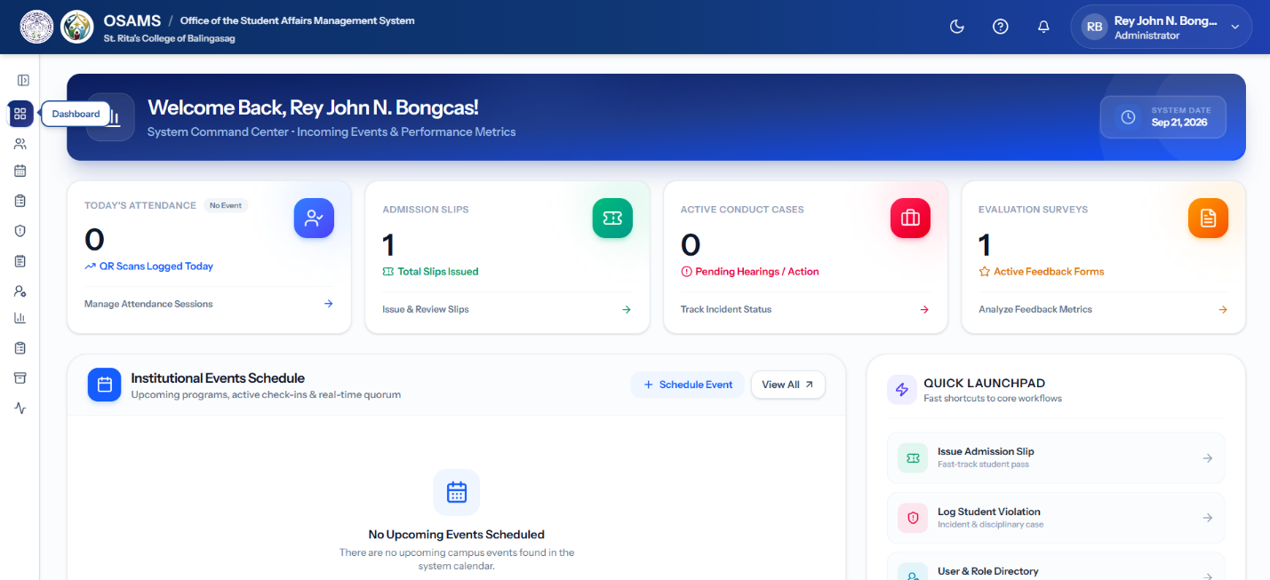
C. Admin Dashboard Screens

Figure 3.27: Admin Dashboard (Main View)
The Admin Dashboard shown in Figure 3.27 presents the central hub for system administrators. It features a welcome banner, real-time statistics widgets (total students, active events, attendance rate), quick action buttons, and analytical overview panels. The dashboard provides a comprehensive at-a-glance summary of system-wide data, enabling efficient monitoring and decision-making.

Figure 3.28: Admin Sidebar Navigation
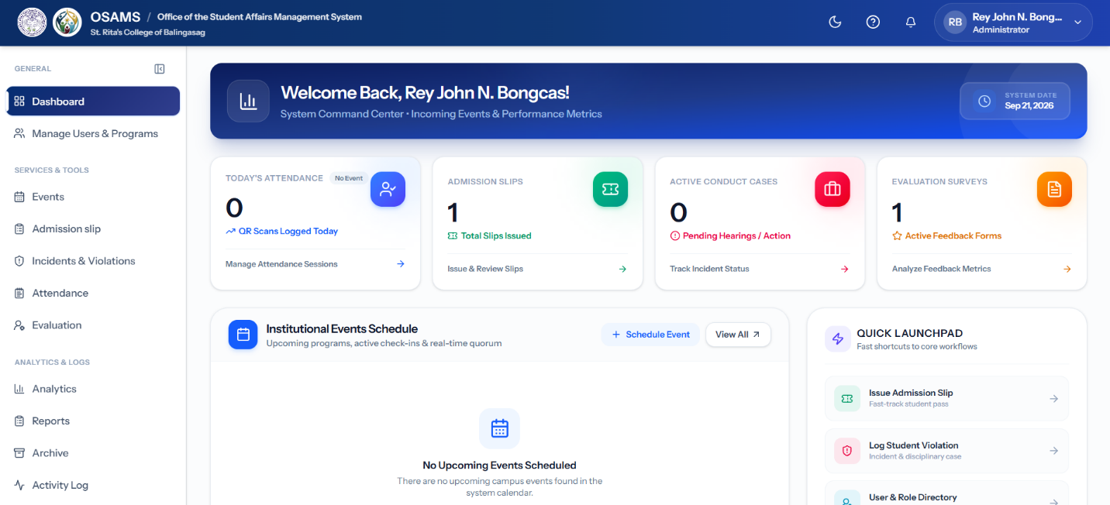
The Admin Sidebar Navigation shown in Figure 3.28 organizes all administrative modules into a logical, hierarchical menu structure with icons for quick visual recognition. The sidebar supports seamless navigation across all management functions while maintaining context awareness through active state highlighting.
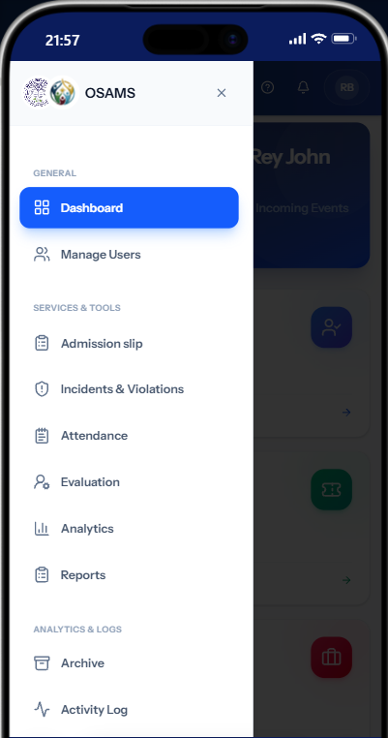

Figure 3.29: Admin Mobile Navigation
The responsive mobile navigation menu shown in Figure 3.29 displays the Admin panel's navigation options. It ensures full administrative functionality is accessible on smaller screen sizes, demonstrating the system's responsive design approach that adapts to various devices without loss of usability.
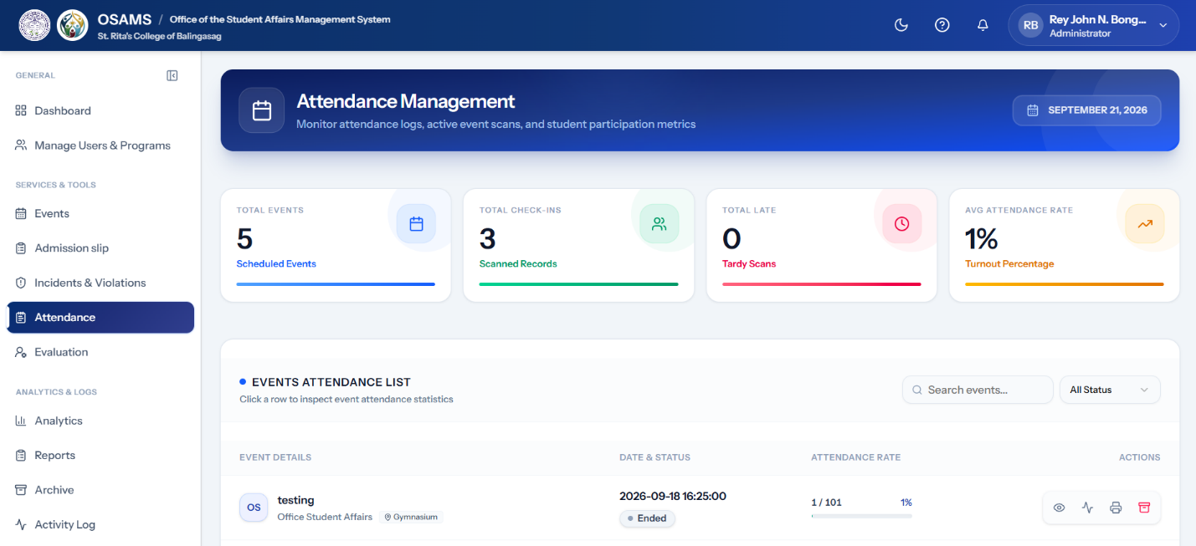
C. Attendance Management Screens (Core Transaction)

Figure 3.30: Admin Attendance Management Page
The Admin Attendance Management interface shown in Figure 3.30 includes statistics cards, filter options, and a comprehensive attendance data table. Administrators can search, filter by date or event, and view attendance records. This screen centralizes all attendance data for monitoring and management purposes.

Figure 3.31: Real-Time Attendance Monitoring Panel
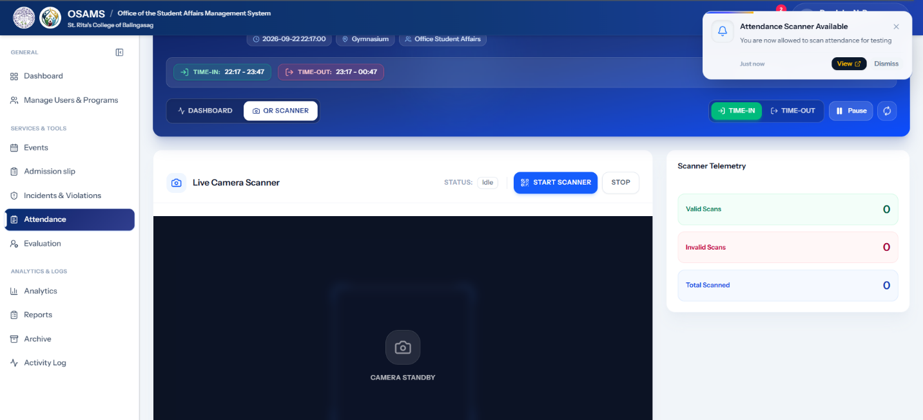
The Real-Time Monitoring Panel shown in Figure 3.31 displays live attendance scanning activity. It provides real-time feedback as students scan in, with visual indicators for successful and failed scan attempts. This feature enables administrators to monitor attendance progress during ongoing events.
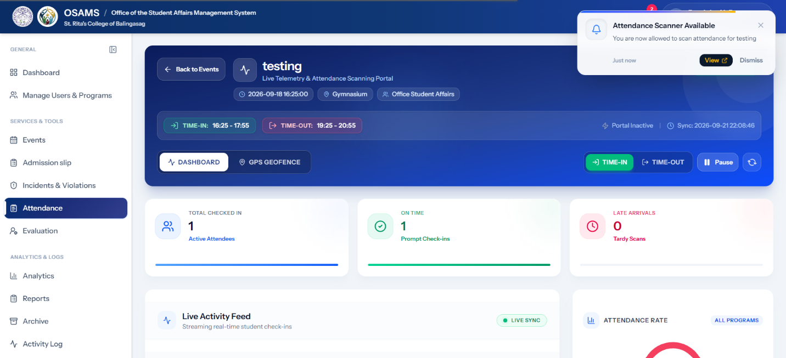
Figure 3.32: QR Scanner Check-In Method
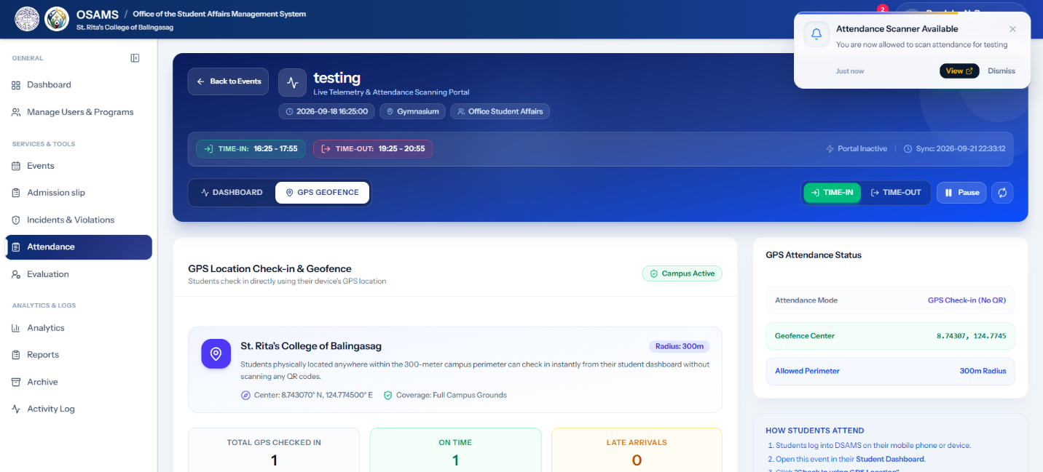
The QR Scanner Check-in method shown in Figure 3.12 allows admins or authorized student scanners to scan the QR codes of attendees using a scanning device. This method provides a convenient way to record student attendance during events through QR code verification.
Figure 3.33: GPS Location Check-In Method
The GPS Location Check-in method shown in Figure 3.33 allows students to check in directly using their device's GPS location at the event venue. The system verifies the student's location based on the designated event venue, allowing attendance to be recorded without the need for a QR code scan.
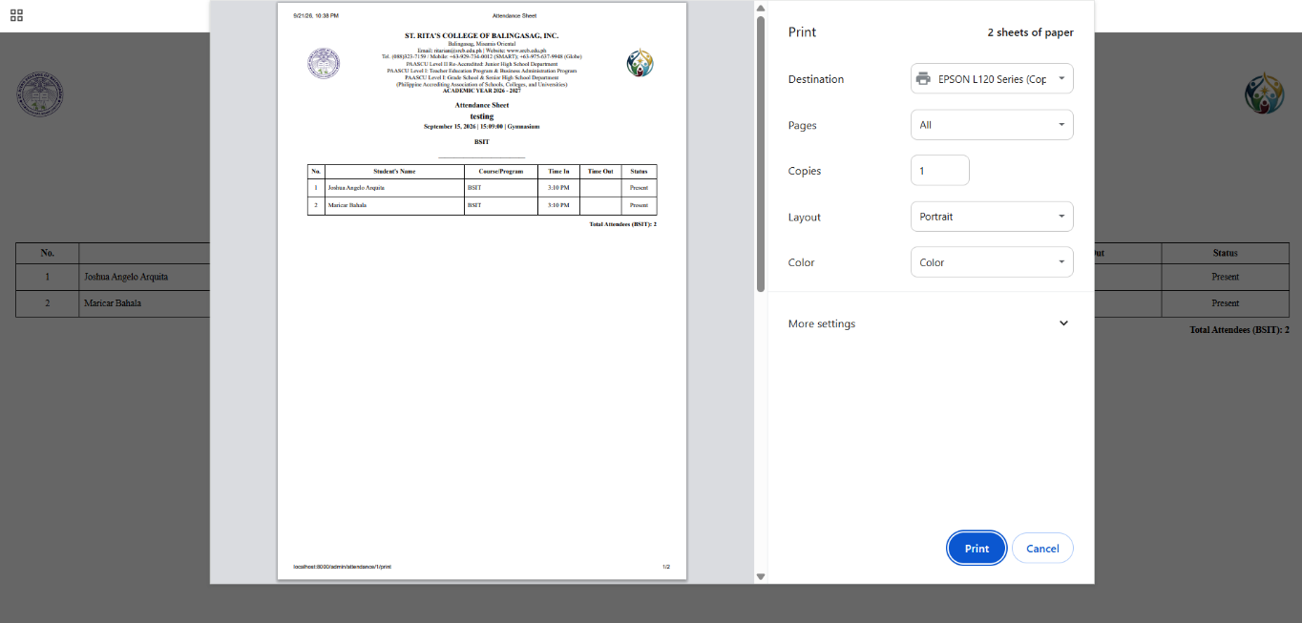
Figure 3.34: Attendance Sheet Print View
The printable Attendance Sheet format shown in Figure 3.34 provides a clean, formatted layout optimized for printing, allowing administrators to generate physical records when required for documentation or compliance purposes.
E. Events Management Screens
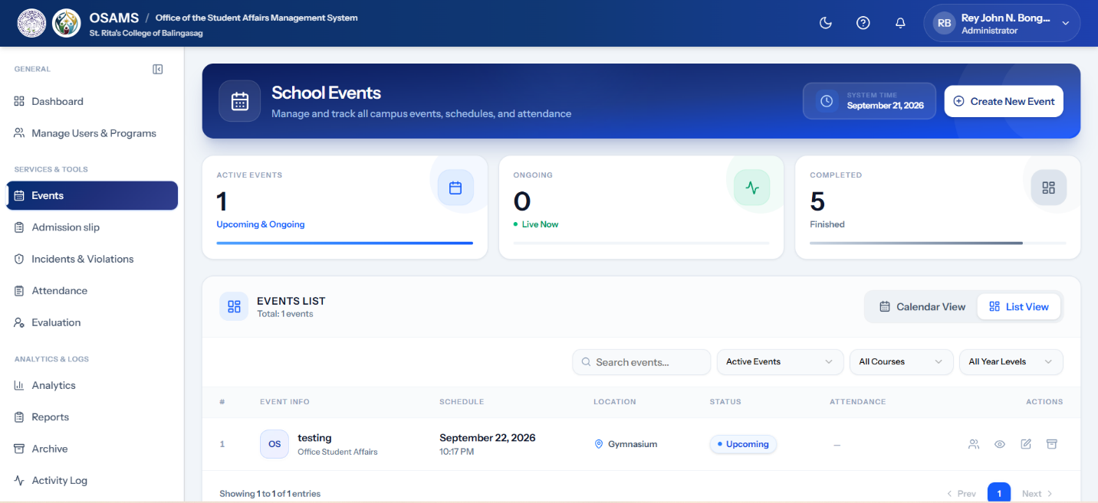
Figure 3.35: Events Management Page (Table View)
The Events Management table shown in Figure 3.35 lists all created events with their status, date, venue, and attendance count. Administrators can filter, search, and manage events from this centralized view. Statistics cards at the top provide a quick summary of total, upcoming, ongoing, and completed events.

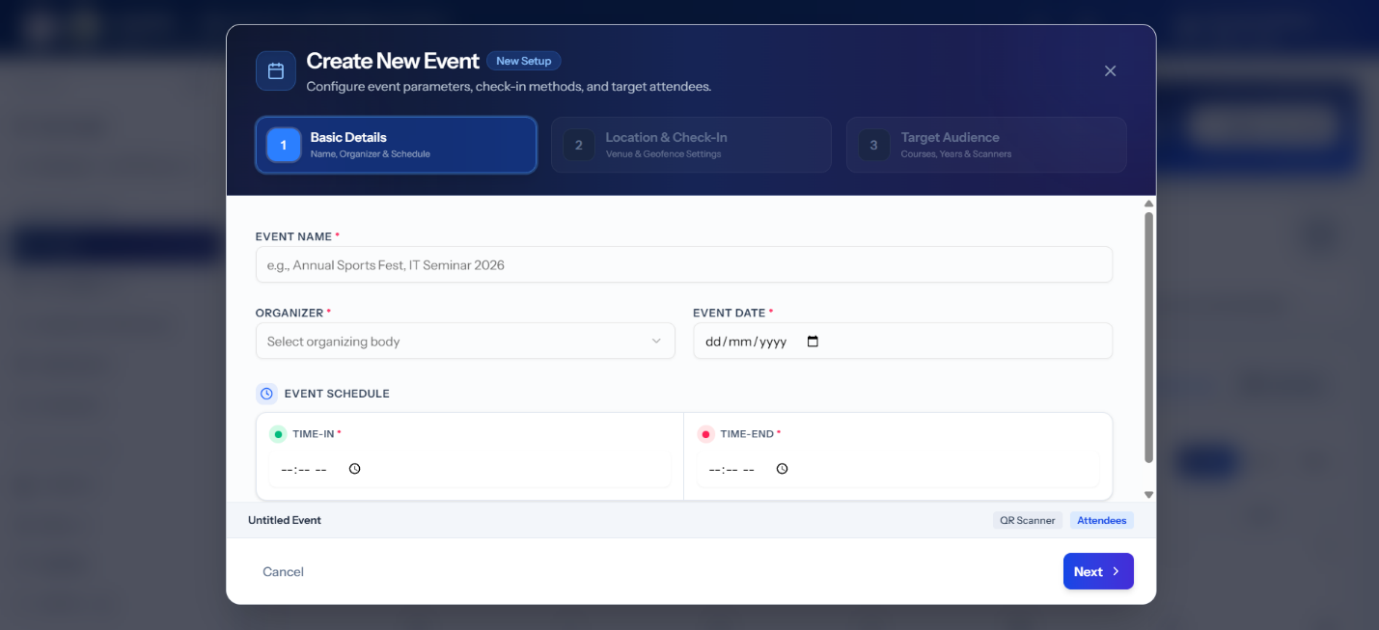
Figure 3.36: Create Event Modal/Form
The Create Event form shown in Figure 3.36 allows administrators to define new events, including the event name, description, date, time, venue, and target participants by course and year level. The comprehensive form ensures that all event details are captured during creation.
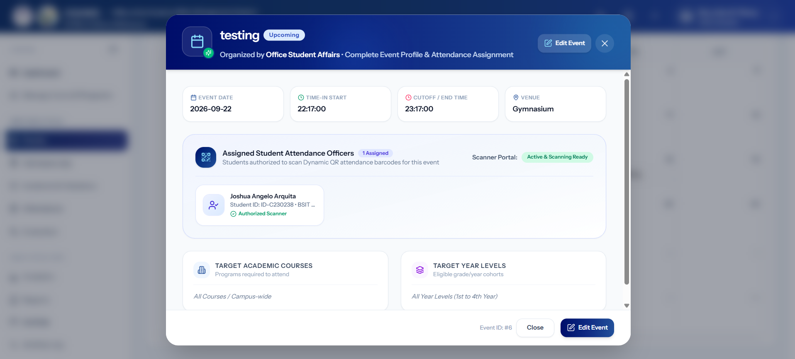Figure 3.37: Event Detail View
The detailed event view shown in Figure 3.37 displays information about an individual event, including event details, attendance statistics, and participant lists. This screen enables administrators to view specific event data for monitoring and management purposes.
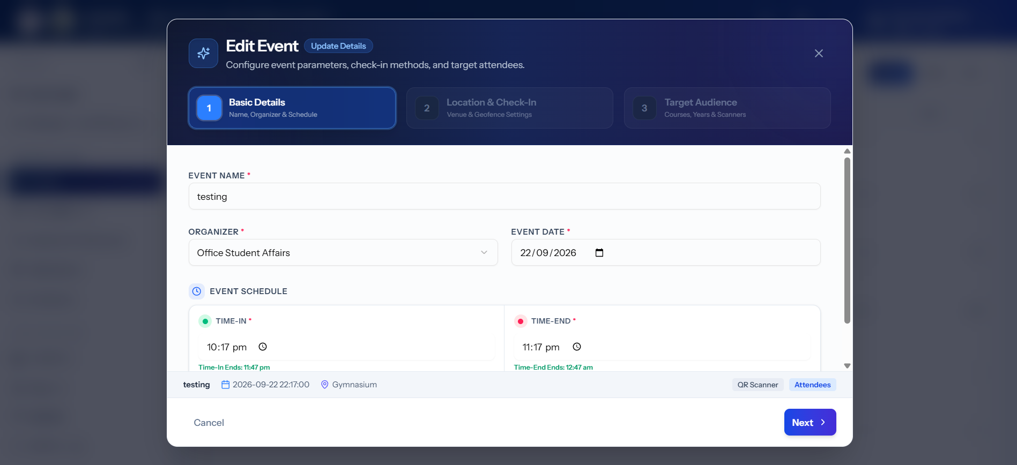Figure 3.38: Edit Event Modal
The Edit Event form shown in Figure 3.38 is pre-populated with existing event data. Administrators can modify event details such as the schedule, venue, or participant scope. The edit interface follows the same structure as the creation form for consistency.
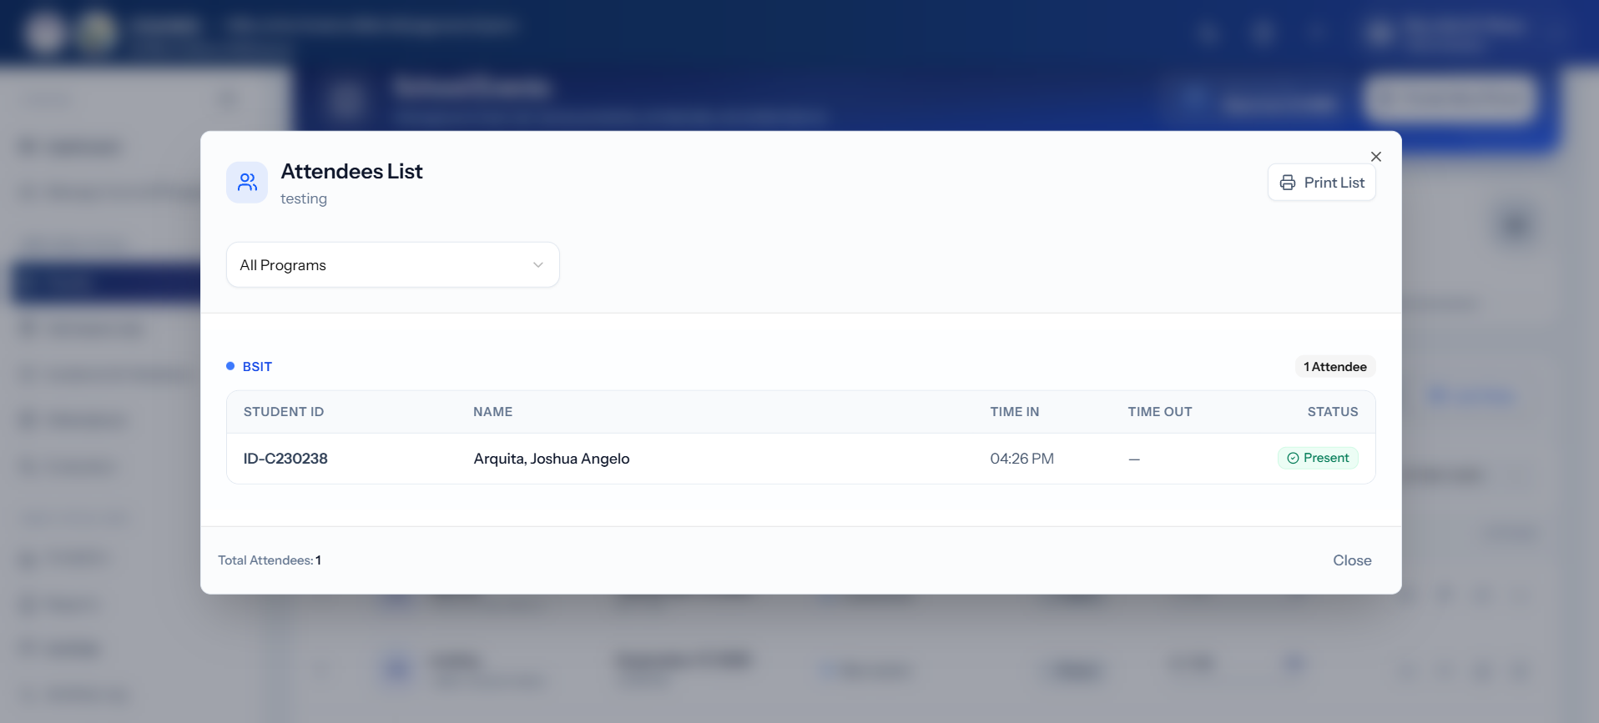Figure 3.39: Event Attendees Modal
The Event Attendees dialog shown in Figure 3.39 presents the list of students who attended a specific event, including their scan-in times and attendance status. This provides detailed visibility into event participation.
F. Admission Slip Management Screens
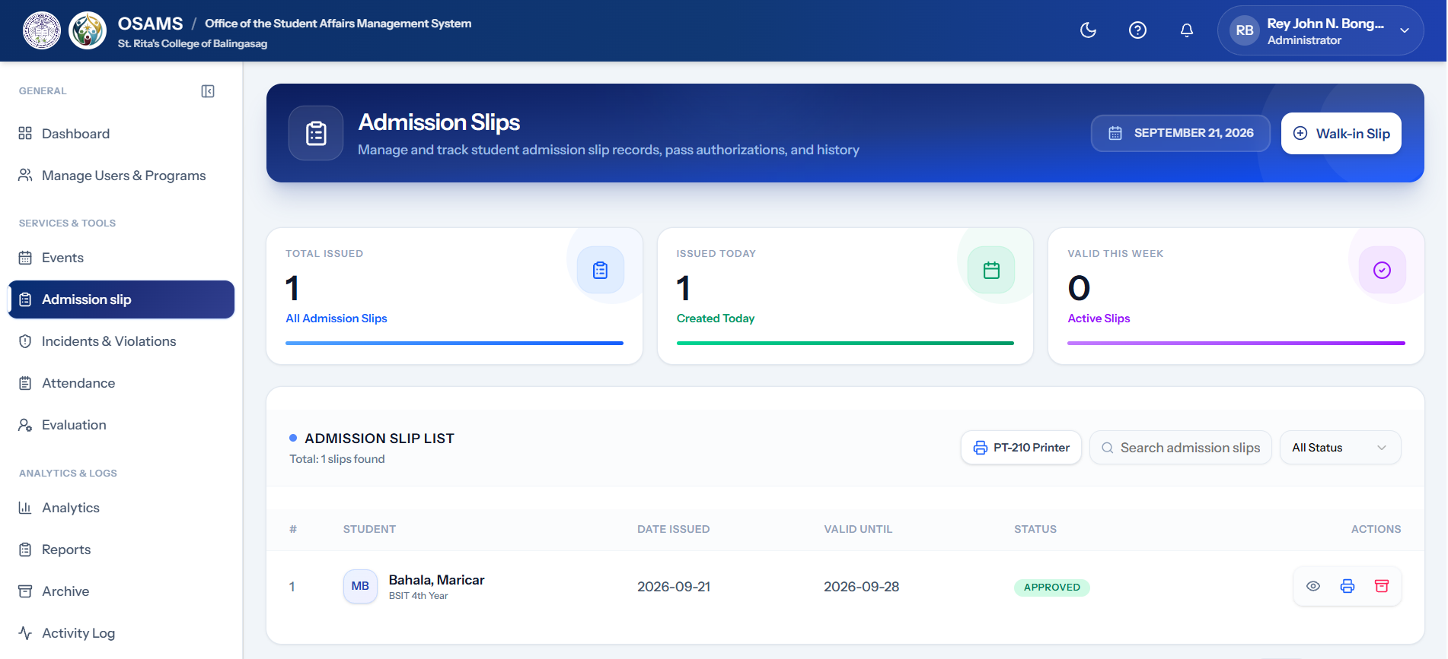Figure 3.40: Admin Admission Slip Management Page
The Admission Slip management interface shown in Figure 3.20 is used by administrators to manage admission slips. It displays a table of all admission slips with status indicators (pending, approved, denied), statistics cards, filter tabs, and search functionality. This digitizes the traditionally paper-based admission slip process.
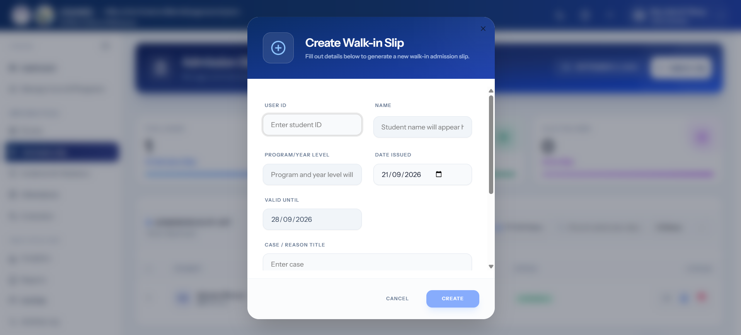
Figure 3.41: Create Admission Slip Dialog
The form for creating a new admission slip shown in Figure 3.41 captures student details, the reason for the slip, and the validity period. The dialog-based design allows quick creation without leaving the main management page.
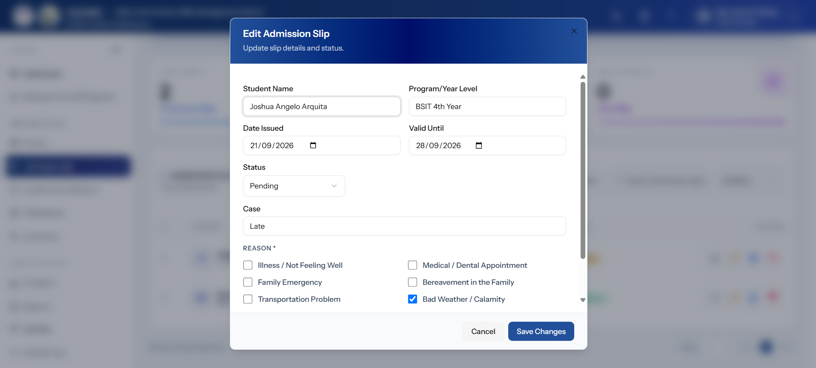Figure 3.42: Edit Admission Slip Dialog
The Edit Admission Slip form shown in Figure 3.42 is used to update or modify existing slip details. Pre-populated fields reduce redundant data entry.
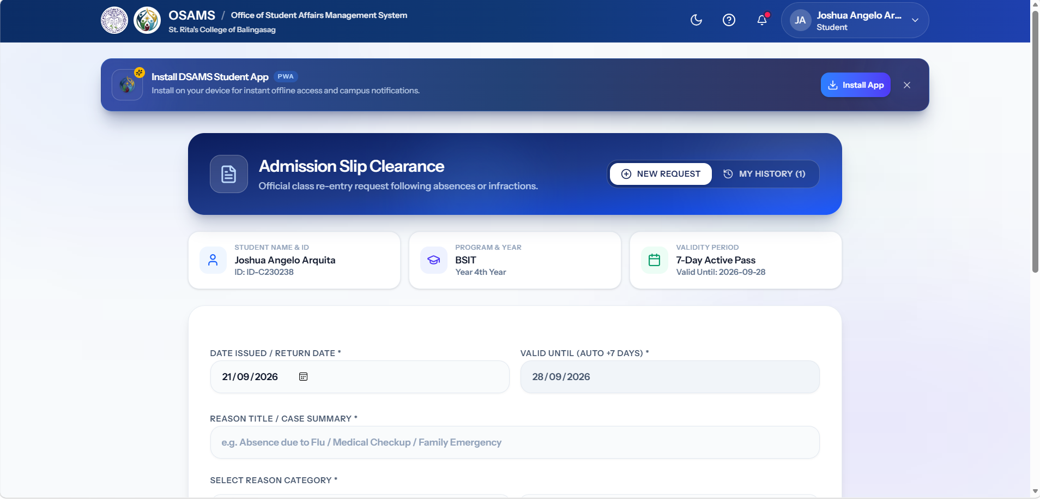Figure 3.43: Student Admission Slip View
The Student Admission Slip interface shown in Figure 3.23 provides students with options to submit a New Request for an admission slip and view their previous requests through My History. The interface allows students to track the status of their admission slip requests and access their request records in one place.
G. User Management Screens (Admin Panel)
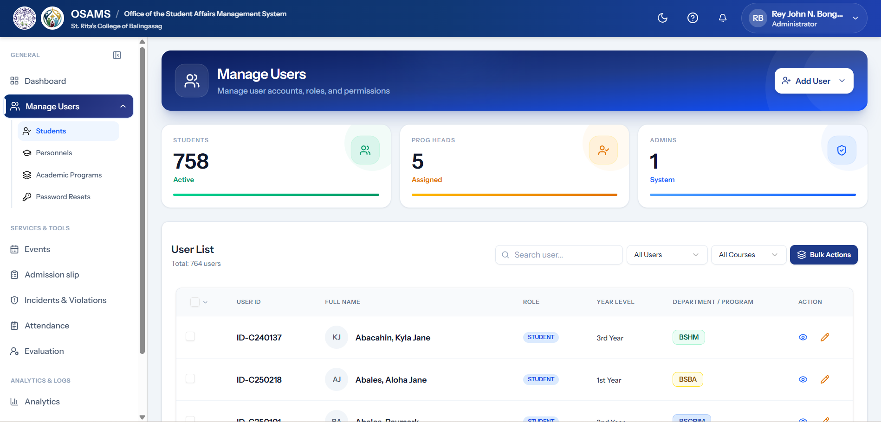 Figure 3.44: Manage Users Page
The User Management interface shown in Figure 3.44 allows administrators to view, search, filter, add, and edit user accounts. The user list displays information such as User ID, full name, role, year level, and department or program, with action options for viewing and editing user records. The summary cards provide an overview of the number of active students, assigned Program Heads, and system administrators, while the search and filtering options help administrators efficiently manage user records.
e.
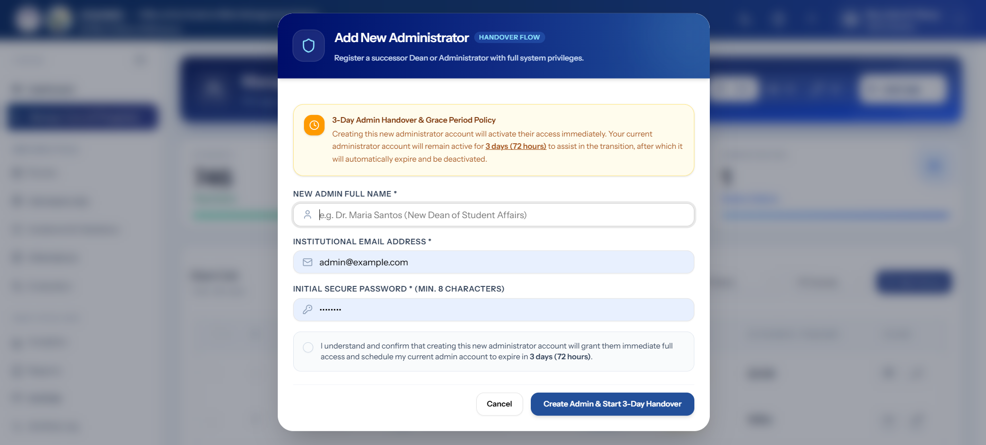
Figure 3.45: Add Admin Dialog
The dedicated form for adding new administrator accounts shown in Figure 3.45 includes role-specific fields and permission settings.
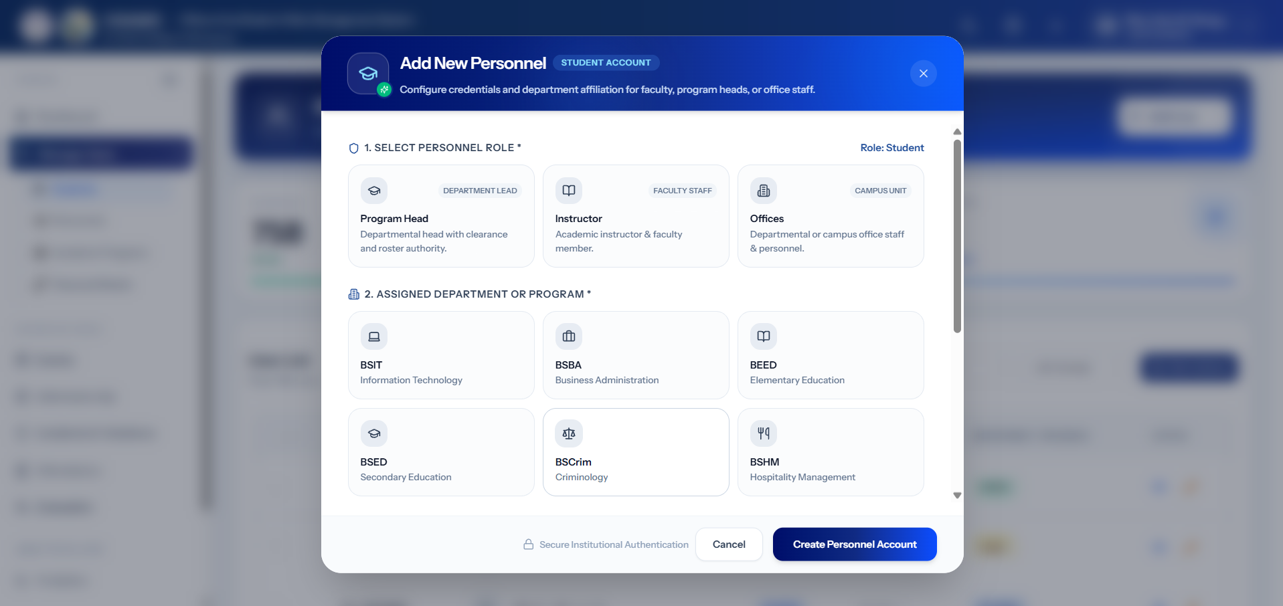Figure 3.46: Add Personnel Dialog
This figure shows the Add Personnel dialog used to create personnel accounts by selecting the appropriate personnel role and assigning a department or academic program. Available roles include Program Head, Instructor, and Offices, allowing administrators to configure the appropriate personnel affiliation and access within the system.
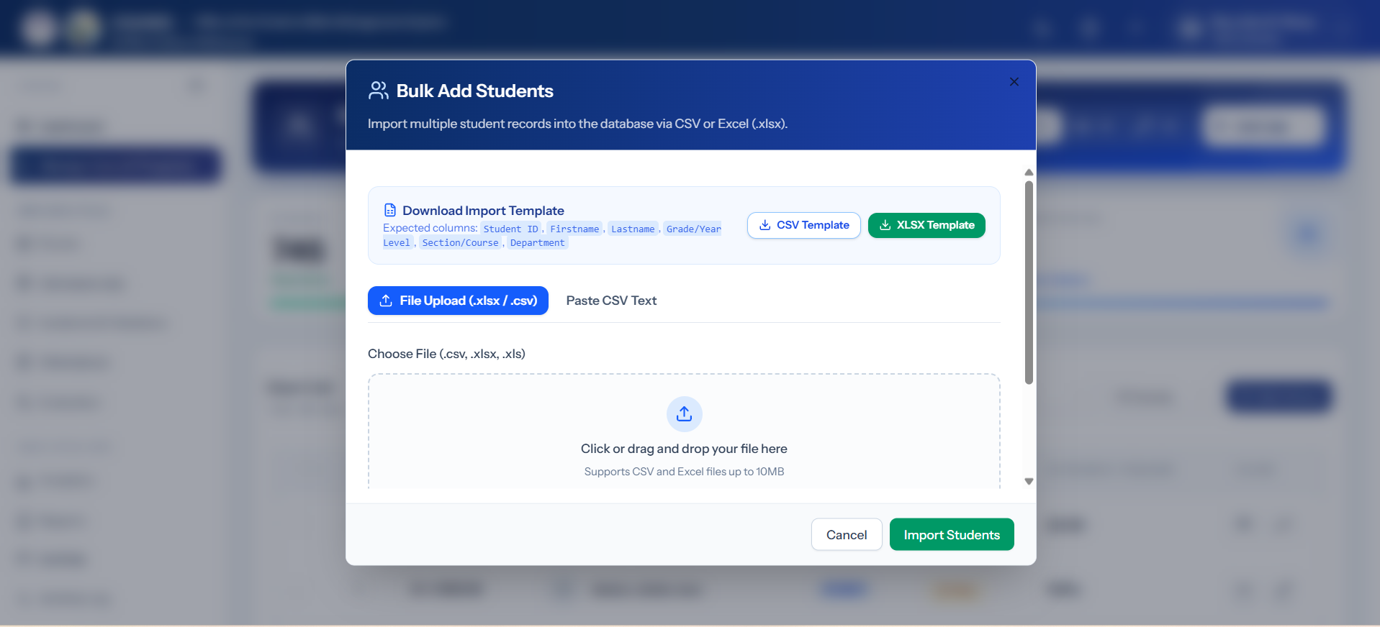Figure 3.47: Bulk Add Users Dialog
The Bulk User Import interface shown in Figure 3.47 enables administrators to upload multiple student records through a CSV/Excel file. This feature significantly reduces the time required for mass enrollment.
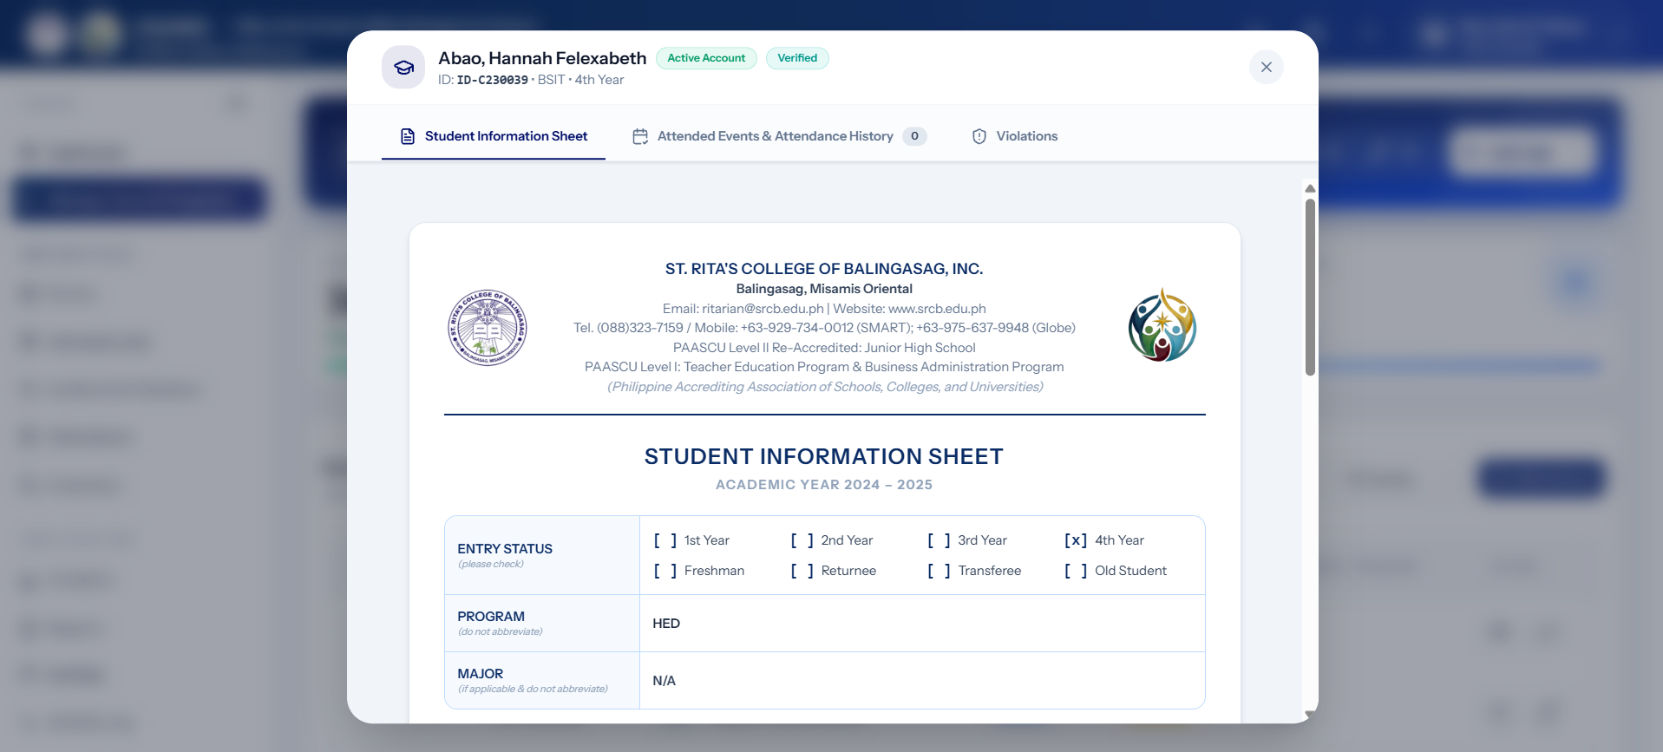Figure 3.48: View Student Details Dialog
The comprehensive Student Profile view shown in Figure 3.48 displays personal information, academic background, attendance history, violations, and certificates in a detailed dialog.
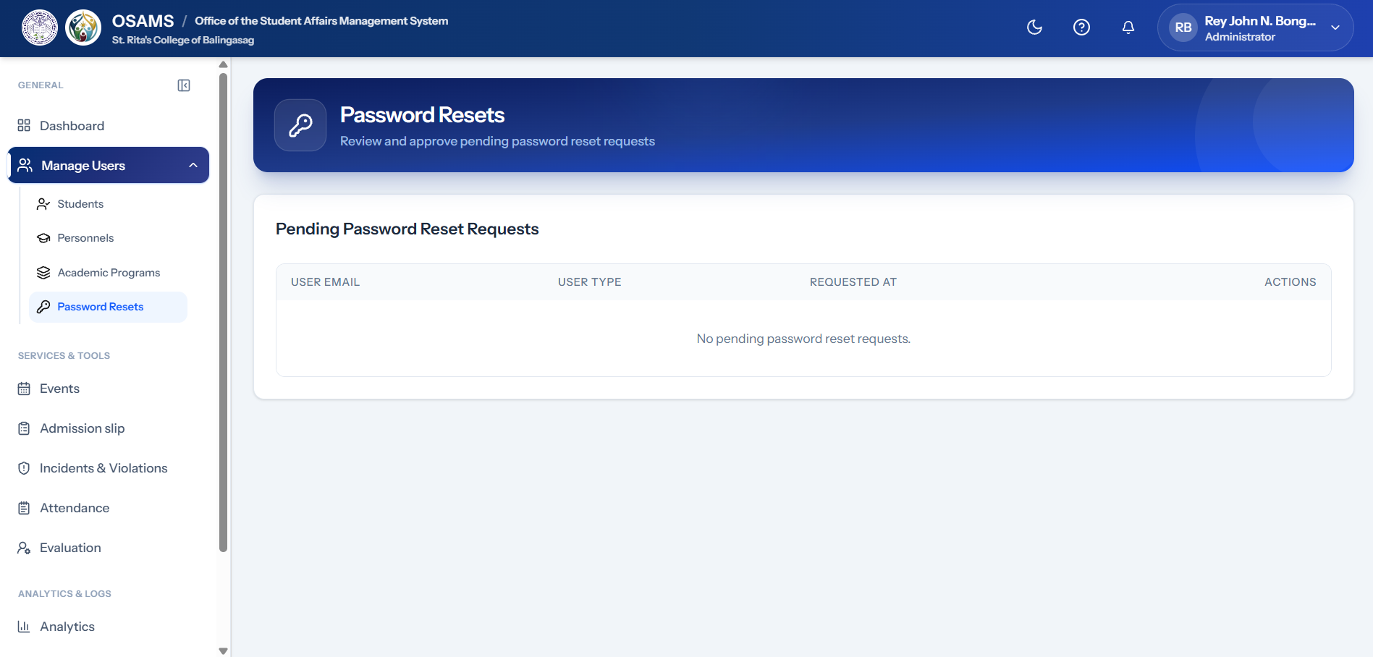Figure 3.49: Manage Password Resets Tab
The Password Reset management tab shown in Figure 3.49 allows administrators to view and process pending password reset requests from users.
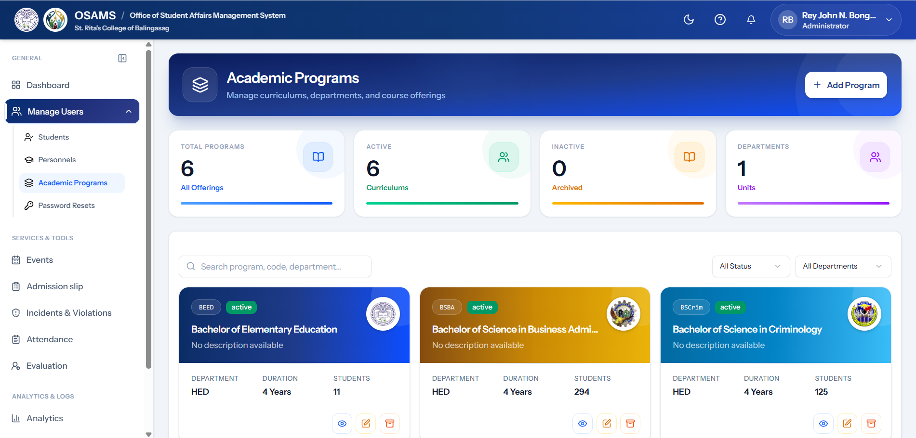Figure 3.50: Manage Programs Page
The Academic Programs Management Page shown in Figure 3.50 allows administrators to add, edit, and manage academic program records, including program codes, status, department, duration, and student information.
H. Evaluation Management Screens
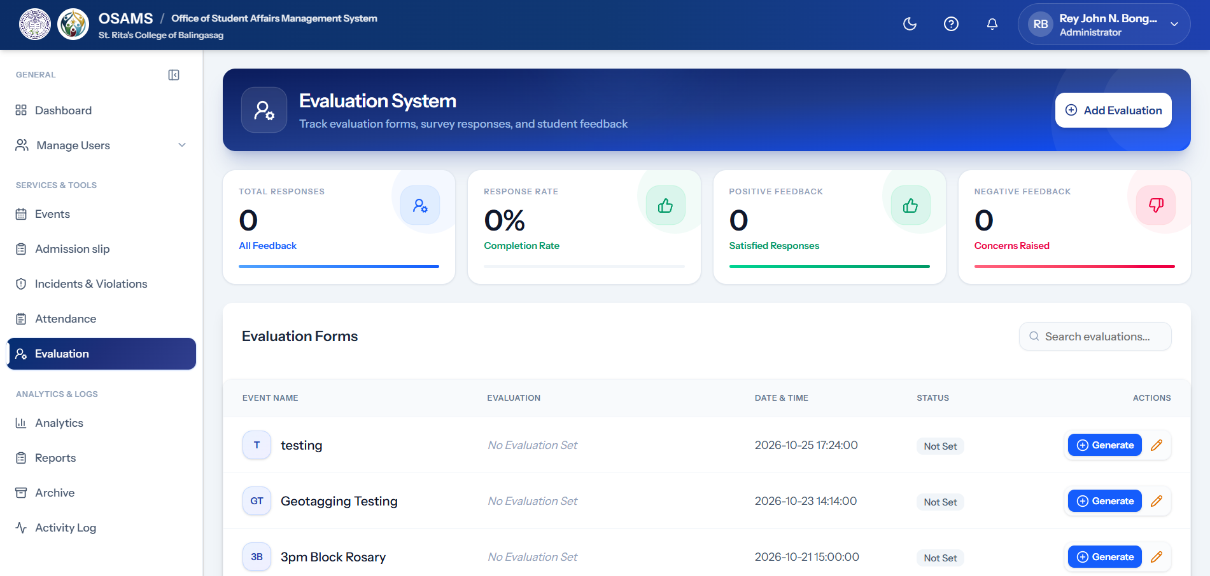Figure 3.51: Admin Evaluation Management Page
The Evaluation Management interface shown in Figure 3.51 lists all evaluation forms with their status, response rates, and associated events. Administrators can create, preview, publish, and analyze evaluation forms from this centralized view.
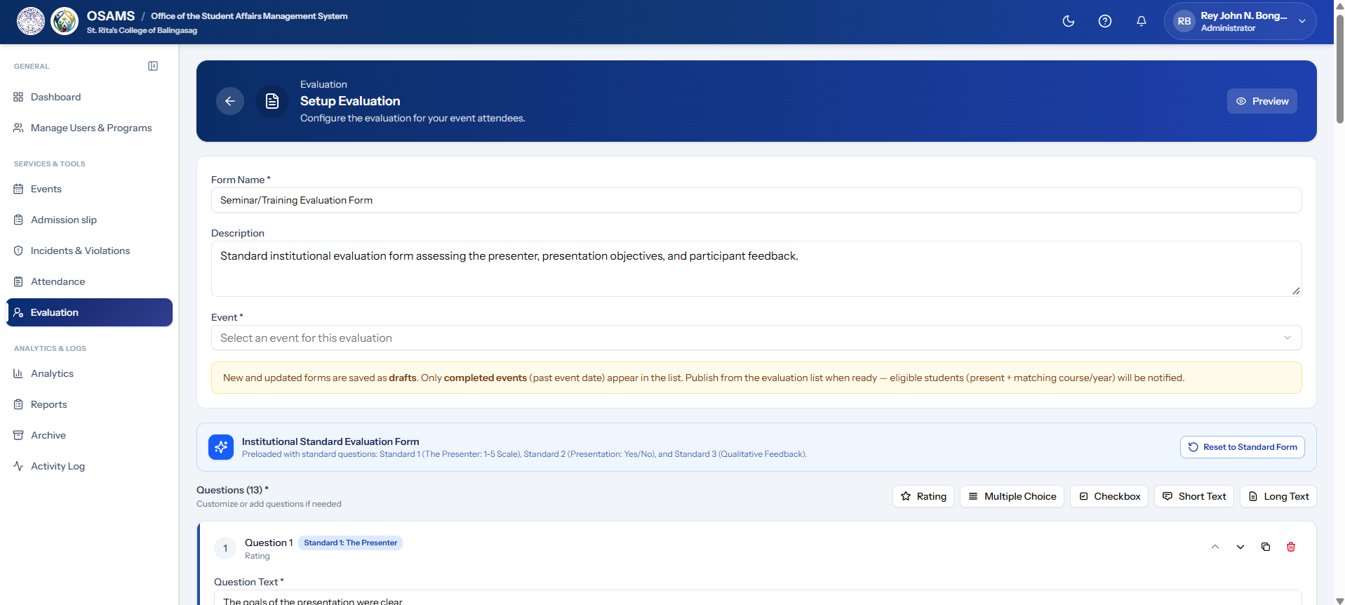Figure 3.52: Create/Edit Evaluation Form Dialog
The Evaluation Form builder shown in Figure 3.52 allows administrators to define evaluation details, including the title, description, and associated event. This form enables the creation of structured evaluation instruments.
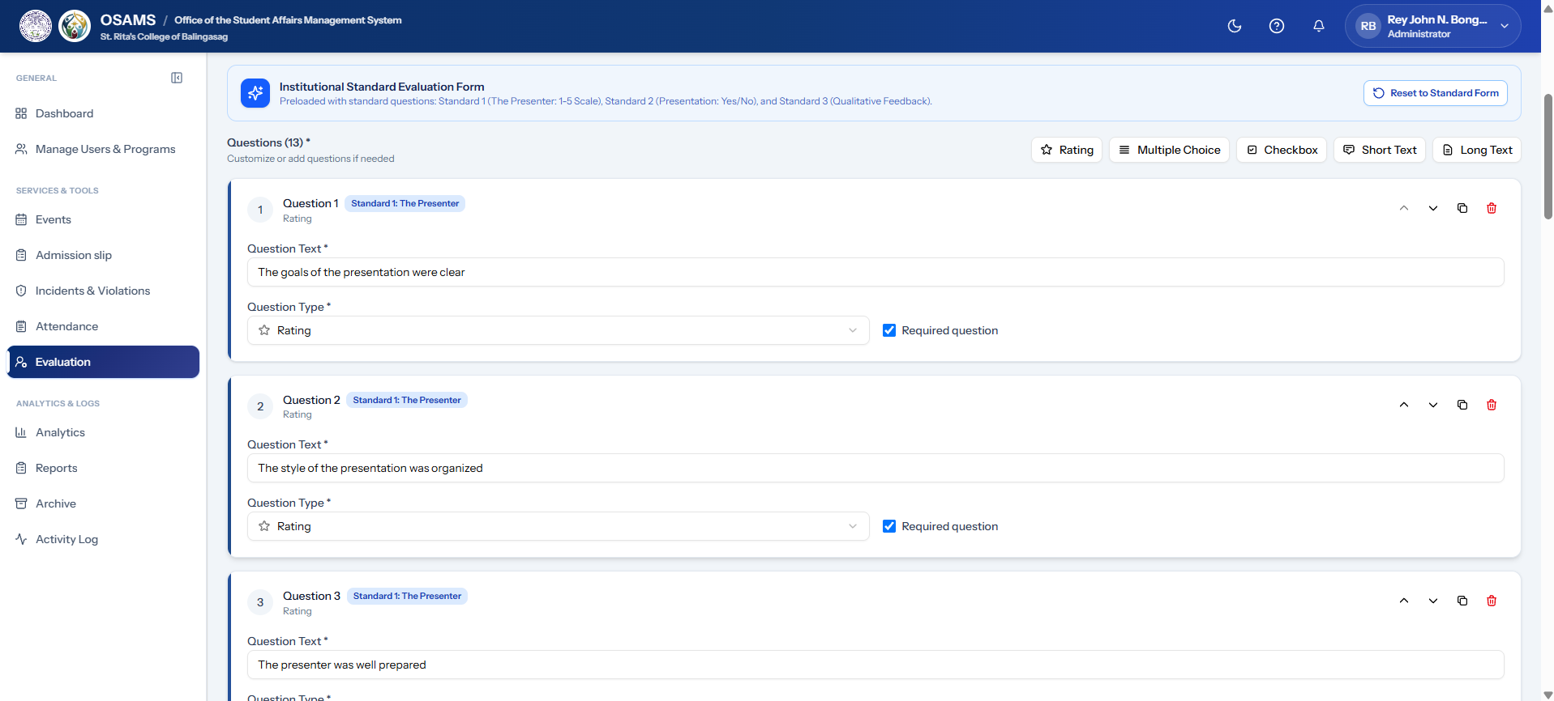Figure 3.53: Evaluation Questions Section
The question management interface shown in Figure 3.53 allows administrators to add, edit, reorder, and configure evaluation questions with various response types, such as Likert scale, text, and multiple choice.
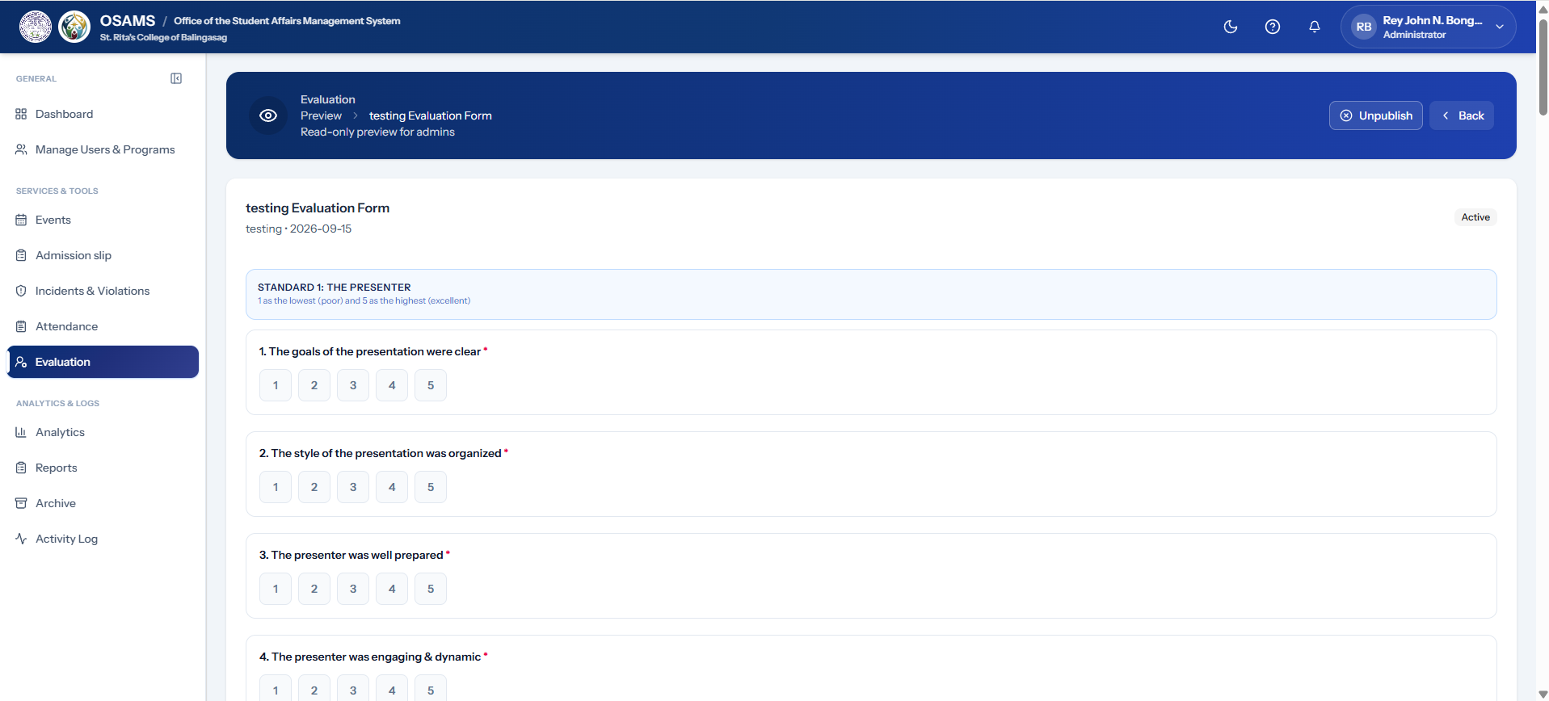Figure 3.54: Evaluation Preview Dialog
The preview mode shown in Figure 3.54 allows administrators to see how the evaluation form will appear to students before publishing. This ensures quality control of evaluation instruments.
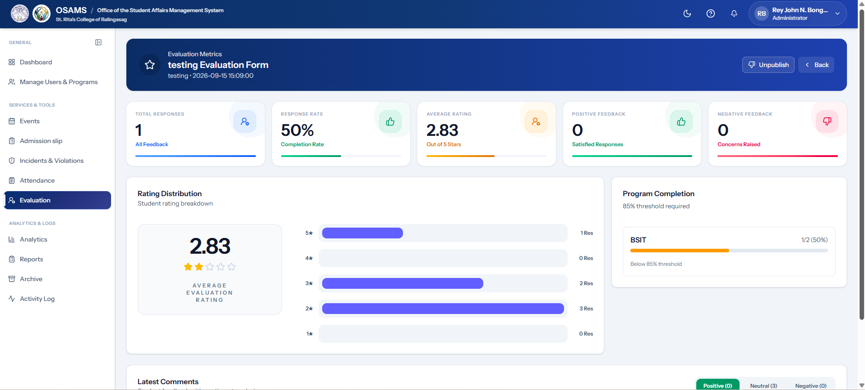Figure 3.55: Evaluation Metrics/Results Page
The Evaluation Metrics dashboard shown in Figure 3.55 displays aggregated results, response rates, charts, and KPI cards for completed evaluations. This analytics view enables data-driven insights from student feedback.
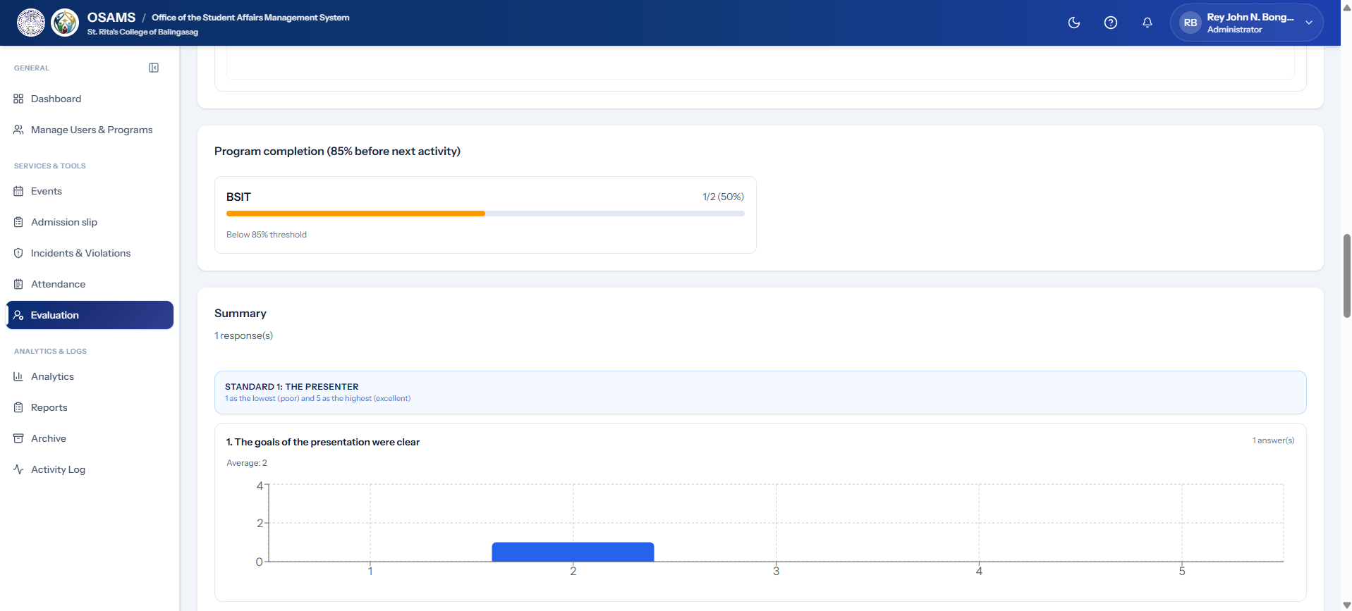Figure 3.56: Evaluation Detail View (Admin)
The detailed view of an individual evaluation form shown in Figure 3.56 includes all questions, settings, and response summary.
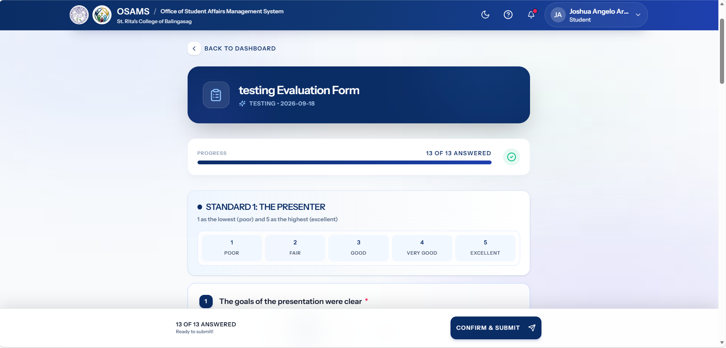Figure 3.57: Student Evaluation Form (Submission View)
The student-facing Evaluation Form shown in Figure 3.57 allows students to rate and provide feedback for attended events. The interface presents questions clearly with intuitive response controls, ensuring high completion rates.
I. Notifications Screens
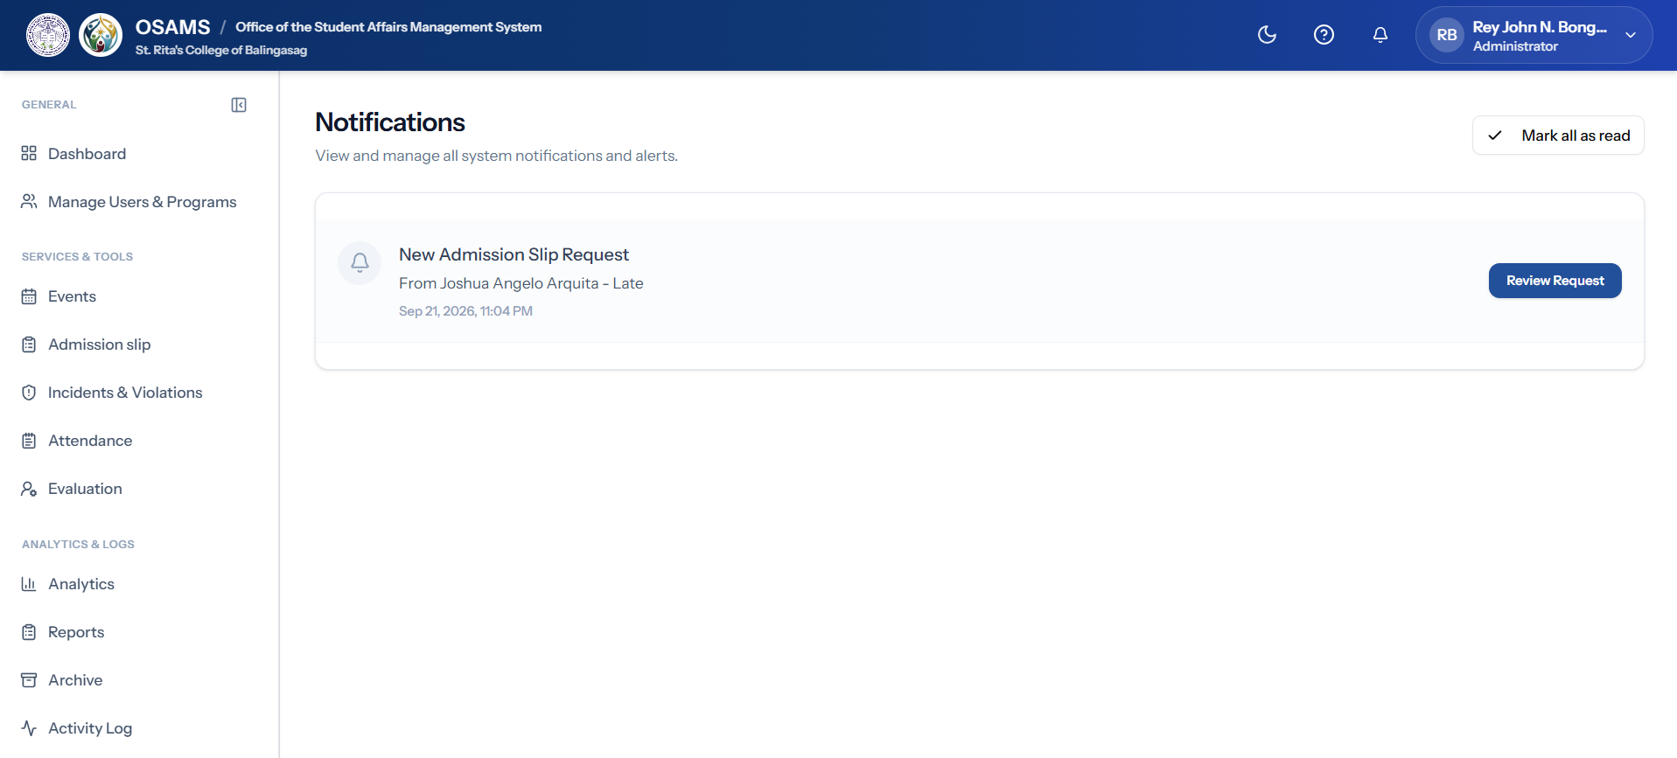
Figure 3.58: Admin Notifications Page
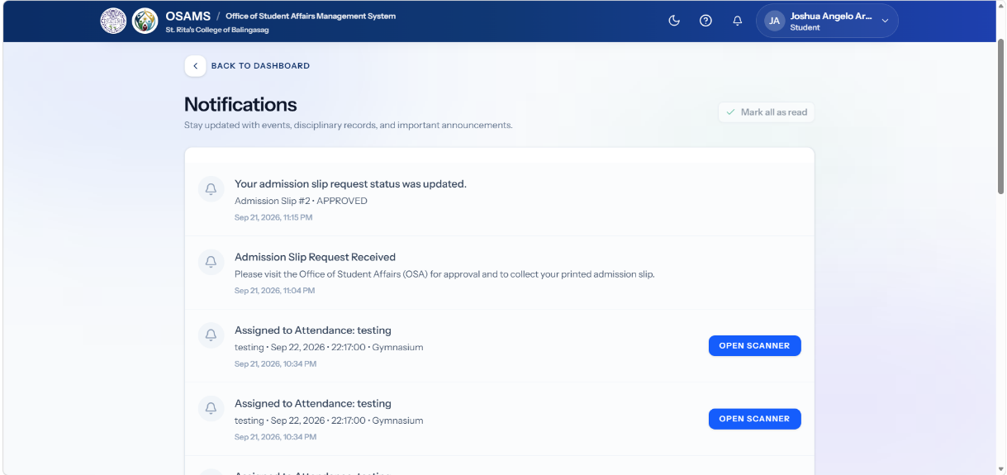
The Admin Notifications panel shown in Figure 3.58 displays system alerts, new registrations, pending requests, and other important updates in chronological order. It allows administrators to monitor notifications and stay informed about activities requiring their attention.

Figure 3.59: Student Notifications Page
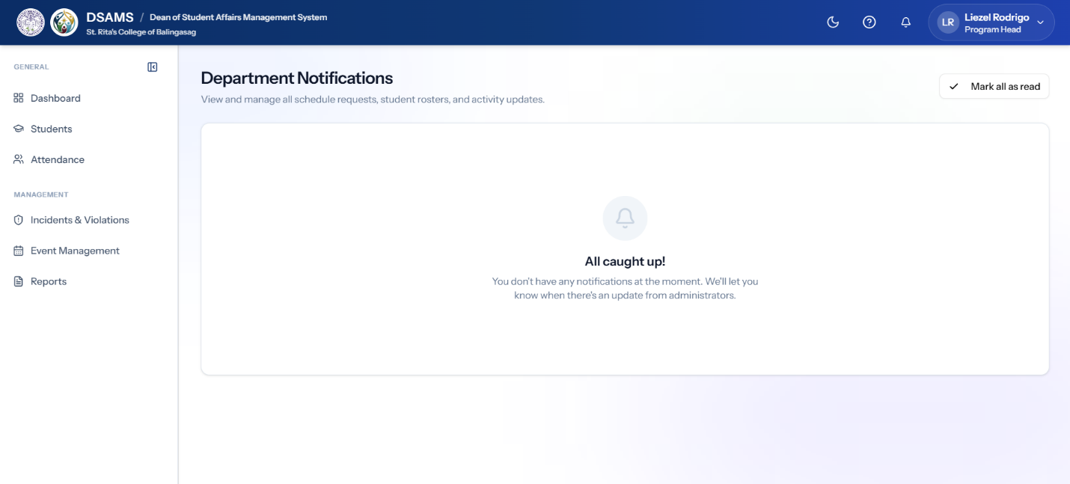
The Student Notifications interface shown in Figure 3.59 provides students with alerts about upcoming events, attendance confirmations, admission slip updates, and evaluation requests. It helps students stay informed about important activities and updates related to their account.

Figure 3.60: Personnel Notifications Page
The Personnel Notifications view shown in Figure 3.60 displays notifications relevant to the assigned program, including attendance reports, student violations, and other important updates. It helps the Personnel monitor information that requires attention within their program.
J. Incidents & Violations Management Screens
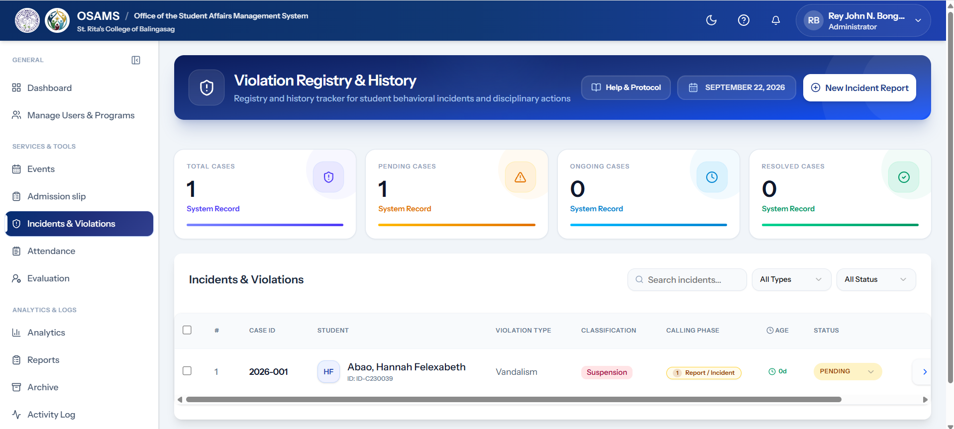Figure 3.61: Incidents & Violations Management Page
The Incidents and Violations Management interface shown in Figure 3.61 presents a centralized view of reported incidents and violations. It includes statistics, filter options, and management actions that allow administrators to monitor and manage reported student incidents.
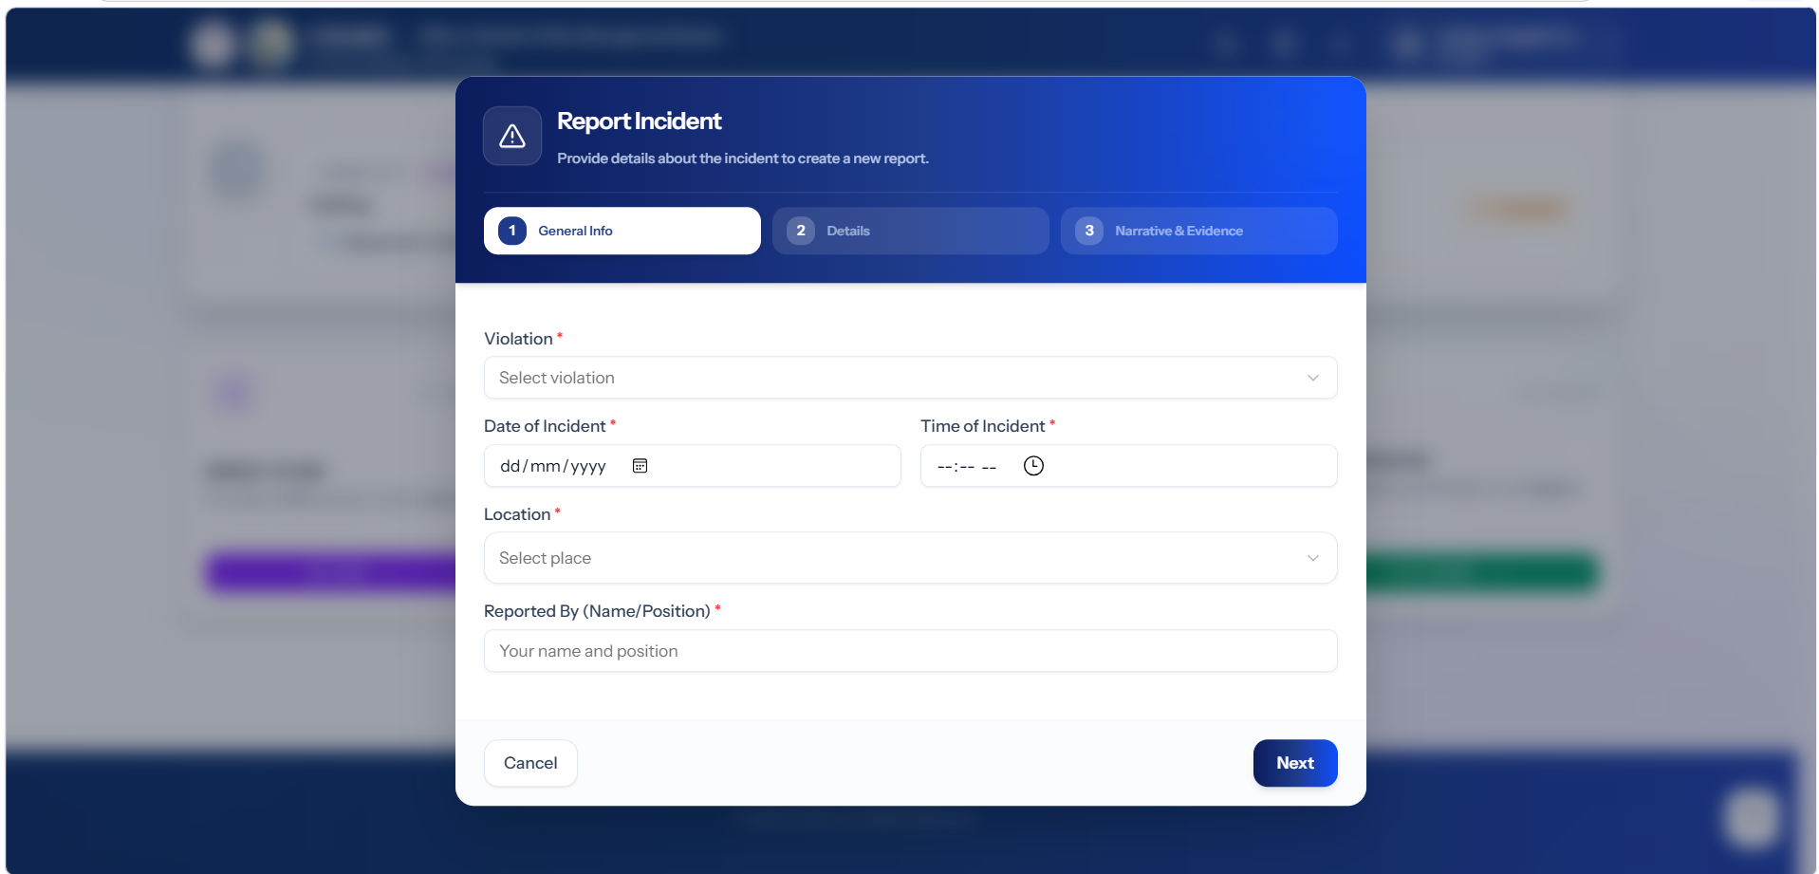Figure 3.62: Incident Report Dialog
The Incident Report form shown in Figure 3.62 allows administrators to create a detailed report of a student incident. It includes information such as the involved student, incident description, date, and supporting evidence.
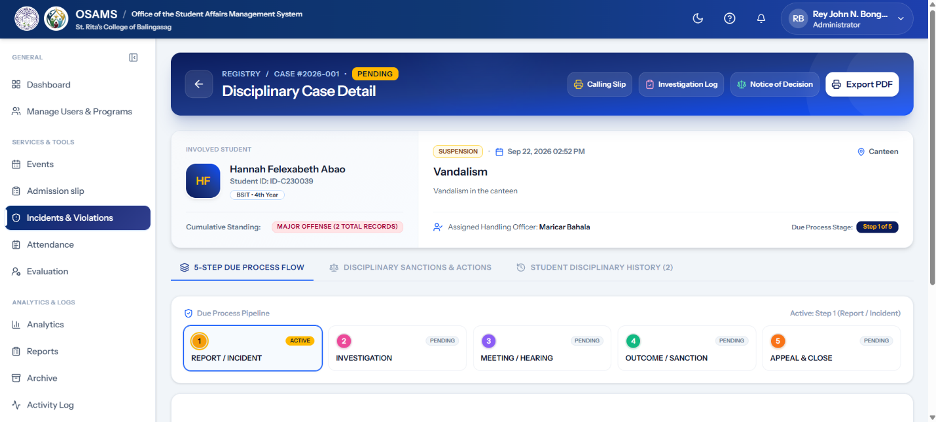
Figure 3.63: Disciplinary Case Detail Dialog
The Disciplinary Case view shown in Figure 3.63 presents the details of a disciplinary case, including the type of violation, severity, and disciplinary information of the involved student.
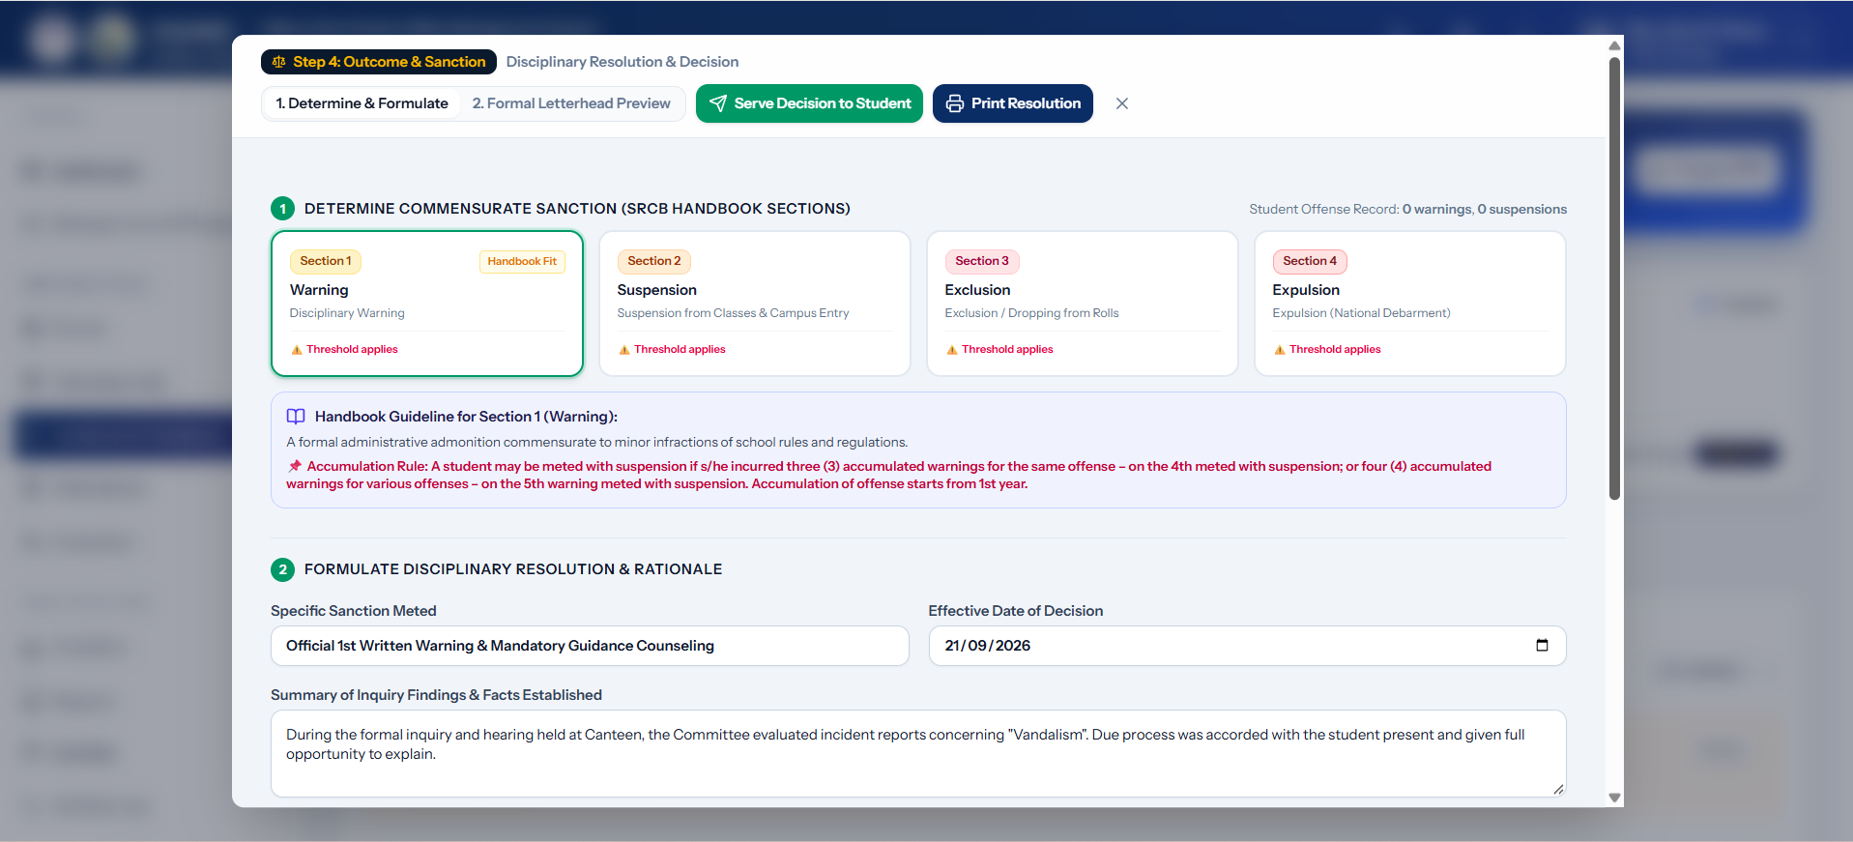Figure 3.64: Disciplinary Resolution Modal
The Resolution form shown in Figure 3.64 allows administrators to record the outcome of a disciplinary case and document the corrective actions taken.
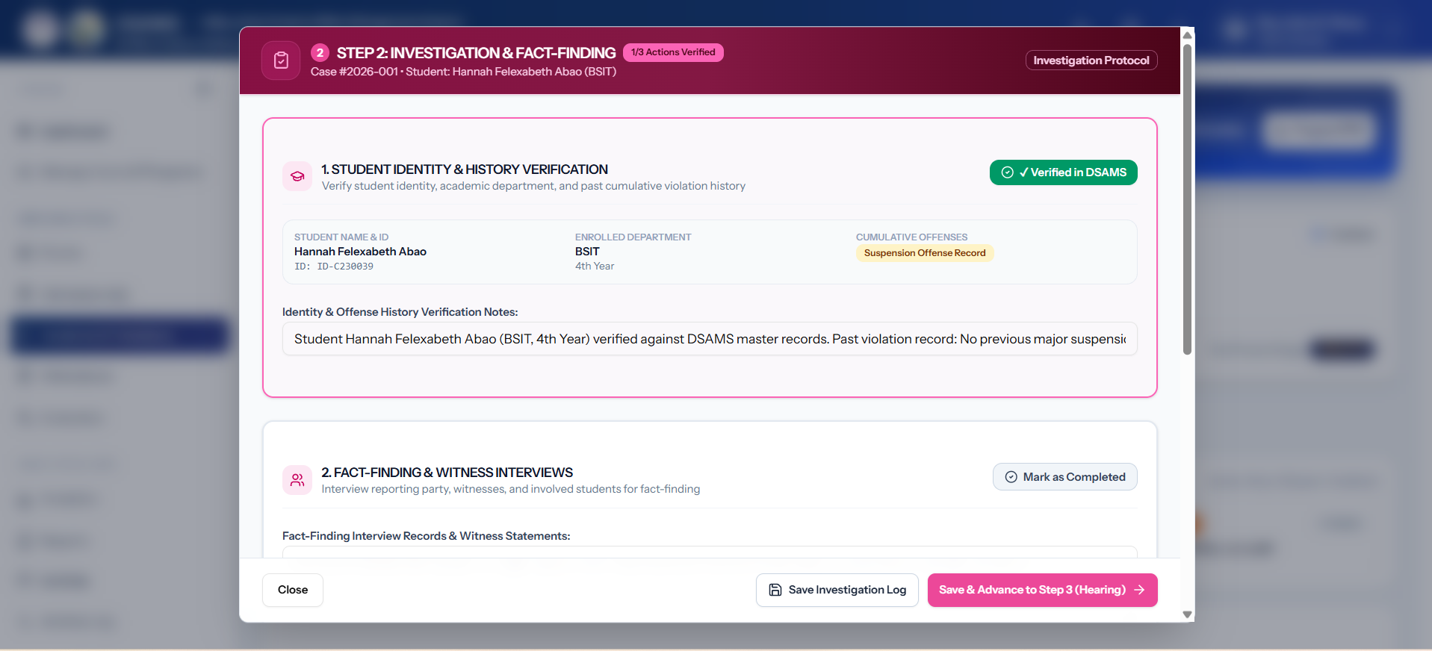Figure 3.65: Investigation Dialog
The Investigation interface shown in Figure 3.65 allows administrators to document investigation findings, record evidence, and include relevant witness statements related to an incident.
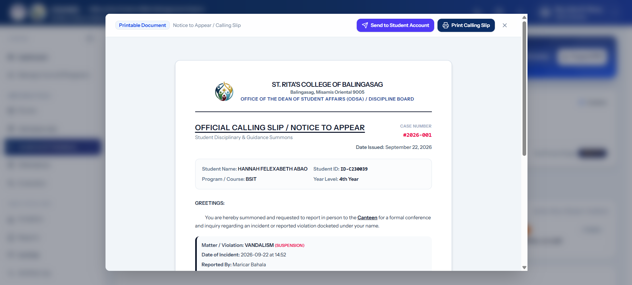Figure 3.66: Calling Slip Modal
The Calling Slip form shown in Figure 3.66 provides the information needed when requesting a student to appear at the Student Affairs office, including the reason, date, and contact details.
L. Programs Management Screens
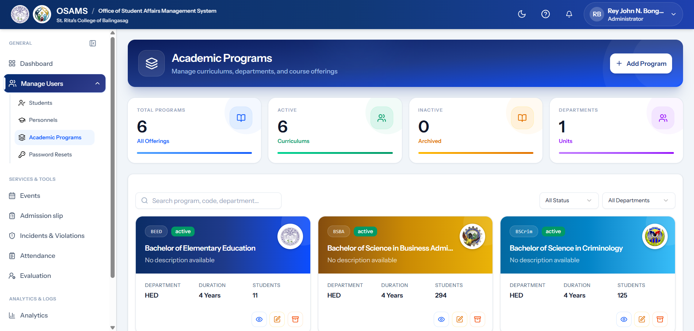Figure 3.67: Programs Management Page
The Programs Management interface shown in Figure 3.67 allows administrators to add, edit, and manage academic programs. It provides a table containing program information and supports the management of programs used within the system.
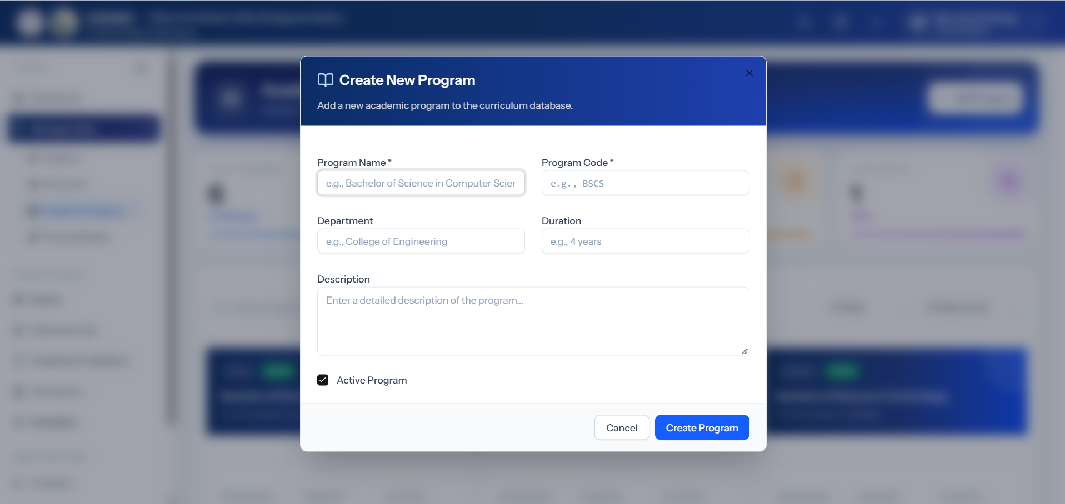Figure 3.68: Create Program Modal
The Create Program modal shown in Figure 3.68 allows administrators to add a new academic program by providing the required program information.
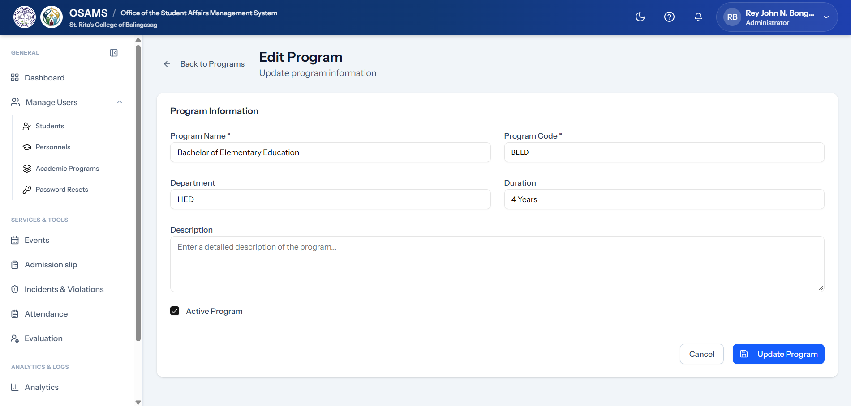Figure 3.69: Edit Program Modal
The Edit Program form shown in Figure 3.69 allows administrators to update the information of an existing academic program. The form displays the current program details for editing.
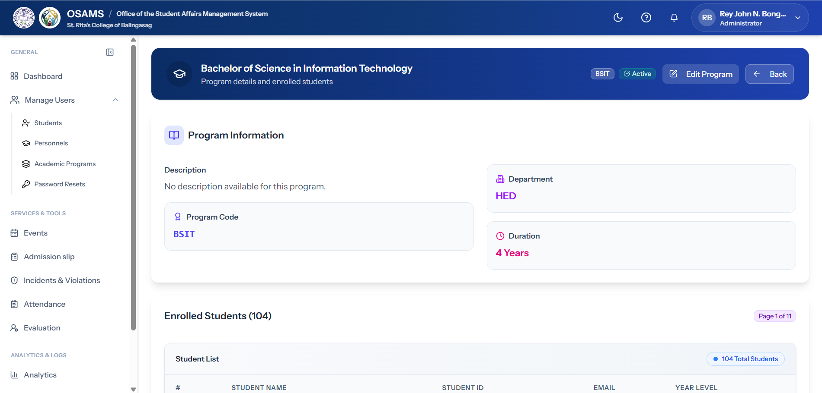Figure 3.70: Program Detail View
The Program Detail view shown in Figure 3.70 displays detailed information about a selected academic program, including its associated students and other relevant program information.
M. Reports & Analytics Screens
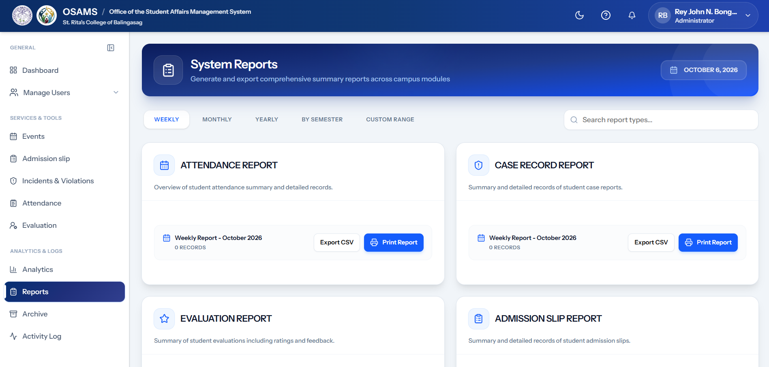
Figure 3.71: Reports Page
The Reports interface shown in Figure 3.71 allows administrators to generate and view system reports based on available records. Filter options can be used to organize the information according to the required report.
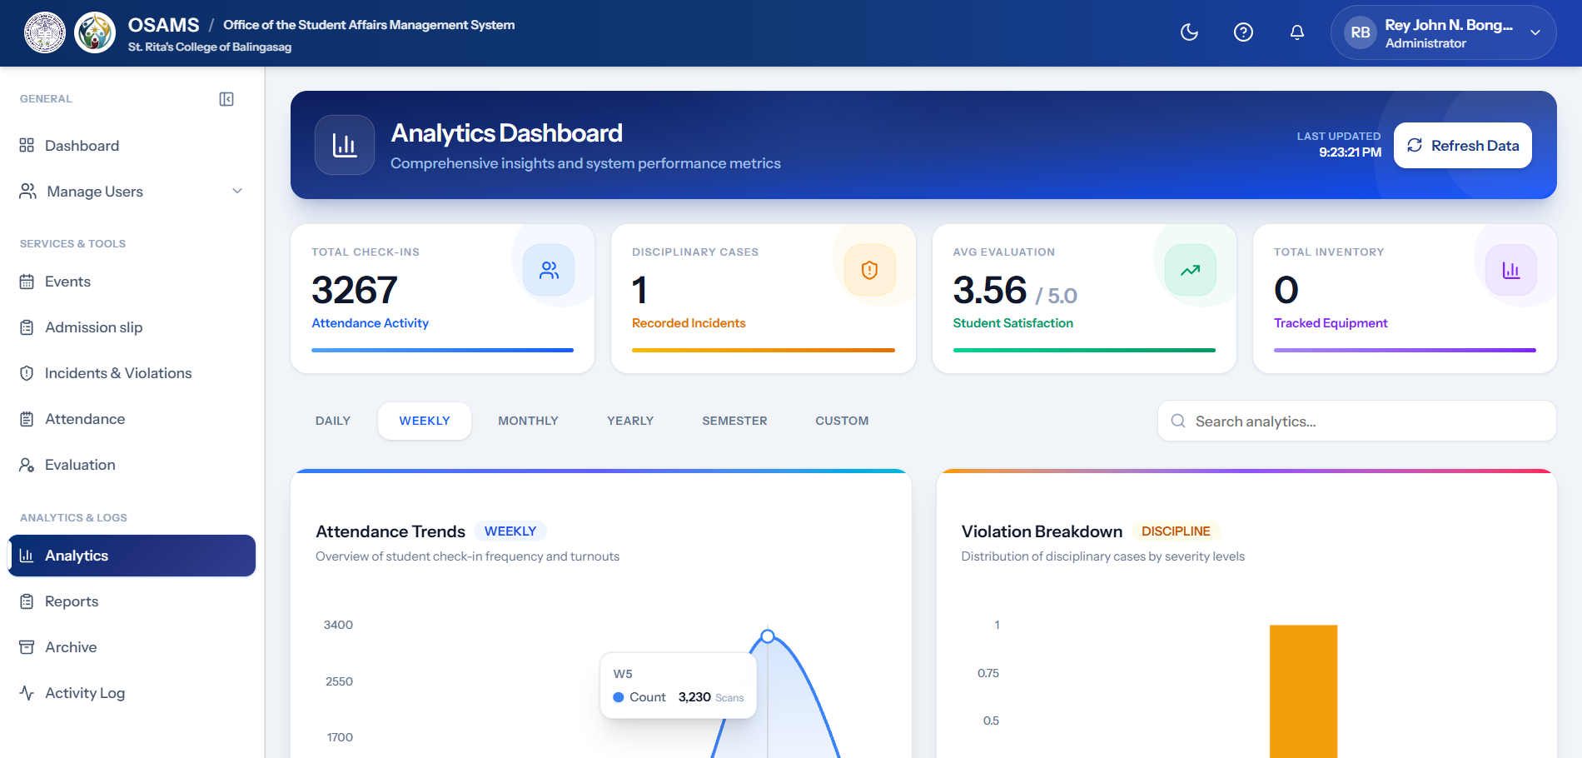Figure 3.72: Analytics Dashboard
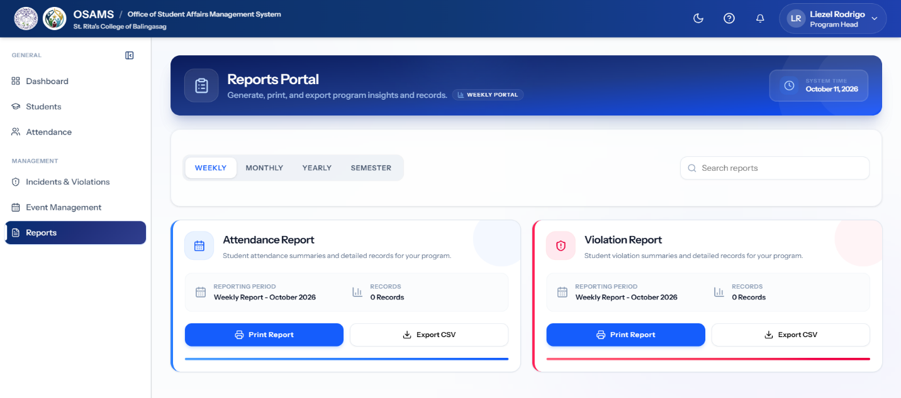
The Analytics Dashboard shown in Figure 3.72 presents summarized system information through charts, graphs, and statistical indicators. It helps administrators view patterns and trends in attendance, events, and other system records.

Figure 3.73: Personnel Reports Page
The Personnel Reports interface shown in Figure 3.75 provides reports on student attendance and violations within the personnel's assigned program. It allows personnel users to view and monitor attendance records and reported violations for their assigned students.
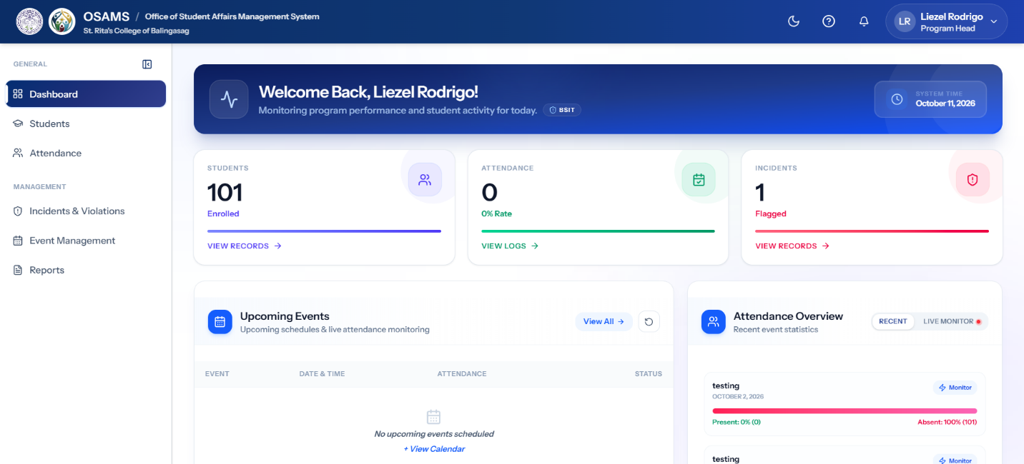
M. Personnel Role Screens
Figure 3.74: Personnel Dashboard
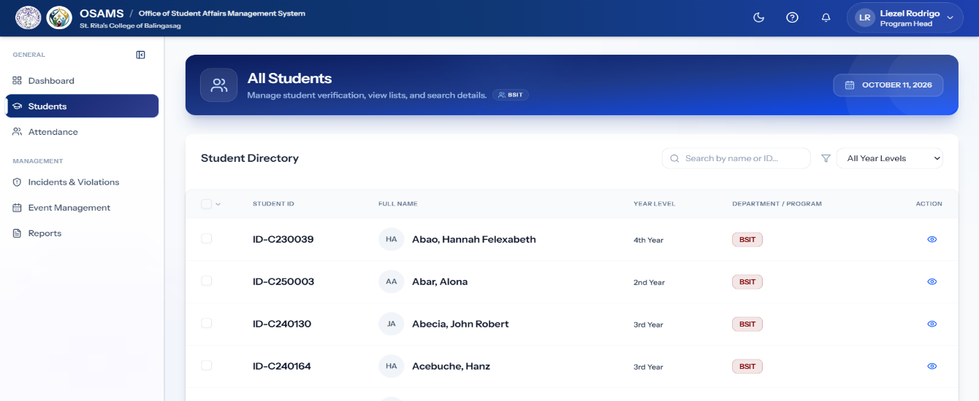
The Personnel Dashboard shown in Figure 3.74 provides an overview of information related to the programs assigned to the personnel. It displays relevant statistics, recent activities, and items requiring attention.

Figure 3.75: Personnel Students List
The Students List shown in Figure 3.75 allows personnel users to view students under their assigned program. The list provides student information that can be searched and filtered for easier monitoring.
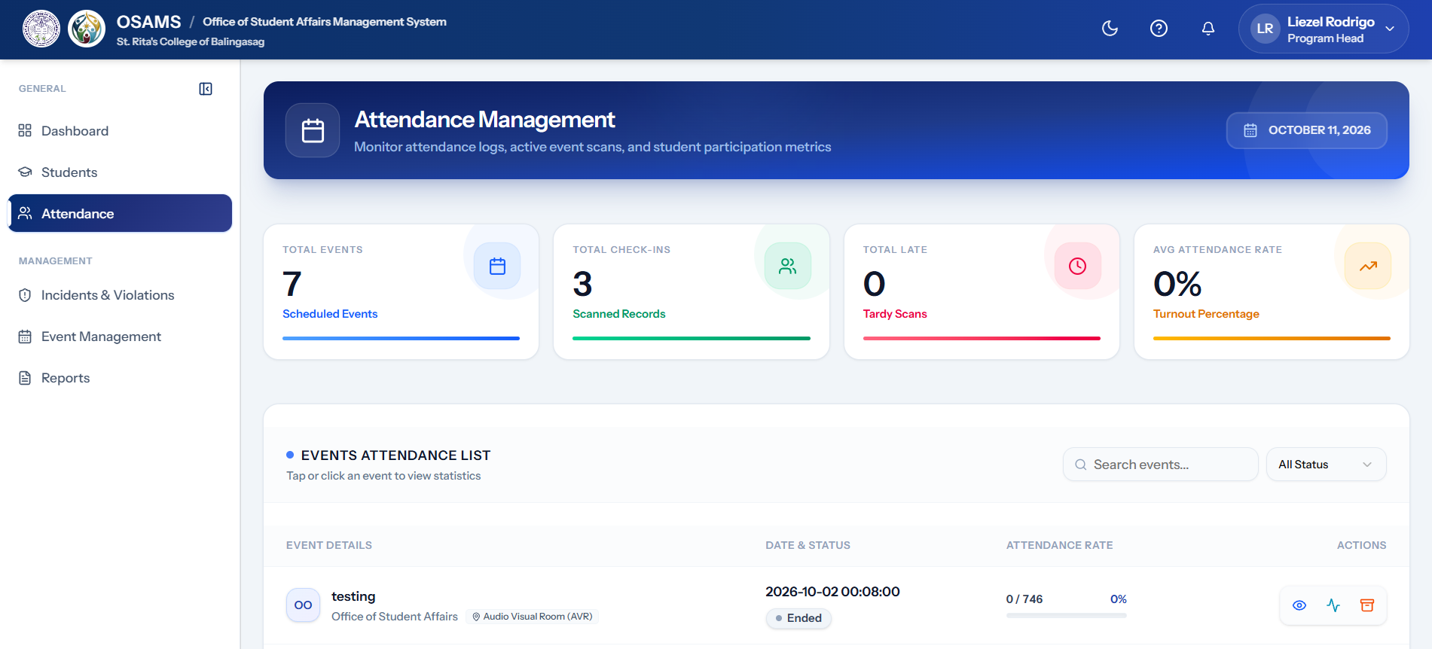Figure 3.76: Personnel Attendance Monitoring
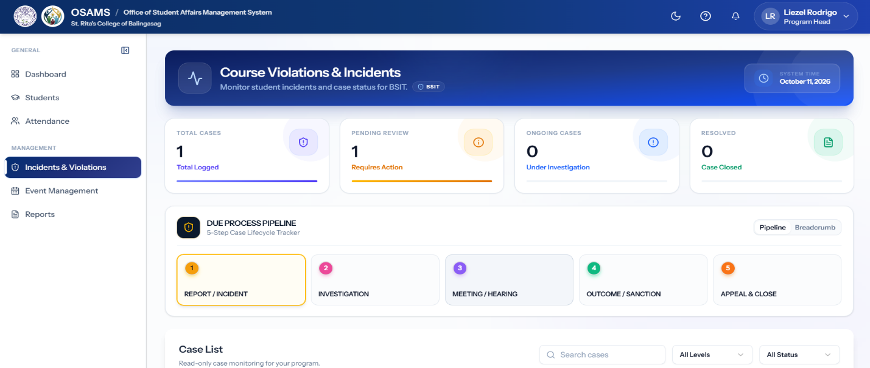
The Attendance Monitoring interface shown in Figure 3.76 allows personnel users to view attendance records of students under their assigned program. It provides information that can be used to monitor student attendance.

Figure 3.77: Personnel Violations View
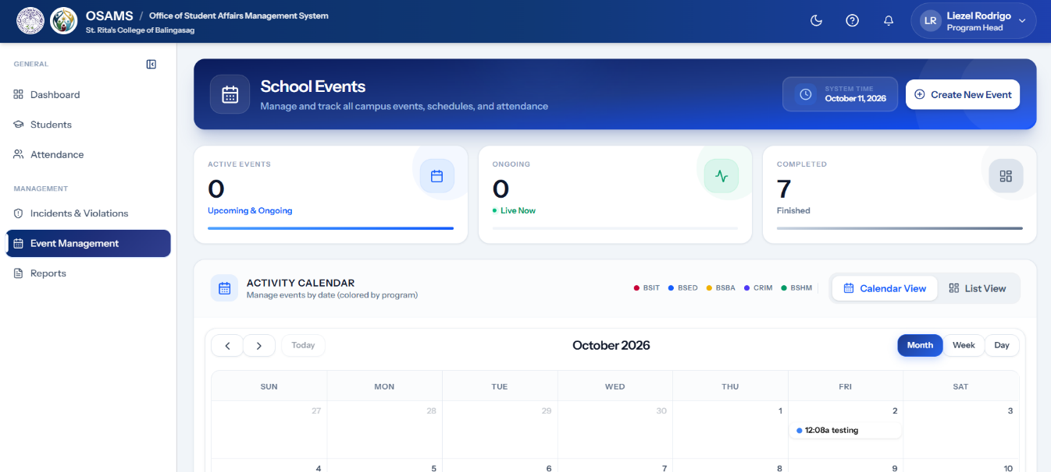
The Violations view shown in Figure 3.77 allows personnel users to view reported violations involving students under their assigned program. This supports monitoring and appropriate follow-up of student cases.
Figure 3.78: Personnel Event Management
The Event Management interface shown in Figure 3.78 allows personnel users to view and manage activities associated with their assigned program. It also provides access to activity-related information and scheduling.
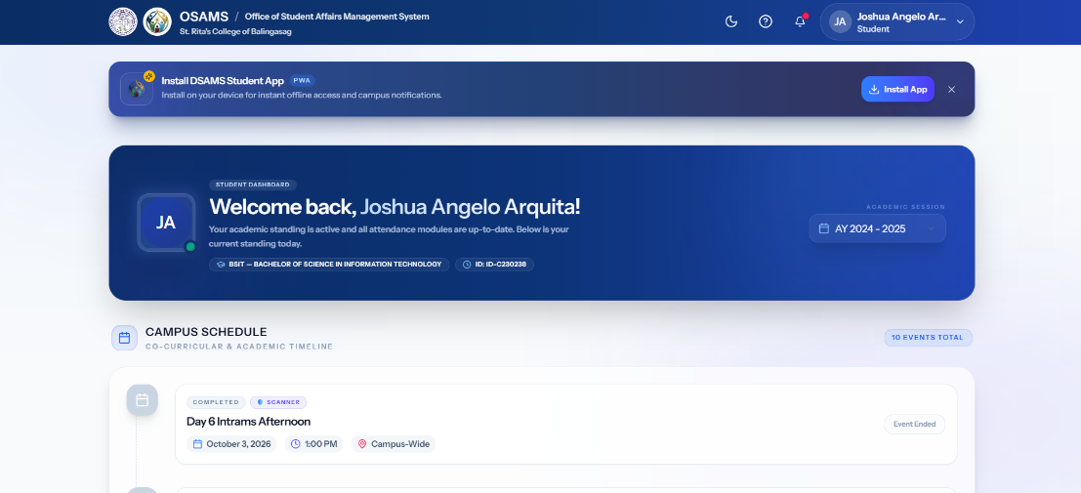
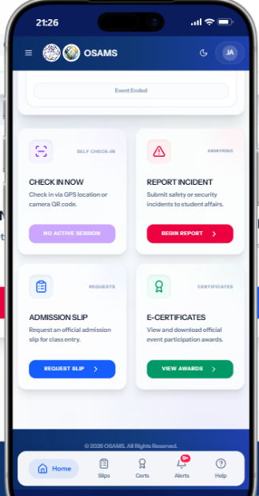
O. Student Role Screens

Figure 3.79: Student Dashboard
The Student Dashboard shown in Figure 3.79 provides students with an overview of their attendance, upcoming events, notifications, and pending evaluation requirements. The information is organized into clear sections for easier access.
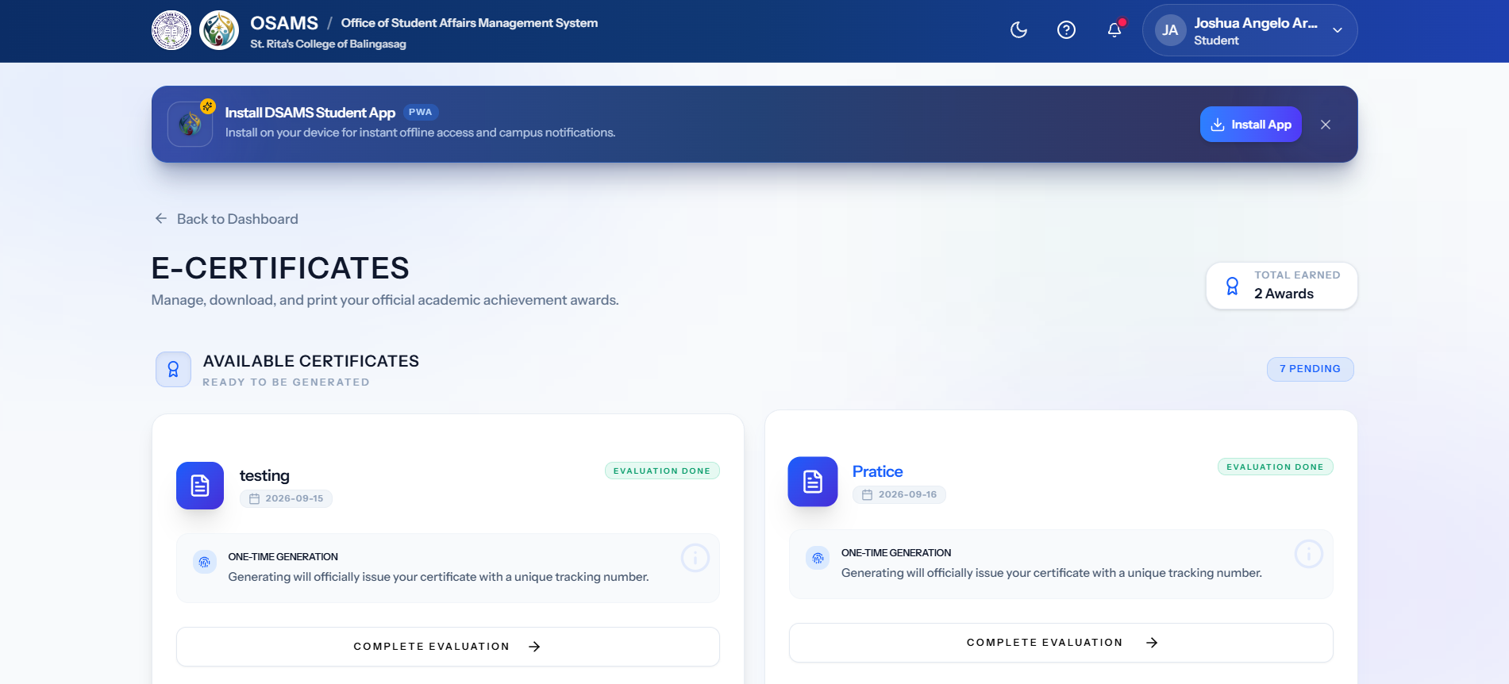Figure 3.80: Student Certificates Page
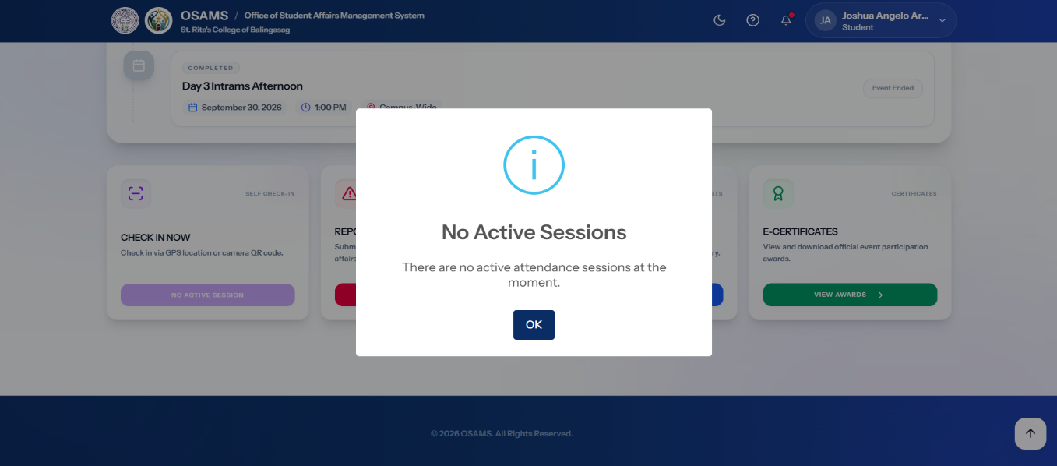
The E-Certificates interface shown in Figure 3.80 allows students to view and download official certificates for event participation and awards. The “View Awards” button provides access to the student's available certificates.

Figure 3.81: Student Check-In
The Student Check-In interface shown in Figure 3.81 allows students to check in to an event using GPS location or a camera QR code. When there is no available attendance session, the interface displays the “No Active Session” status.
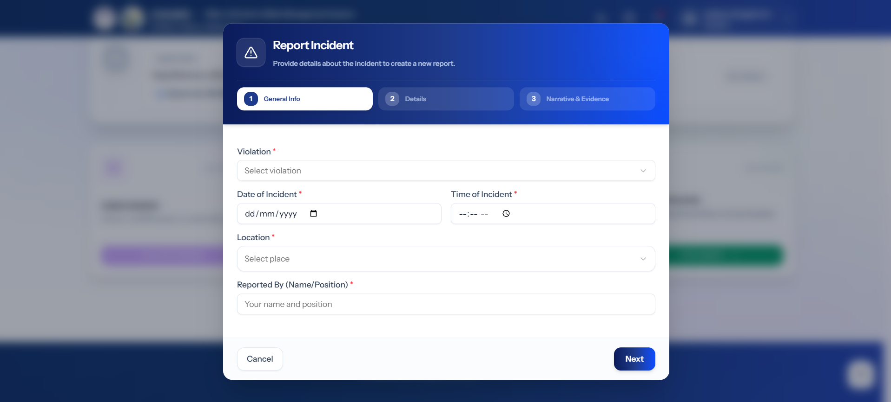Figure 3.82: Report Incident
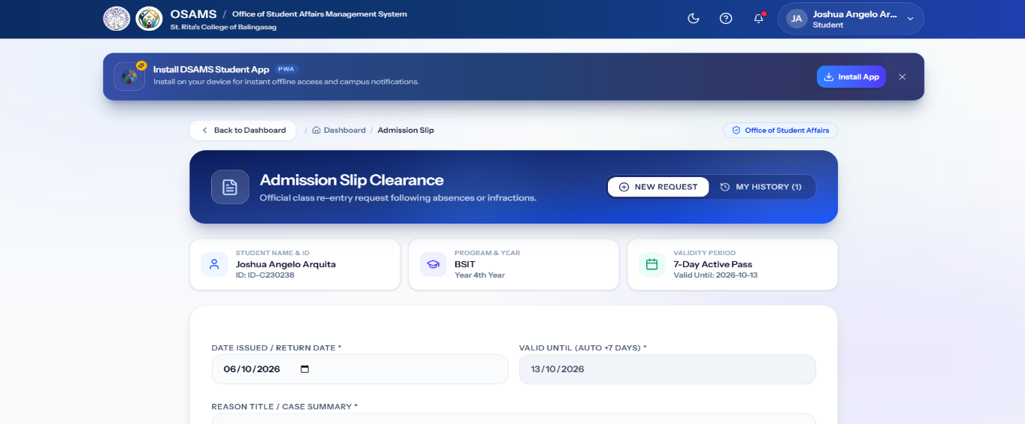
The Report Incident interface shown in Figure 3.82 allows students to submit safety or security incidents to the Office of Student Affairs. The “Begin Report” button provides access to the incident reporting process.
Figure 3.83: Admission Slip
The Admission Slip interface shown in Figure 3.83 allows students to request an official admission slip for class entry. The “Request Slip” button provides access to the admission slip request process.
P. Settings & Accounts Management Screens
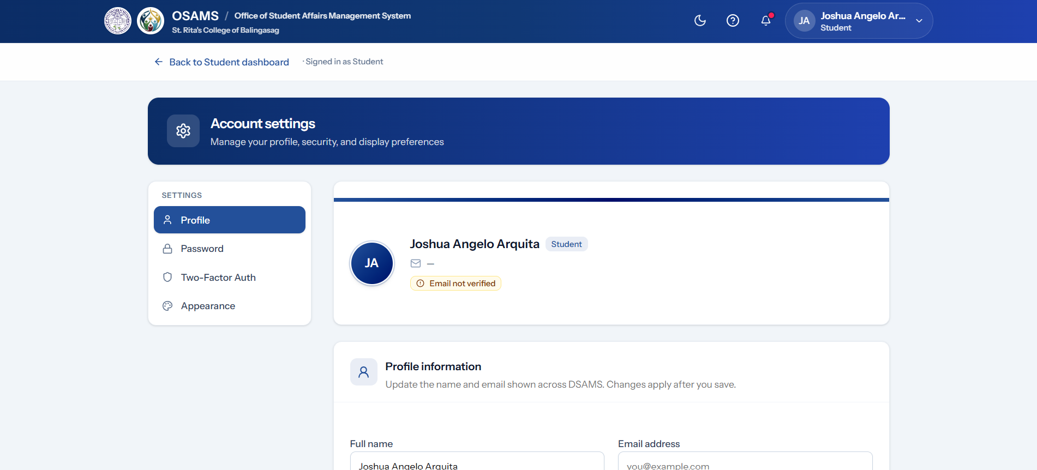
Figure 3.84: Profile Settings Page
The Profile Settings interface shown in Figure 3.84 allows users to view and update their account information. It provides the necessary fields for maintaining accurate profile details.
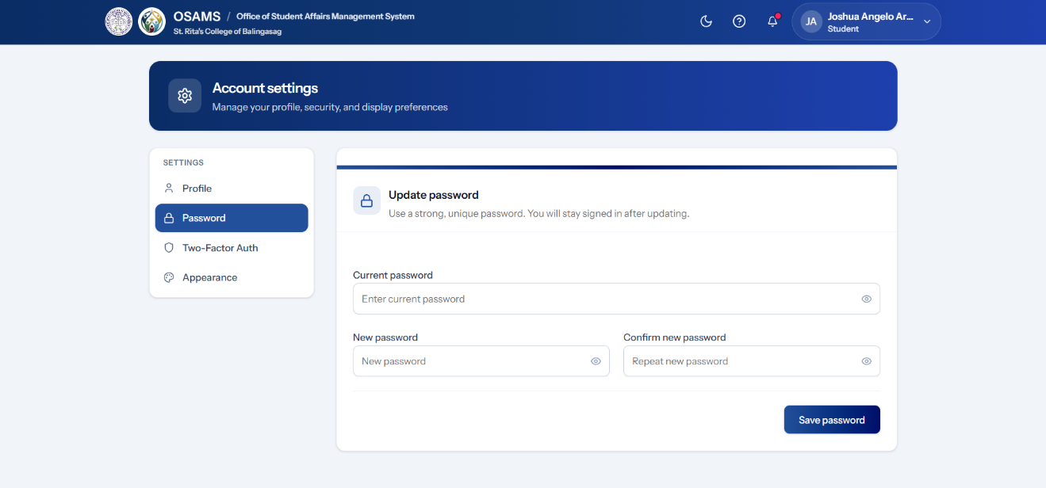
Figure 3.85: Password Settings Page
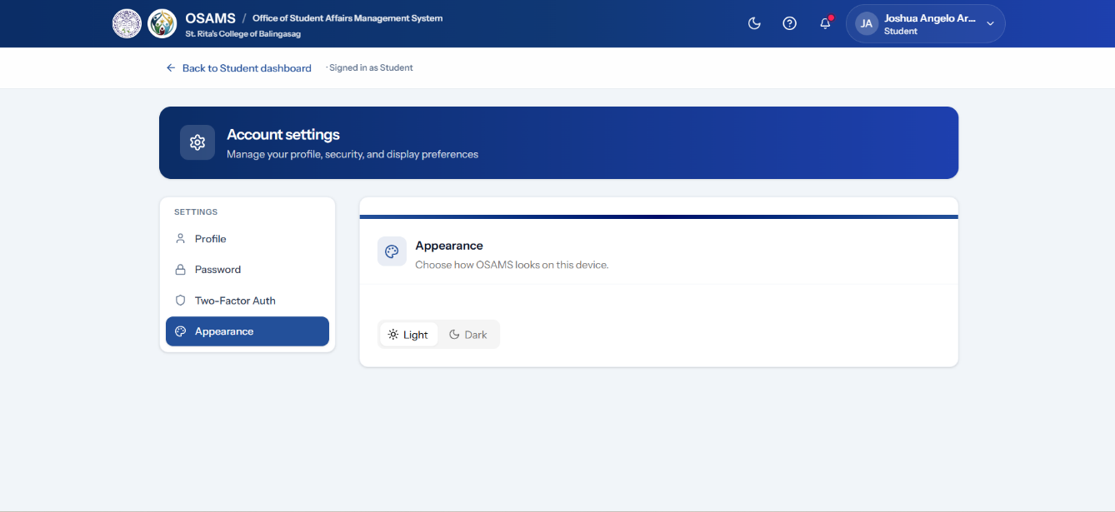
The Password Settings interface shown in Figure 3.85 allows users to change their account password. The page provides the required fields for entering and confirming a new password.
. Figure 3.86: Appearance Settings Page
The Appearance Settings interface shown in Figure 3.86 allows users to adjust the system's display appearance according to the available settings. This provides a more comfortable and accessible interface for different users.
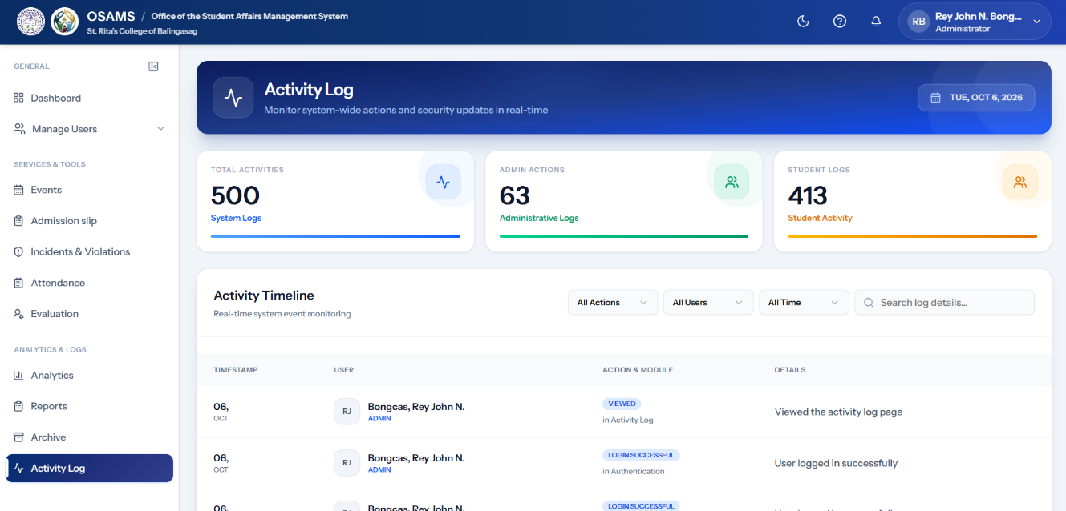
Q. System Utility Screens
Figure 3.87: Activity Log (Admin)
The Admin Activity Log shown in Figure 3.87 displays a chronological record of administrative activities performed in the system. It supports monitoring and accountability by providing information about recorded system actions.
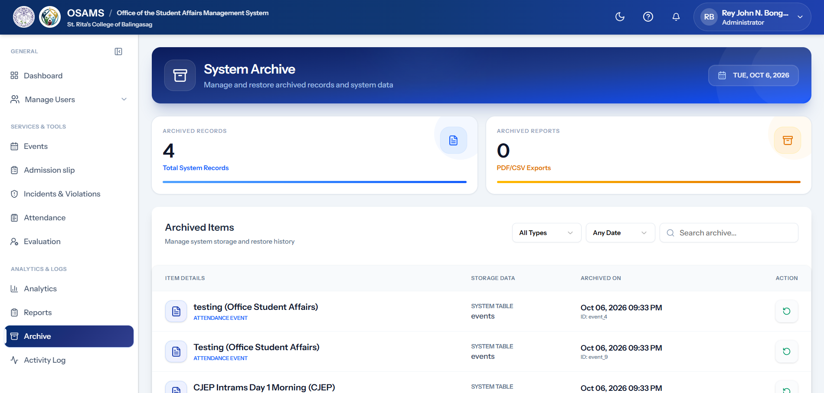
Figure 3.88: Archive Management Page
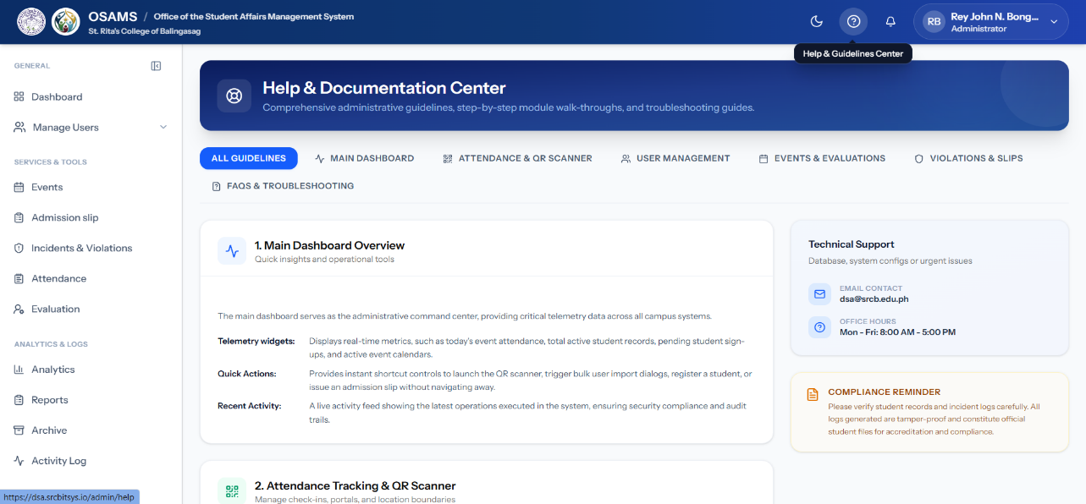
The Archive Management interface shown in Figure 3.88 allows administrators to view records that have been archived. This helps preserve previous records while keeping active system information organized.
. Figure 3.89: Help Center (Admin)
The Admin Help Center shown in Figure 3.89 provides administrators with information and guidance for using the system's features and functions.
. 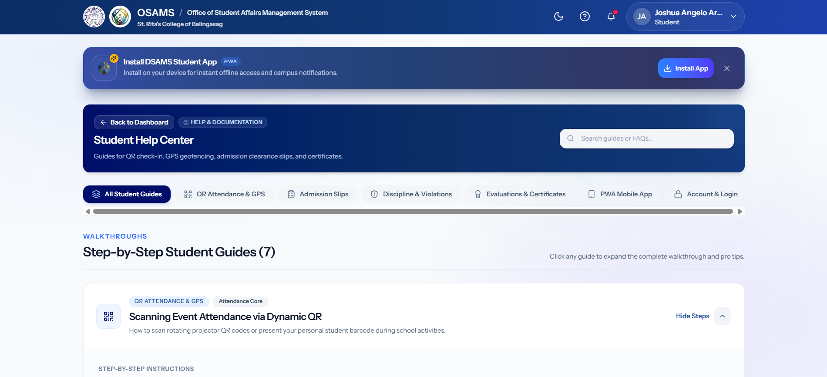
Figure 3.90: Help Center (Student)
The Student Help Center shown in Figure 3.90 provides students with guidance for using the available system features, such as attendance, events, evaluations, and admission slip requests.
. 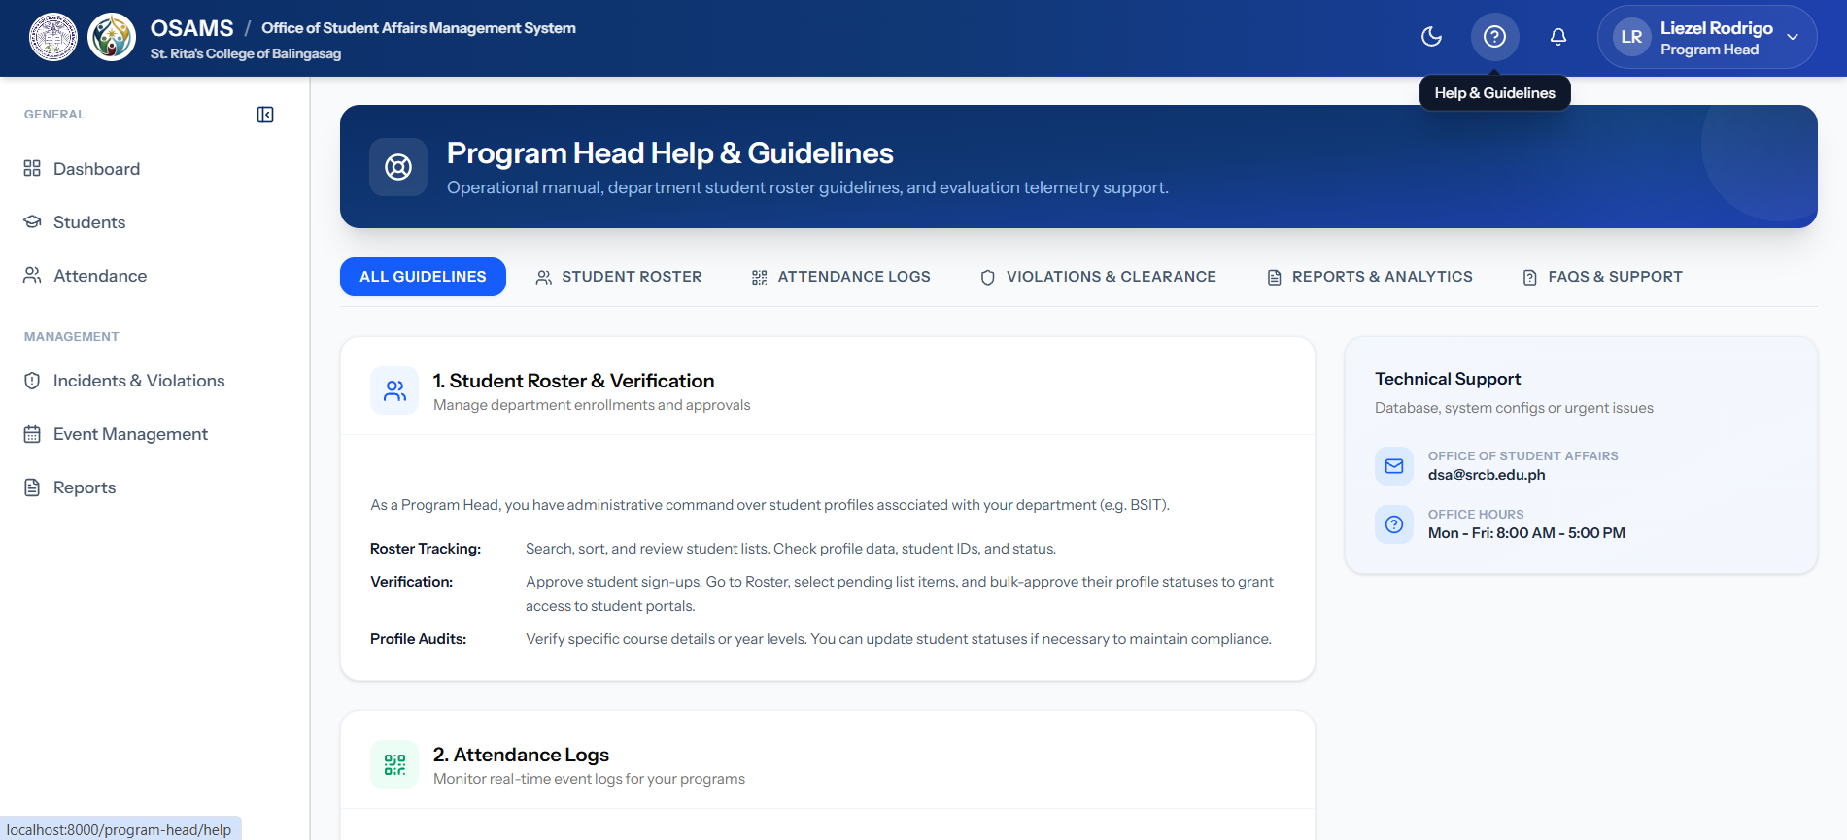Figure 3.91: Help Center (Personnel)
The Personnel Help Center shown in Figure 3.91 provides role-specific guidance to help Personnel use the functions available within their assigned access.
. 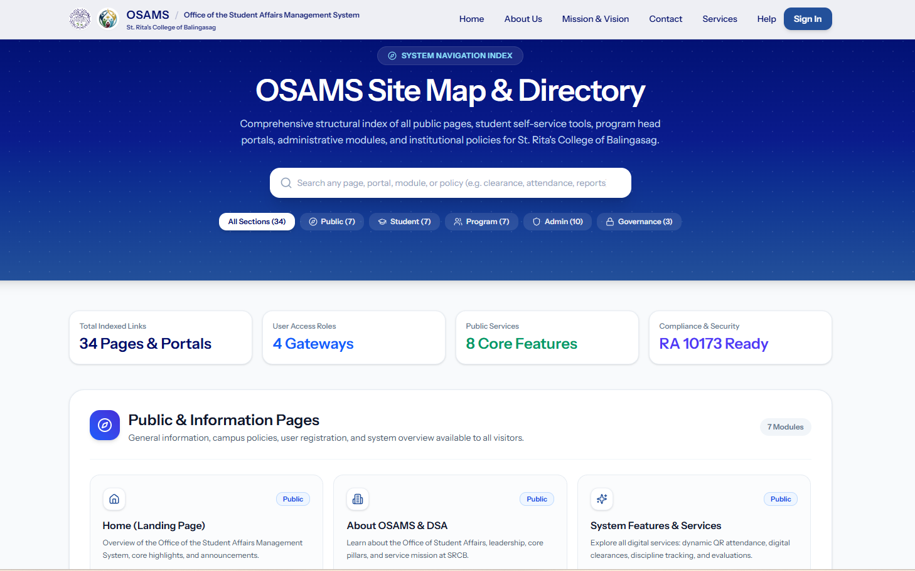
Figure 3.92: Sitemap Page
The Sitemap shown in Figure 3.92 provides a structured overview of the accessible pages and modules of the system. It helps users understand the organization of the system and locate available features.
. 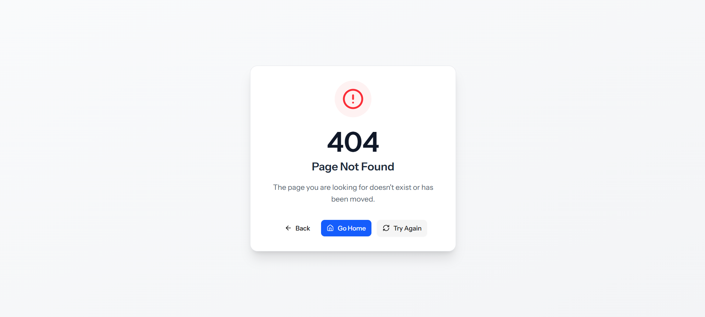Figure 3.93: Error Page (404/500)
The Error Page shown in Figure 3.93 provides a user-friendly message when an invalid page or system error is encountered. It also provides navigation options to help users return to an available page.
R. Legal & Compliance Screens
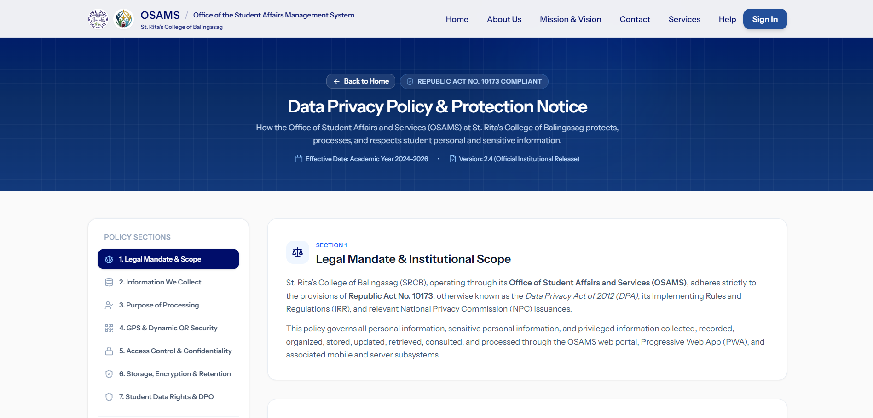
Figure 3.94: Privacy Policy Page
The Privacy Policy page shown in Figure 3.94 presents information about the collection, use, and protection of user data. It provides users with information about the system's privacy practices and applicable data protection requirements.
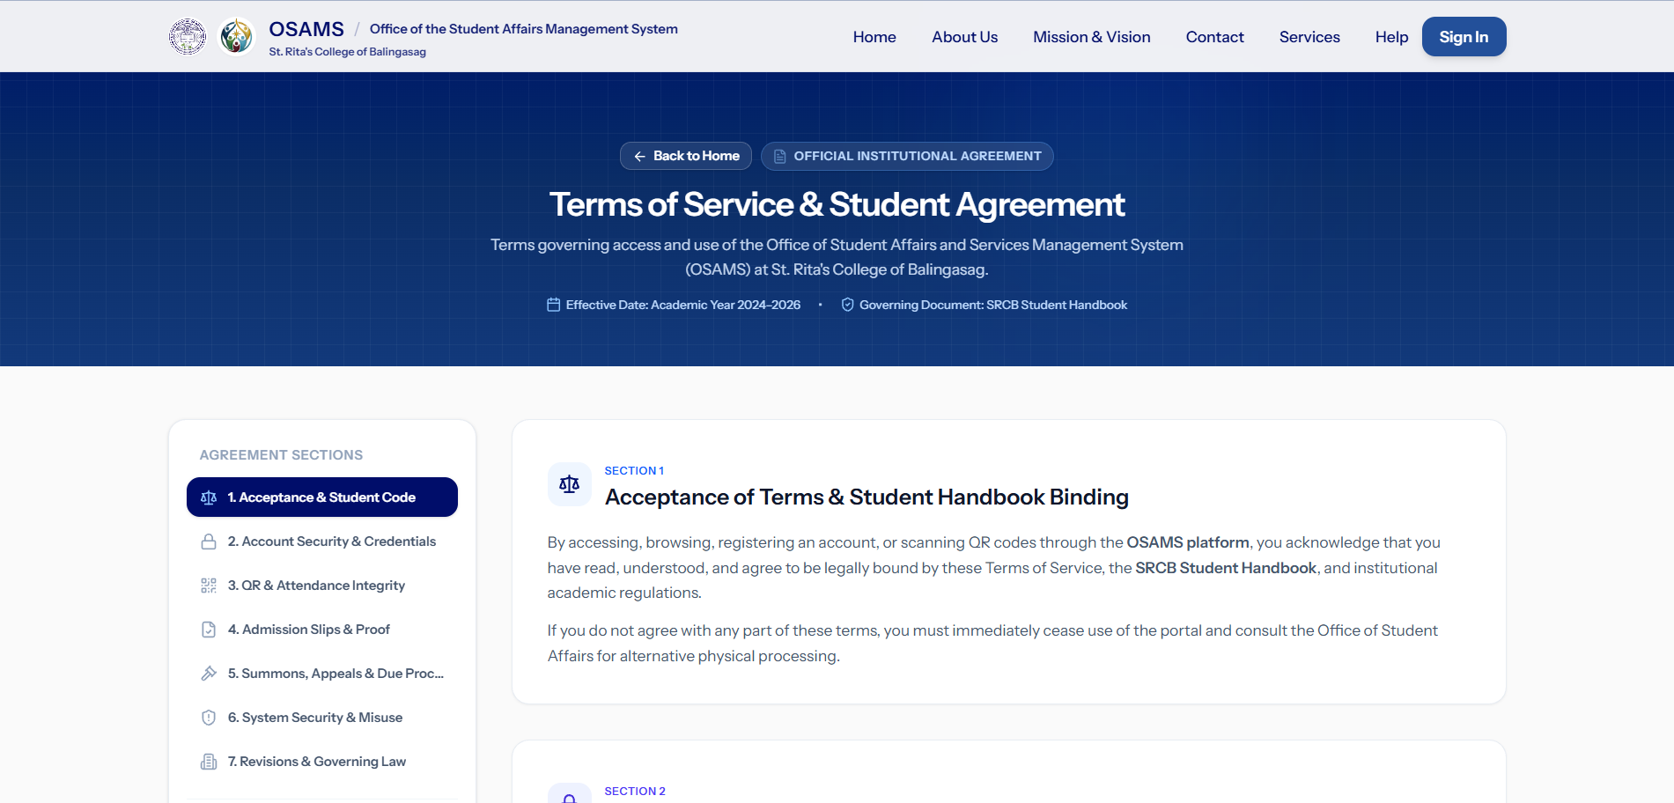Figure 3.95: Terms of Service Page
The Terms of Service page shown in Figure 3.95 presents the conditions and responsibilities associated with using the OSAMS platform. It provides users with information about the proper use of the system and its available services.

3.5 Tools, Technologies, and Development Environment
The development, implementation, and deployment of the Office of Student Affairs Management System (OSAMS) utilize a comprehensive set of hardware specifications, software stacks, development tools, and frameworks to ensure system efficiency, responsiveness, and security.
Category | Tools / Technologies Used | Purpose
Project Management | Trello / GitHub Projects / Jira | Managing Sprint Backlog, Sprints, and Tasks
UI/UX Design | Figma / Draw.io | Creating Wireframes, Prototypes, and System Diagrams
Frontend Stack | React / TypeScript / Inertia.js / Tailwind CSS | Building responsive and interactive user interfaces
Backend Stack | Laravel 12 / PHP 8.2+ / Laravel Fortify | Developing system logic, authentication, routing, and access control
Database | MySQL / phpMyAdmin | Storing and managing system data and records
Geotagging & Mapping | Leaflet.js | Capturing GPS coordinates and validating attendance locations
QR Code Processing | ZXing Browser / Endroid QR Code | Generating, scanning, and verifying QR codes
Real-Time Communication | Node.js / Express.js / Socket.IO | Providing real-time notifications and updates
Reporting & File Processing | Barryvdh DomPDF / PhpSpreadsheet | Generating PDF reports and Excel files
Data Analytics & Scheduling | Recharts / FullCalendar | Displaying data charts, statistics, and activity schedules
Version Control | Git / GitHub | Code tracking and team collaboration
Development Environment | Laragon / Vite 7 | Running and testing the system locally
Code Editor | Visual Studio Code / Antigravity IDE | Writing and managing source code
Testing & Evaluation | Pest PHP / ISO/IEC 25010 / SUS | Testing the system, checking code quality, and evaluating system quality and usability
Table 3.17: Software Tools, Technologies and Development Environment
Table 3.17 presents the software tools and technologies used in developing the proposed system. It shows the tools used for system design, development, database management, geotagging, QR code processing, reporting, and other development activities.
Component | Minimum Specification | Recommended Specification | Purpose
Development Workstation / Host PC | Intel Core i3 / AMD Ryzen 3, 8 GB RAM, 256 GB SSD | Intel Core i5/i7 / AMD Ryzen 5/7, 16 GB RAM, 512 GB NVMe SSD | Used by developers for coding, testing, running the local server, and managing the database.
Client Workstation | Dual-core processor, 4 GB RAM, Chrome/Edge browser | Quad-core processor, 8 GB RAM, 1080p display | Used by OSA administrators and authorized personnel to manage activities, attendance, admission slips, and reports.
Mobile Client Device | Android 8.0+ or iOS 12+, camera, GPS | Android 11+ or iOS 15+, high-resolution camera, 4G/5G/Wi-Fi | Used by students to access the system, scan QR codes, submit requests, and provide location information for attendance.
Portable Thermal Printer | Goojprt PT-210, Bluetooth/USB connectivity, thermal printing | Goojprt PT-210 with compatible thermal paper and stable Bluetooth/USB connection | Used by OSA personnel to print approved admission slips for students.
Table 3.18: Hardware Requirements and Specifications
Table 3.18 presents the hardware requirements needed for the development and operation of the proposed system. It includes the minimum and recommended specifications for developer, administrator, authorized personnel, and student devices.

3.6 System Testing and Evaluation Plan
The system testing and evaluation plan is designed to determine whether the developed Office Student Affairs (OSA) Management System with QR Code and Geotagging System for Student Activity and Attendance works according to its requirements and meets the expected quality, usability, accessibility, and user acceptance standards. The testing and evaluation will be conducted after the development of the system and will involve technical testing, user testing, software quality evaluation, technology acceptance, and web accessibility evaluation. The results will provide evidence of whether the developed system can properly support the processes of the OSA Personnel/System Administrators, Academic Personnel, Student Leaders (CSG Officers), and Students.

3.6.1 Software Testing
The researchers will conduct different types of software testing to verify that the system functions correctly and that its different modules work together properly. The testing will include Unit Testing, Integration Testing, User Acceptance Testing, and Technology Acceptance based on the Technology Acceptance Model (TAM).
Unit and Integration Testing. Unit Testing will be conducted to test individual functions and components of the system. Each major function will be checked to determine whether it produces the expected result based on the given input. The testing will cover important functions such as user authentication, role-based access, QR code attendance, geotagging attendance validation, activity evaluation, admission slip requests, student case records, reports, analytics, and e-certificate generation. Both valid and invalid inputs will be tested to identify possible errors in individual functions.
Integration Testing will be conducted after testing the individual functions. It will verify whether the different modules and components work correctly when connected with one another. The testing will include the connection between the user accounts and their assigned roles, attendance and student records, events and attendance, evaluations and activity records, admission slip requests and approval status, student case records and reports, and other related system functions. The purpose is to identify errors that may occur when data are transferred or shared between connected modules.
User Acceptance Testing (UAT). User Acceptance Testing will be conducted to determine whether the developed system meets the operational requirements of its intended users. The target users will include OSA Personnel / System Administrators, Academic Personnel (Program Heads, Department Instructors, and Academic Office Staff), Student Leaders (CSG Officers), and Students. The participants will perform representative tasks based on their assigned roles, such as managing events, recording attendance, checking geotagging attendance, submitting evaluation forms, processing admission slip requests, viewing records, and generating reports. The results of the UAT will be used to determine whether the system performs the required functions and is acceptable for actual use. The UAT will also support the evaluation of the system's usability and user acceptance.
Technology Acceptance Model (TAM). The Technology Acceptance Model will be used as a basis for evaluating users' acceptance of the developed system. The evaluation will consider the users' perceived usefulness and perceived ease of use when interacting with the system. Perceived usefulness will determine whether users believe that the system helps improve their tasks and activities, while perceived ease of use will determine whether users find the system easy to understand and operate. The TAM concepts will support the evaluation of technology acceptance among the intended users after they have performed the required system tasks.

3.6.2 Evaluation Framework and Standards
The developed system will be evaluated using recognized software quality and accessibility standards. The main software quality framework will be ISO/IEC 25010:2023, while Web Content Accessibility Guidelines (WCAG) will be used as a basis for evaluating applicable accessibility features of the web-based system.
ISO/IEC 25010:2023 Software Quality Standard. The ISO/IEC 25010:2023 Software Quality Model will be used to evaluate the overall quality of the developed system. The evaluation will be conducted by selected IT experts using the applicable software quality characteristics. These characteristics include Functional Suitability, Performance Efficiency, Compatibility, Interaction Capability, Reliability, Security, Maintainability, Flexibility, and Safety. The use of this standard will provide a structured basis for determining whether the developed system meets expected software quality requirements. The same nine quality characteristics are used in the Chapter 4 evaluation.
Functional Suitability. This characteristic will evaluate whether the system provides the required functions for the intended users. It will focus on functions such as user management, event management, QR code attendance, geotagging attendance validation, activity evaluation, admission slip processing, student case records, reports, analytics, and e-certificate generation.
Performance Efficiency. This characteristic will evaluate whether the system performs its functions within an acceptable response time while using system resources appropriately. It will consider the responsiveness of important operations such as login, attendance recording, geotagging validation, data retrieval, report generation, and other system transactions.
Compatibility. This characteristic will evaluate whether the system can operate properly with supported browsers, devices, and other related system components. It will also consider whether the system's functions can work properly across the devices used by OSA Personnel/System Administrators, Academic Personnel, Student Leaders (CSG Officers), and Students.
Interaction Capability. This characteristic will evaluate whether users can understand, learn, and operate the system effectively. It will consider the clarity of the interface, ease of navigation, ease of completing tasks, and overall user interaction with the system.
Reliability. This characteristic will evaluate whether the system can perform its required functions consistently and correctly during normal use. It will consider the system's ability to maintain accurate records and continue performing important functions without unexpected failures.
Security. This characteristic will evaluate whether the system protects user accounts, records, and other stored information from unauthorized access or improper actions. It will consider authentication, role-based access, password protection, session management, input validation, and other implemented security controls.
Maintainability. This characteristic will evaluate whether the system can be maintained, modified, and improved when changes or corrections are required. It will consider the organization of the system's source code, modular structure, and ability to support future updates.
Flexibility. This characteristic will evaluate whether the system can adapt and operate effectively across the supported devices and environments. It will consider access through supported computers, mobile devices, browsers, and other environments required by the intended users.
Safety. This characteristic will evaluate whether the system avoids causing harm to users, their records, or the institution during normal use. It will consider safeguards such as protection of student information, controlled actions on sensitive records such as student cases, and warnings or confirmations before important actions are completed.
Web Content Accessibility Guidelines (WCAG). The developed web-based system will also be evaluated using applicable Web Content Accessibility Guidelines (WCAG) criteria. The evaluation will focus on whether important interface elements are perceivable, operable, understandable, and robust across supported devices and browsers. The assessment will include applicable features such as readable text, sufficient contrast, alternative text where needed, keyboard navigation, visible controls and focus, clear form labels, instructions, error messages, and browser or device compatibility. The accessibility evaluation will help determine whether the important functions of the system can be accessed and understood by its intended users. The Chapter 4 evaluation plan already identifies these four accessibility principles: Perceivable, Operable, Understandable, and Robust.

3.6.3 Data Gathering Instrument
The researchers will use standardized evaluation instruments to gather data after system testing. The main instruments will include the ISO/IEC 25010 evaluation questionnaire, User Acceptance Testing activities, Technology Acceptance Model-based evaluation, and the System Usability Scale (SUS).
System Usability Scale (SUS). The System Usability Scale will be administered to the target users after they have completed the required system tasks. SUS will be used to measure the perceived usability of the developed system. It consists of ten statements answered using a five-point response scale. The responses will be scored using the standard SUS scoring procedure and summarized into a composite usability score ranging from 0 to 100. The target respondents will include OSA Personnel/System Administrators, Academic Personnel, Student Leaders (CSG Officers), and Students. The SUS results will provide a standardized measure of the users' perception of the system's usability. This follows the evaluation procedure already specified in Chapter 4.
Five-Point Likert Scale. The evaluation questionnaires will use a five-point Likert scale to record the respondents' level of agreement with the statements presented in the evaluation instruments. The scale will allow the researchers to summarize the responses and determine the perceived quality, usability, and acceptance of the developed system. The gathered responses will be analyzed using appropriate descriptive statistics, including frequency, percentage, mean, and standard deviation, as applicable to the evaluation instrument.
The results gathered from Unit and Integration Testing, User Acceptance Testing, TAM-based evaluation, ISO/IEC 25010 evaluation, WCAG evaluation, and SUS will be used as evidence in determining whether the developed system meets its functional, quality, usability, accessibility, and user acceptance requirements. These results will also support the discussion of the identified problems and the extent to which the proposed system addresses the operational needs of the Office of Student Affairs.

CHAPTER 4
This chapter presents the results of the development, implementation, and evaluation of the Office Student Affairs (OSA) Management System with QR Code and Geotagging System for Student Activity and Attendance. It discusses how the system was implemented based on the requirements and design presented in the previous chapters. It also presents the completed system modules, their functions, and their relationship to the identified problems of the Office of Student Affairs (OSA). Furthermore, the chapter presents the results of software quality evaluation, User Acceptance Testing (UAT), usability evaluation using the System Usability Scale (SUS), and other applicable evaluation procedures. The findings are discussed based on the objectives and problems identified in Chapter 1.

4.1 System Implementation and Architecture Realization
The Office Student Affairs (OSA) Management System with QR Code and Geotagging System for Student Activity and Attendance was developed as a web-based system based on the requirements, system architecture, database design, and workflows established during the development process. The implementation followed the Agile Scrum Framework described in Chapter 3, where the development was divided into four-week sprint cycles. Each sprint focused on specific system modules and included development, testing, integration, review, and refinement activities. The implementation used Laravel 12, PHP, React, TypeScript, Inertia.js, Tailwind CSS, MySQL, Leaflet.js, QR code processing tools, and other supporting technologies identified in the system development environment.
The implemented system follows a layered architecture consisting of the client, presentation, application, security, API/backend, and data layers. Users access the system through web browsers using computers or mobile devices. The presentation layer provides the interfaces for the OSA Personnel/System Administrators, Academic Personnel, Student Leaders (CSG Officers), and Students, while the application layer processes authentication, attendance, evaluations, admission slips, incidents, reports, analytics, and other system functions. The MySQL database stores student, attendance, event, evaluation, admission slip, incident, certificate, notification, and activity log records. The architecture therefore provides a centralized environment for managing OSA-related records and transactions.

4.1.1 Overview and Sprint Summary
The development of the Office of Student Affairs Management System (OSAMS) was conducted from June 5 to September 30, 2026, using the Agile Scrum framework. The development process followed an iterative approach, dividing the work into four structured sprints, each lasting one to four weeks. Each sprint focused on specific system features, allowing the development team to plan tasks, develop functionalities, test results, and make improvements based on identified issues and feedback. Daily Scrum meetings were conducted to monitor the team's progress, discuss completed and upcoming tasks, and identify challenges encountered during development. The system was developed using PHP, Laravel, HTML, CSS, React, and MySQL. The development activities covered system foundation and administration, student services and attendance, personnel management, record monitoring, reporting, and system testing.

Sprint Cycle | Duration | Focus Area | Completed Deliverables
Sprint 1 | June 5–June 30, 2026 (4 weeks) | Administration and System Foundation | Admin Module, User Authentication, User Management, Dashboard, Role-Based Access Control, and Event Management
Sprint 2 | July 1–July 31, 2026 (4 weeks) | Student and Attendance Functions | Student Module, QR Code Attendance, Geotagging Validation, Admission Slip Requests, and Activity Evaluation
Sprint 3 | August 1–August 31, 2026 (4 weeks) | Personnel Management and Record Monitoring | Academic Personnel Module, Department Roster, Event and Attendance Management, and Student Disciplinary Records
Sprint 4 | September 1–September 30, 2026 (4 weeks) | Reporting, Integration, Testing, and Finalization | Analytics Dashboard, Report Generation, E-Certificate Generation, System Integration, Final Testing, Error Correction, and Deployment Preparation

Table 4.1 Summary of Agile Sprint Execution

Table 4.1 presents the summary of the four Agile Scrum sprint cycles implemented during the development of the Office of Student Affairs Management System (OSAMS). Sprint 1 focused on establishing the system foundation and administrative functions, including user authentication, user management, dashboard, role-based access control, and event management. Sprint 2 concentrated on student services and attendance functions, such as QR code attendance, geotagging validation, admission slip requests, and activity evaluation. Sprint 3 focused on personnel management, attendance monitoring, and student disciplinary records. Sprint 4 covered analytics, report generation, e-certificate generation, system integration, final testing, error correction, and deployment preparation. Each sprint contributed to the gradual development and refinement of the system's features to ensure that the required functionalities were implemented and tested.

4.2 System Presentation and Module Walkthrough
This section presents the implemented Office Student Affairs Management System (OSAMS) through high-resolution screenshots of the deployed interfaces. Each module is discussed according to its purpose, major functions, and its direct contribution to resolving the specific Statement of the Problem (SOP) identified in Chapter 1 (Section 1.2). The SOP addressed by each module is explicitly indicated to establish traceability between the identified operational problems and the implemented system features.

4.2.1 Authentication and Role-Based Access Control Module (Resolution for SOP 3 & Security)
To address SOP 3 and institutional security requirements ("How can unauthorized system access, identity proxy operations, and data tampering across multi-role student affairs processes be prevented?"), the system implemented a unified multi-guard authentication and role-based access control interface as shown in Figure 4.1.

Figure 4.1. Authentication and Role-Based Access Control Interface

Figure 4.1 demonstrates the unified authentication gateway. Input fields utilize real-time sanitization, email format masking, and bcrypt/argon2id password hashing. Upon submission, credentials are dynamically authenticated across three isolated database guards (admin_users, program_heads, and students). The module actively enforces device binding via DeviceBindingService, which registers the student's unique client device UUID upon initial login to enforce a strict 'One Device, One Account' policy. This mechanism completely prevents proxy check-ins and unauthorized credential sharing. All login attempts, whether successful or rejected, are immediately persisted to the audit log table with IP address and timestamp tracking.

4.2.2 OSA Administrator Dashboard and Management Module (Resolution for SOP 3 & SOP 4)
To address SOP 3 and SOP 4 ("How can fragmented student affairs records be unified into a single centralized repository and retrieved instantaneously without multi-day delays?"), the system implemented the centralized OSA Administrator Dashboard as shown in Figure 4.2.
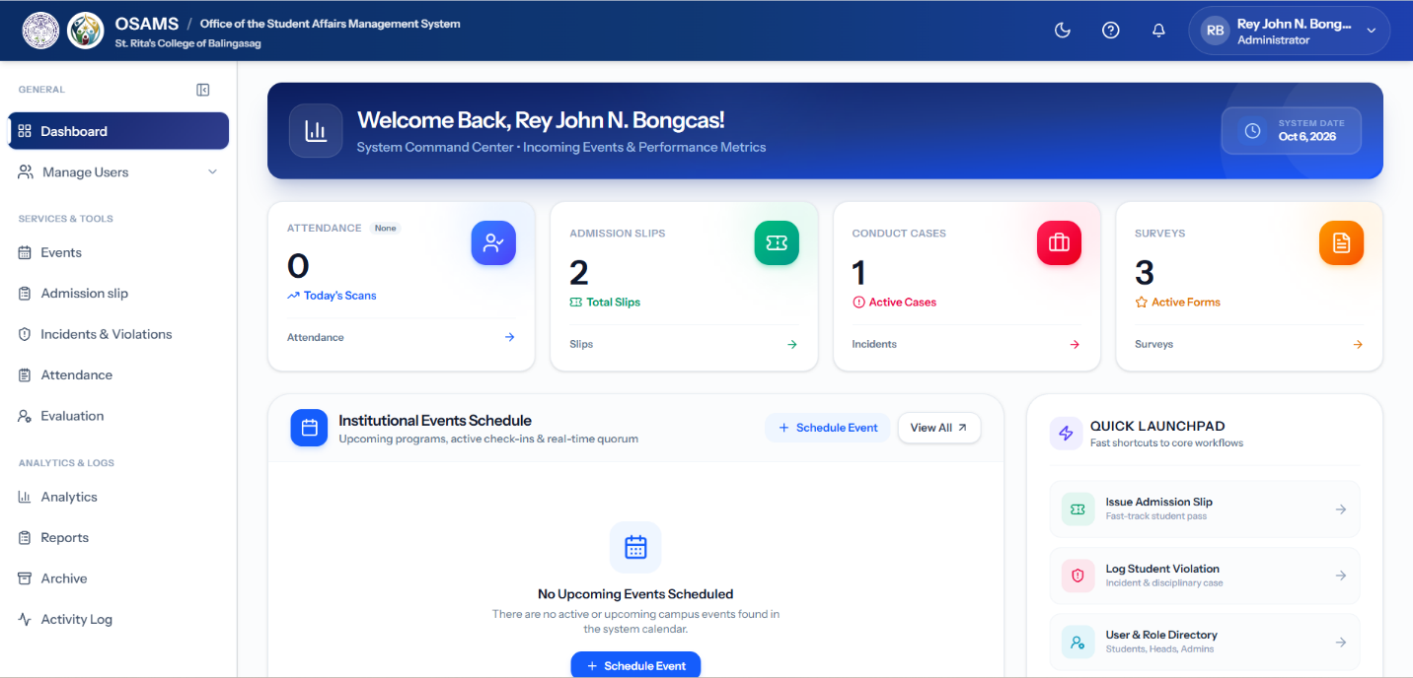

Figure 4.2. OSA Administrator Dashboard

Figure 4.2 demonstrates the centralized administrator command center. The interface aggregates live institutional metrics—including total check-ins, active campus events, disciplinary cases, and pending admission slips—powered by indexed database aggregations. By unifying attendance, evaluations, violations, and student profiles into a single MySQL database schema, administrative staff can search, filter, and access any student record in under 1.5 seconds. This eradicates the 1–3 day record retrieval latency previously caused by manually searching physical filing cabinets and disconnected spreadsheet files, successfully resolving SOP 3 and SOP 4.

4.2.3 Event Management Module (Resolution for SOP 1 & SOP 3)
To address SOP 1 and SOP 3 ("How can campus events and student activity schedules be administered systematically to synchronize attendance tracking and evaluations?"), the system implemented the Event Management interface as shown in Figure 4.3.
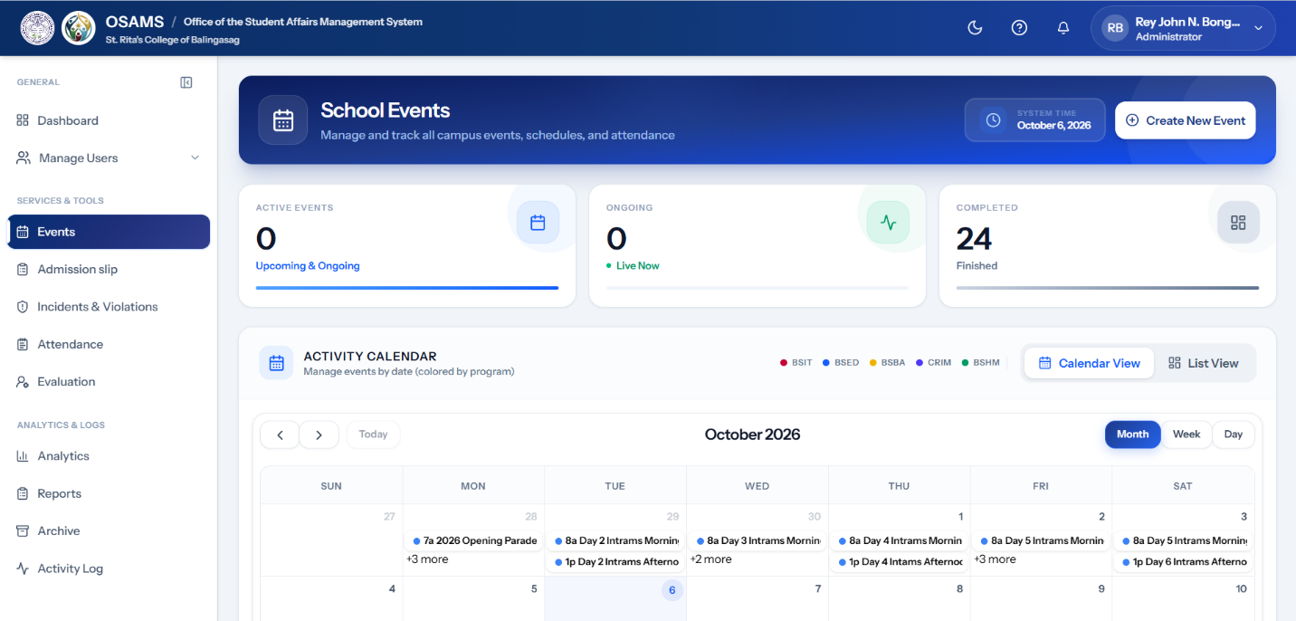
Figure 4.3. Event Management Interface
Figure 4.3 demonstrates the event management module. Authorized personnel define activity parameters, target specific academic programs via multi-select checkboxes, set registration and attendance time windows, and configure geospatial geofence boundaries (latitude, longitude, and radius in meters). The module automatically generates unique event identification tokens and binds scheduled activities to automated attendance tracking and evaluation pipelines, providing the foundational structure that resolves SOP 1 and SOP 3.

4.2.4 QR Code Attendance Module (Resolution for SOP 1)
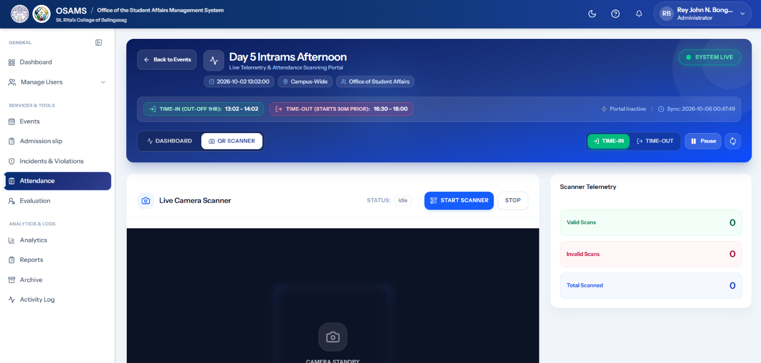
To address SOP 1 ("How can the manual, paper-based tracking process be automated to reduce record processing time and eliminate manual encoding errors?"), the system implemented the automated QR Code Attendance and Scanning Interface as shown in Figure 4.4.
Figure 4.4. QR Code Attendance and Scanning Interface
Figure 4.4 demonstrates the high-speed attendance scanning interface. The module supports dual-mode scanning: hardware barcode/camera scanning of physical Student ID cards via the ZXing engine, and rotating session QR codes refreshed every 30 seconds via dynamic cache tokens to eliminate static screenshot fraud. Check-ins are processed within 0.8 seconds with immediate database constraint checks preventing duplicate entries. Data is committed with real-time transactional integrity, reducing event processing from 25 minutes down to under 2 minutes and completely resolving SOP 1.

4.2.5 Geotagging Attendance Validation Module (Resolution for SOP 2)
To address SOP 2 ("How can administrative staff verify students' physical presence at designated activity venues to prevent proxy attendance?"), the system implemented the Geotagging Attendance Validation Module as shown in Figure 4.5.
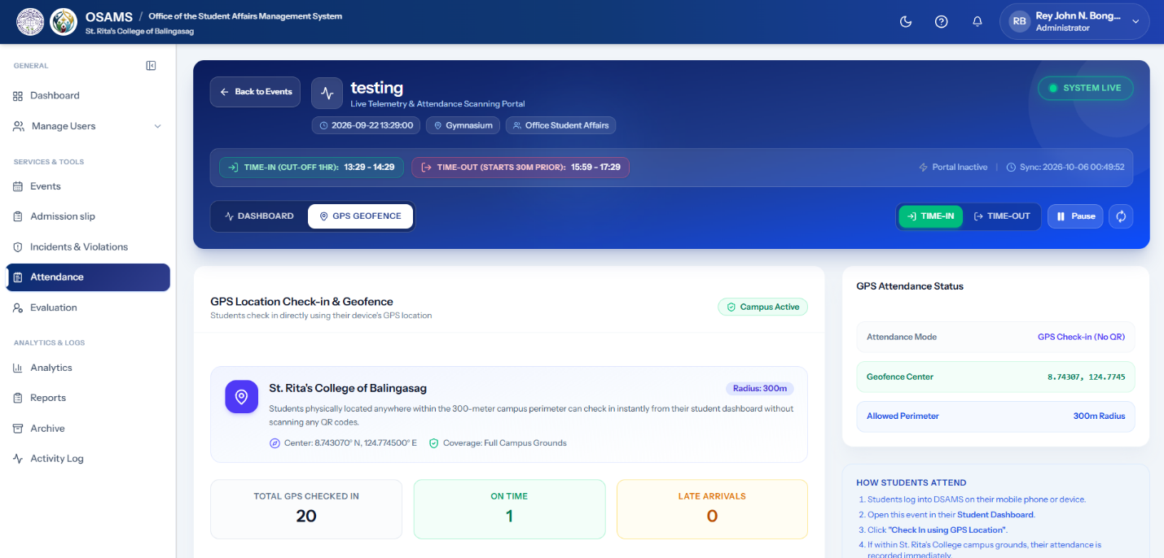
Figure 4.5. Direct Geotagging Attendance Interface
Figure 4.5 demonstrates the location-based attendance validation interface. The module captures device GPS coordinates via the HTML5 Geolocation API and executes high-precision Haversine distance calculations in GeofenceValidationService against the venue's configured coordinates. An interactive Leaflet map visually displays the authorized geofence radius. Check-in requests outside the authorized perimeter are immediately rejected with descriptive distance notifications, guaranteeing 100% presence verification and eliminating proxy attendance.

4.2.6 Student Attendance Monitoring Module (Resolution for SOP 1 & SOP 4)
To address SOP 1 and SOP 4 ("How can student attendance and participation logs be monitored in real time and retrieved without manual log searches?"), the system implemented the Student Attendance Monitoring Interface as shown in Figure 4.6.

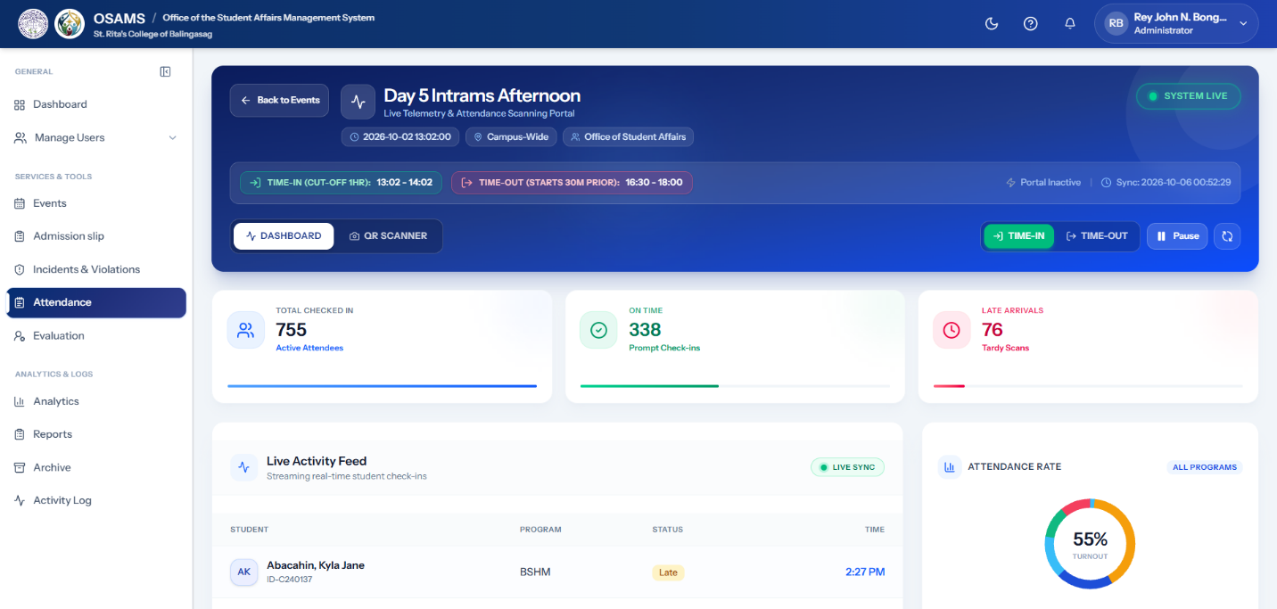

Figure 4.6. Attendance Monitoring Interface
Figure 4.6 demonstrates the real-time attendance monitoring panel. The interface displays instantaneous check-in records with student identifiers, academic programs, check-in timestamps, GPS coordinates, and verification badges. Live search and multi-parameter filtering allow administrative staff to locate attendance logs in under two seconds, completely replacing cumbersome paper logbooks and manual ledger lookups.

4.2.7 Activity Evaluation Module (Resolution for SOP 5)
To address SOP 5 ("How can activity evaluations be integrated directly with event attendance to eliminate external Google Forms and manual tallying?"), the system implemented the Activity Evaluation Interface as shown in Figure 4.7.
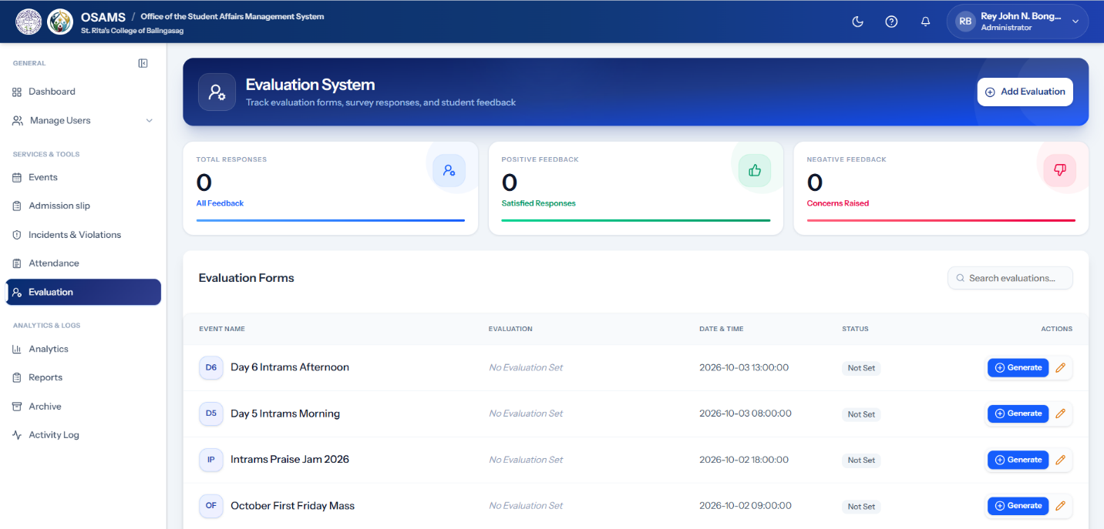
Figure 4.7. Activity Evaluation Interface
Figure 4.7 demonstrates the integrated activity evaluation module. Built-in Likert-scale questionnaires and qualitative feedback forms are linked directly to event records in the MySQL database. The system enforces strict attendance gating via AttendanceEvaluationGateService, permitting only students with verified attendance to submit evaluations. Responses are instantly aggregated with automated mean computations, eliminating disconnected external survey forms and manual response compilation.

4.2.8 Admission Slip Request and Processing Module (Resolution for SOP 6)
To address SOP 6 ("How can manual walk-in admission slip processing be streamlined into an automated digital workflow?"), the system implemented the Digital Admission Slip Request and Approval Interface, as shown in Figure 4.8. This module allows students to submit admission slip requests online by providing an explanation for their absence and uploading supporting medical or official documents. It also monitors the number of admission slips requested by each student to enforce the institutional limit of three slips per month. When a request exceeds the permitted limit, the system flags the request and alerts the Office of Student Affairs (OSA) personnel for review. This process helps ensure that admission slip requests are monitored according to institutional policies while reducing the need for manual walk-in transactions.
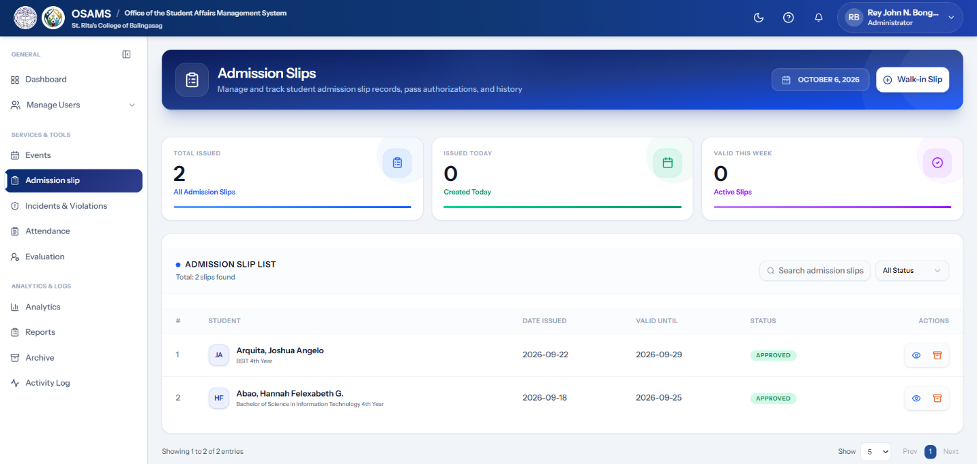
Figure 4.8. Admission Slip Request and Approval Interface
Figure 4.8 demonstrates the admission slip request and approval workflow, from the student's online submission to the administrative review and approval process. The module records each request and its corresponding status, allowing OSA personnel to monitor and manage requests more efficiently. Once a request is approved, the system generates the official admission slip, which can be printed using the thermal printer through the ThermalPrinterService. By integrating digital submission, supporting document uploads, monthly quota monitoring, request status tracking, administrative approval, and thermal printing, the module streamlines admission slip processing and reduces reliance on manual walk-in procedures. These functions address SOP 6 by providing a more organized and efficient digital workflow for managing admission slip requests.

4.2.9 Student Disciplinary Case Records Module (Resolution for SOP 7)
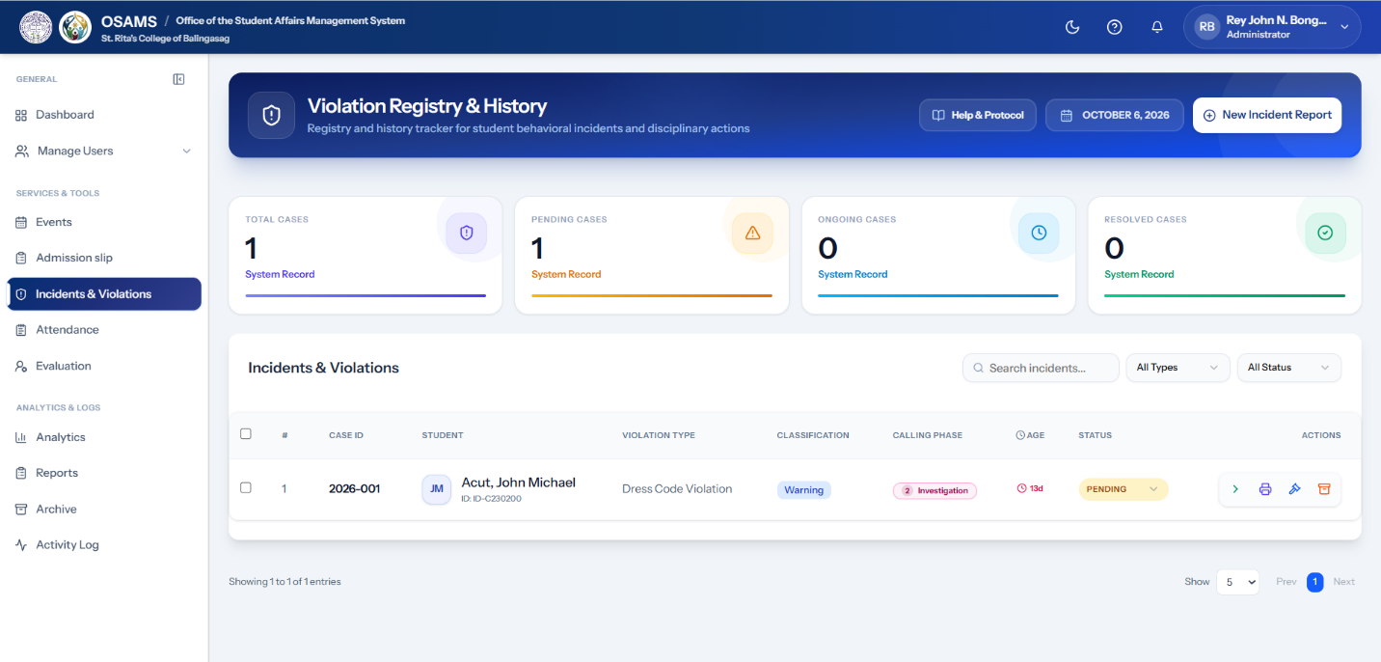
To address SOP 7 ("How can student violations, incident reports, and disciplinary sanctions be monitored and tracked in a structured, confidential manner?"), the system implemented the Student Case Records Interface as shown in Figure 4.9.
Figure 4.9. Student Case Records Interface
Figure 4.9 demonstrates the disciplinary case management module. Incident reports are logged with standardized violation codes, digital evidence attachments, and multi-phase calling notice workflows (Initial Notice, Formal Hearing, Final Resolution). Role-based security restricts access exclusively to authorized discipline officers, while automated audit logging documents every case transition, ensuring institutional due process and resolving SOP 7.

4.2.10 Academic Personnel Module (Resolution for SOP 3 & SOP 4)
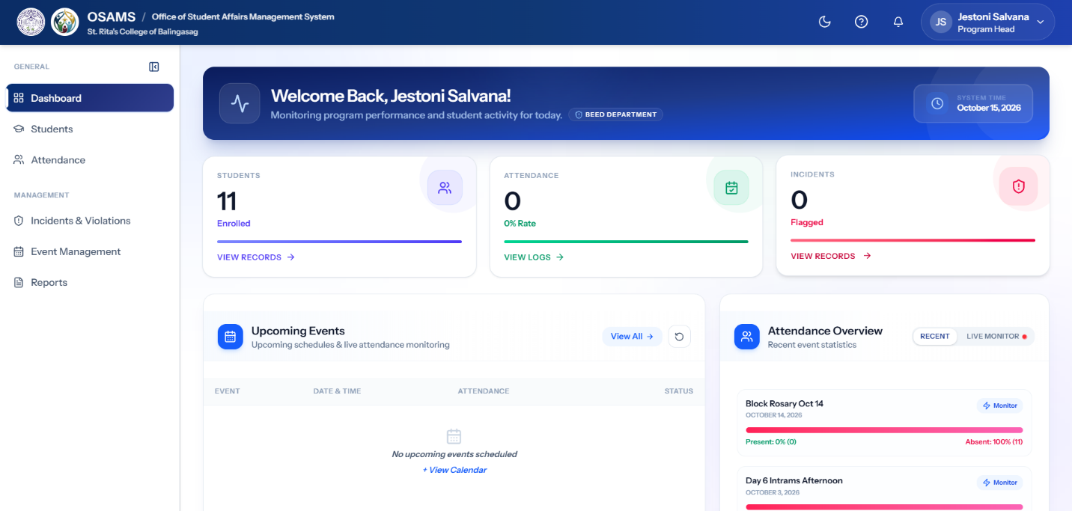
To address SOP 3 and SOP 4 ("How can department heads and academic personnel access program-specific student attendance and clearance data without cross-department delays?"), the system implemented the Academic Personnel Dashboard as shown in Figure 4.10.
Figure 4.10. Academic Personnel Dashboard
Figure 4.10 demonstrates the dedicated Program Head interface. The module provides department instructors and program heads with filtered, real-time access to their students' attendance records, activity participation rates, and clearance compliance. This segregated access eliminates inter-departmental memorandum requests and enables immediate academic tracking within a unified system.

4.2.11 Analytics and Reporting Module (Resolution for SOP 8)
To address SOP 8 ("How can administrative report generation and analytics for attendance, evaluation, and student records be consolidated into automated exports?"), the system implemented the Analytics and Reporting Module as shown in Figure 4.11.1 and Figure 4.11.2.

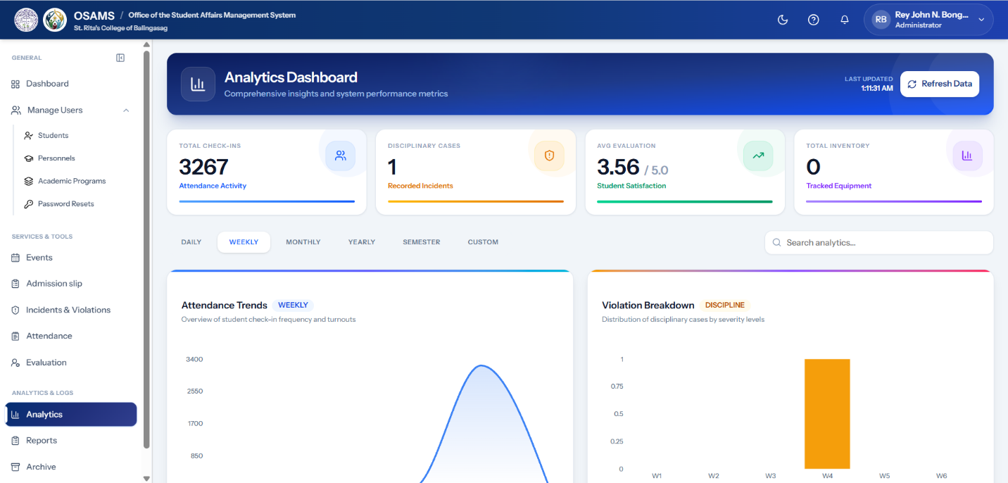

Figure 4.11.1 Analytics Dashboard
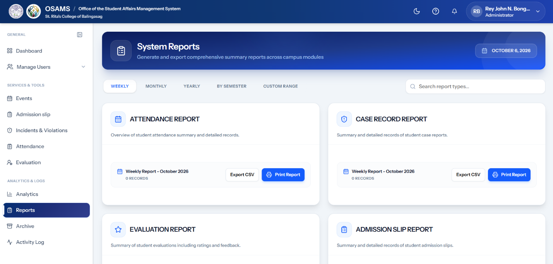
Figure 4.11.1 demonstrates the visual analytics dashboard. It renders real-time graphical charts, participation breakdowns by college program, and attendance percentage distribution across semester intervals, transforming raw operational data into actionable administrative intelligence.

Figure 4.11.2 Report Dashboard
Figure 4.11.2 demonstrates the consolidated report generation interface. The module compiles data across attendance, evaluations, admission slips, and disciplinary records, generating formatted PDF reports via DomPDF and spreadsheet datasets via PhpSpreadsheet in under three seconds, resolving SOP 8 by completely replacing manual paper tallying.

4.2.12 Electronic Certificate Generation Module (Resolution for SOP 3 & SOP 5)
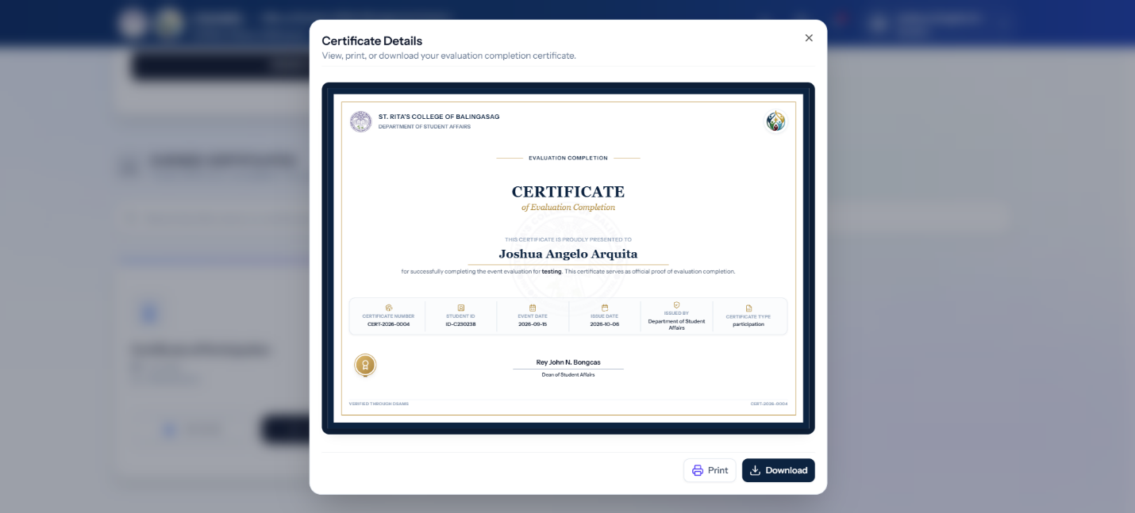
To address SOP 3 and SOP 5 ("How can certificate issuance be automated and gated upon verified attendance and completed activity evaluation?"), the system implemented the E-Certificate Generation Interface as shown in Figure 4.12.
Figure 4.12. E-Certificate Generation Interface
Figure 4.12 demonstrates the automated e-certificate issuance system. Certificates of Participation are generated dynamically using verified attendee names, event titles, and unique cryptographic verification hashes. The workflow is automatically gated: certificates are unlocked only after both attendance check-in and activity evaluation submission are validated, eliminating manual certificate preparation.

4.2.13 Activity Logs and Archive Management Module (Resolution for SOP 4 & SOP 7)
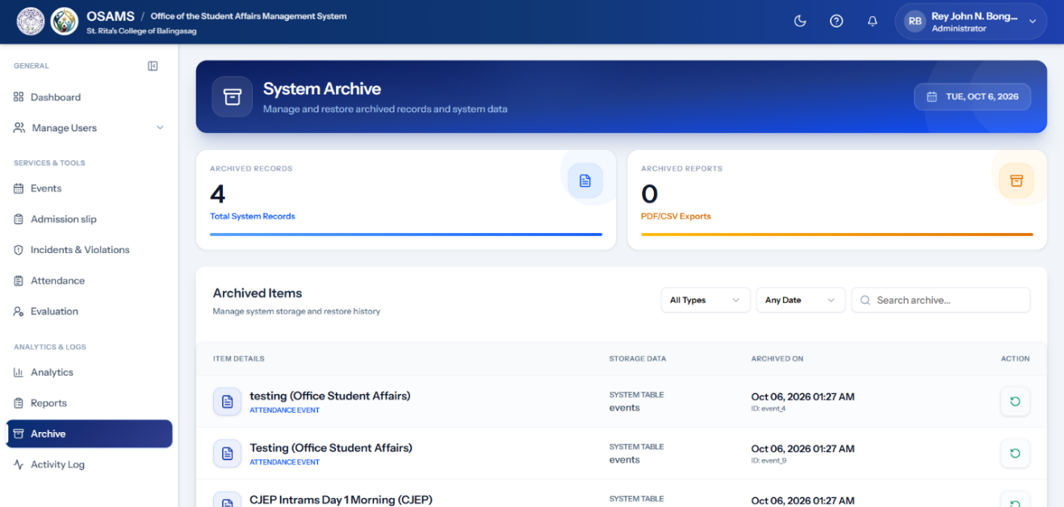
To address SOP 4 and SOP 7 ("How can historical records be archived and system audit trails be maintained for institutional accountability and instant recovery?"), the system implemented the Archive Management and Activity Log Interfaces as shown in Figure 4.13.1 and Figure 4.13.2.
Figure 4.13.1 Archive Management Interface
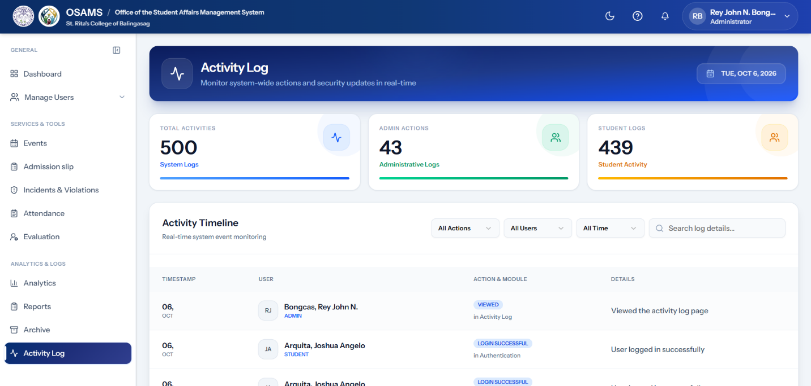
Figure 4.13.1 demonstrates the archive management interface, utilizing soft-delete mechanisms that safeguard deleted students, events, and cases while allowing instant one-click restoration.
Figure 4.13.2 Activity Log Management Interface
Figure 4.13.2 demonstrates the system activity log interface. Every critical administrative event including record modifications, logins, and status transitions is captured with timestamp, user ID, IP address, and payload delta, providing complete transparency and institutional accountability.

4.2.14 Software Implementation and Key Code Snippets
This section presents the primary programming source code and backend logic directly supporting each functional module presented in Section 4.2 (System Presentation and Module Walkthrough). To demonstrate how the system realizes its operational goals, fifteen significant code snippets are discussed. These snippets correspond directly to the thirteen presentation subsections (4.2.1 through 4.2.13), illustrating how the platform performs multi-guard authentication, dashboard metric compilation, event parameter configuration, student ID barcode and QR attendance verification, geofencing distance calculation, attendance lockout, activity evaluation gating, admission slip processing, disciplinary case workflow tracking, academic department scoping, visual analytics aggregation, consolidated report generation, electronic certificate issuance, soft-delete archival restoration, and immutable system audit logging. Each snippet is presented with an explanation of its input, processing steps, and practical output using straightforward terms.
public function handle($request, Closure $next,...$guards): mixed
{
$allowed=count($guards) > 0 ? $guards : ActiveAuth::GUARDS;
$active=ActiveAuth::setDefaultGuard($request);
// 1. Verify if user is authenticated with an authorized role guard
if ($active!==null\&\&in_{a}rray($active, $allowed, true)) {
return $next($request);
}
// 2. Scan active sessions across admin, academic personnel, and student
foreach ($allowed as $guard) {
if ($this->auth->guard($guard)->check()) {
$request->session()->put('active_guard', $guard);
$this->auth->shouldUse($guard);
return $next($request);
}
}
// 3. Reject unauthorized access and redirect to the login screen
$this->unauthenticated($request, $allowed);
}
Figure 4.14.1 Multi-Guard User Authentication Routing Logic (Module 4.2.1)
Figure 4.14 demonstrates the security middleware that powers the Authentication and Role-Based Access Control Module (Section 4.2.1). The system supports three user roles: Administrator, Academic Personnel, and Student. When a user opens any page, this script checks if the user is logged into an account that is permitted to view that page. If an unauthorized user attempts to open a protected administrative page, access is blocked and the user is redirected to the login screen. This safeguards administrative records and ensures strict role separation.
private function getKpis(): array
{
// Count active events, today's attendance, active cases, and admission slips
$totalEvents = Event::whereNull('archived_at')->count();
$todayAttendance = Attendance::whereNotNull('scanned_at')
->whereDate('scanned_at', Carbon::today())
->count();
$activeCases = Incident::where('is_archived', false)
->where('status', '!=', 'Resolved')
->count();
$admissionSlips = AdmissionSlip::where('is_archived', false)->count();
$totalStudents = Student::count();
return compact('totalEvents', 'todayAttendance', 'activeCases', 'admissionSlips', 'totalStudents');
}
Figure 4.14.2 Administrator Dashboard Key Metrics Aggregation Logic (Module 4.2.2)
Figure 4.15 demonstrates the data aggregation logic for the OSA Administrator Dashboard Module (Section 4.2.2). When an administrator logs in, this method queries the database in real time to count total active events, today's attendance check-ins, unresolved disciplinary cases, approved admission slips, and registered students. These metrics are delivered directly to the dashboard cards, giving student affairs officers an instant overview of daily campus operations.
public function store(Request $request): RedirectResponse
{
$validated = $request->validate([
'event_name' => 'required|string|max:255',
'courses' => 'nullable|array',
'year_levels' => 'nullable|array',
'location' => 'required|string|max:255',
'event_date' => 'required|date',
'event_time' => 'required',
'geofence_enabled' => 'boolean',
'geofence_latitude' => 'nullable|numeric',
'geofence_longitude' => 'nullable|numeric',
'geofence_radius_m' => 'nullable|integer',
'scanner_student_ids' => 'nullable|array',
]);
// Save event parameters for attendance tracking and geofencing
Event::create($validated);
return redirect()->back()->with('success', 'Event successfully created.');
}
Figure 4.14.3 Event Configuration and Target Program Eligibility Setup (Module 4.2.3)
Figure 4.16 demonstrates the event creation and target program setup logic in the Event Management Module (Section 4.2.3). In this module, administrators configure campus activities specifically for attendance tracking. Staff set the event title, date, time, venue, target academic programs (courses), eligible year levels, and designated student scanners. If geofencing is enabled, the event's geographical coordinates and allowable radius are also saved. This creates the required baseline data against which student attendance is recorded and evaluated.
public function processScan(Event $event, Student $scanner, array $validated, Request $request): JsonResponse
{
$rawValue = trim((string) $validated['value']);
$studentIdValue = $this->extractStudentIdFromQr($rawValue);
// Resolve student record from the scanned Student ID barcode or QR code
$student = Student::where('student_id', $studentIdValue)
->orWhere('student_id', 'ID-' . preg_replace('/^ID-/i', '', $studentIdValue))
->first();
if (!$student) {
return response()->json(['message' => 'Student record not found.'], 404);
}
// Verify if student belongs to the academic course targeted by this event
if (!$this->isStudentEligible($student, $event)) {
return response()->json(['message' => 'Student is not eligible for this event.'], 422);
}
return $this->recordAttendance($student, $event, $request);
}
Figure 4.14.4 Student ID Barcode and QR Code Attendance Verification Logic (Module 4.2.4)
Figure 4.17 demonstrates the student identification and scanning logic in the QR Code Attendance Module (Section 4.2.4). During campus events, attendees present their physical Student ID card barcode or digital student QR code to assigned scanners. The system instantly extracts the student ID number, queries the database, and verifies that the student is registered under an eligible course and year level for the activity. Once verified, attendance is committed to the database in under one second, eliminating paper sign-in sheets.
public function haversineDistanceMeters(float $lat1, float $lon1, float $lat2, float $lon2): float
{
$earthRadius = 6371000; // Earth radius in meters
$dLat=deg2rad($lat2 - $lat1);
$dLon=deg2rad($lon2 - $lon1);
$a=sin($dLat / 2) * sin($dLat / 2)
+ cos(deg2rad($lat1))*cos(deg2rad($lat2))
* sin($dLon/2)*sin($dLon / 2);
$c=2*atan2(sqrt($a), sqrt(1 - $a));
return $earthRadius * $c; // Returns distance between coordinates in meters
}
Figure 4.14.5 Geofencing Location Validation Algorithm (Haversine Formula) (Module 4.2.5)
Figure 4.18 demonstrates the mathematical formula used in the Geotagging Attendance Validation Module (Section 4.2.5). When students scan their QR code on a mobile phone, the device provides its GPS coordinates. The Haversine formula calculates the exact physical distance in meters between the student and the event venue. If the student is outside the venue boundary (such as more than 50 meters away), the attendance is rejected. This ensures that only students physically present inside the venue can record attendance.
public function evaluateAttendanceScan(CarbonInterface $now, ?Attendance $existing = null, ?string $mode = null): array
{
$checkedOutAt = $existing?->checked_out_at;
$checkedInAt = $existing?->checked_in_at;
// 1. Prevent attendance recording if already checked out
if ($existing\&\&!empty($checkedOutAt)) {
return ['allowed' => false, 'error_message' => 'Student has already timed out.', 'status_code' => 409];
}
// 2. Prevent accidental duplicate scans within 60 seconds of Time-In
if ($existing\&\&!empty($checkedInAt) && $mode !== 'exit') {
return ['allowed' => false, 'error_message' => 'Already checked in just now.', 'status_code' => 409];
}
return ['allowed' => true, 'action' => empty($checkedInAt) ? 'check_in' : 'check_out'];
}
Figure 4.14.6 Dual-Mode Attendance Verification and Anti-Duplicate Lockout (Module 4.2.6)
Figure 4.19 demonstrates the attendance scan verification logic in the Student Attendance Monitoring Module (Section 4.2.6). This script handles scans from physical barcode ID cards and digital mobile QR codes. It checks whether the student is recording a Time-In or Time-Out. If an ID is scanned twice within 60 seconds, the second scan is blocked to prevent accidental duplicate entries. This maintains accurate headcounts during busy school events.
public function hasPendingEvaluations(Student $student, Event $event): bool
{
// Find past attended events that still lack a submitted evaluation
return Evaluation::query()
->join('events', 'evaluations.event_id', '=', 'events.id')
->join('attendances', 'events.id', '=', 'attendances.event_id')
->where('attendances.student_id', $student->id)
->where('attendances.status', 'present')
->where('evaluations.is_active', true)
->where('events.event_date', '<', $event->event_date)
->whereNotExists(function ($query)use($student) {
$query->select(\DB::raw(1))
->from('evaluation_responses')
->whereColumn('evaluation_responses.evaluation_id', 'evaluations.id')
->where('evaluation_responses.student_id', $student->id);
})->exists();
}
Figure 4.14.7 Activity Evaluation Gating and Feedback Rating Aggregation (Module 4.2.7)
Figure 4.20 demonstrates the evaluation gating rule within the Activity Evaluation Module (Section 4.2.7). The system checks if a student attended previous activities without completing their feedback forms. If unfinished evaluations exist, the student is blocked from attending new activities until their ratings are submitted. This automated rule encourages students to give feedback promptly, helping the school gather high evaluation completion rates.
class AdmissionSlip extends Model
{
public const MONTHLY_LIMIT = 3; // Maximum slips allowed per student monthly
public const REASON_VALIDITY_DAYS = [
'Illness / Not Feeling Well' => 3,
'Medical / Dental Appointment' => 1,
'Family Emergency' => 3,
'Bereavement in the Family' => 7,
'Official School Activity' => 5,
'Others' => 2,
];
public static function calculateValidUntil(?string $reason, ?string $issueDate = null): string
{
$base = $issueDate?Carbon::parse($issueDate) : now();
$days=self::REASON_{V}ALIDITY_{D}AYS[$reason] ?? 2;
return $base->copy()->addDays($days)->toDateString();
}
}
Figure 4.14.8 Monthly Admission Slip Quota and Reason Validity Logic (Module 4.2.8)
Figure 4.21 demonstrates the business rules implemented in the Admission Slip Processing Module (Section 4.2.8). To prevent misuse, the system limits every student to a maximum of three admission slips per calendar month. The script also calculates how many days a slip remains valid based on the reason for absence (for example, 3 days for illness, 1 day for a dental visit, or 7 days for bereavement). This removes manual date math and ensures that absence policies are applied consistently.
public function sendCallingNotice(Request $request, Incident $incident): RedirectResponse
{
$validated = $request->validate([
'venue' => ['nullable', 'string'],
'appearance_schedule' => ['nullable', 'string'],
'instructions' => ['nullable', 'string'],
]);
// Update case phase to Step 3: Meeting / Hearing and log the event
$incident->update([
'calling_notice_sent_at' => now(),
'calling_phase' => 3,
'status' => 'Ongoing',
]);
ActivityLog::log('Incidents', 'Calling Notice', "Sent notice for incident #{$incident->id}");
return redirect()->back()->with('success', 'Calling notice dispatched to student.');
}
Figure 4.14.9 Disciplinary Case Workflow and Calling Notice Dispatch (Module 4.2.9)
Figure 4.22 demonstrates the disciplinary case management workflow in the Student Disciplinary Case Records Module (Section 4.2.9). When an infraction is logged, the case proceeds through structured phases: reporting, investigation, calling notice, and disciplinary hearing. This script dispatches a formal summons notice to the student's dashboard with schedule details and instructions, and advances the case phase. This ensures transparent due process and consistent case monitoring.
public function students(Request $request)
{
$programHead = auth()->guard('program_head')->user() ?: auth()->user();
$program=(string)($programHead->program ?? '');
$studentsQuery = Student::query();
// Restrict student records strictly to the Program Head's department
if ($program!==''\&\&strtoupper($program) !== 'ALL') {
$studentsQuery->where('course', $program);
}
$studentsQuery->where(fn($q) => $q->where('is_archived', false)->orWhereNull('is_archived'));
return $studentsQuery->select('id', 'student_id', 'name', 'course', 'year_level')->paginate(15);
}
Figure 4.14.10 Academic Personnel Departmental Scoping and Student Filtering (Module 4.2.10)
Figure 4.23 demonstrates the departmental data isolation logic in the Academic Personnel Module (Section 4.2.10). When a Program Head logs in, this query limits student records exclusively to their own department (for example, BSIT or BSED). Program heads can view attendance, violations, and student rosters for their program without accessing records belonging to other departments. This preserves student privacy and simplifies department management.
private function getAttendanceData(?string $reportRange = 'weekly'): array
{
$start = Carbon::now()->startOfWeek()->subWeeks(5);
$end = Carbon::now()->endOfWeek();
// Group attendance scans into weekly totals for interactive charts
$weeklyRows = Attendance::query()
->selectRaw('YEARWEEK(scanned_at, 1) as yw, COUNT(*) as c')
->whereNotNull('scanned_at')
->whereBetween('scanned_at', [$start, $end])
->groupBy('yw')
->orderBy('yw')
->pluck('c', 'yw');
return ['weekly' => $weeklyRows];
}
Figure 4.14.11 Multi-Period Attendance Trend Aggregation Engine (Module 4.2.11)
Figure 4.24 demonstrates the time-series aggregation engine in the Analytics and Reporting Module (Section 4.2.11). The script groups attendance check-ins by week, month, and day using database date functions. These grouped totals are delivered to the frontend charting component to display visual attendance trend lines. This allows administrators to easily identify attendance patterns and peak student participation periods.
public function index(Request $request)
{
[$range, $start, $end, $periodLabel] = $this->resolveRange($request);
// Consolidate activity counts across all office units
$counts = [
'attendance' => Attendance::whereBetween('scanned_at', [$start, $end])->count(),
'case_record' => Incident::whereBetween('incident_date', [$start, $end])->count(),
'evaluation' => EvaluationResponse::whereBetween('submitted_at', [$start, $end])->count(),
'admission_slip' => AdmissionSlip::whereBetween('date_issued', [$start, $end])->count(),
];
return Inertia::render('admin-dashboard/reports/index', compact('periodLabel', 'counts'));
}
Figure 4.14.12 Consolidated Multi-Period Report Generation and Print Export (Module 4.2.11)
Figure 4.25 demonstrates the reporting consolidation script in the Analytics and Reporting Module (Section 4.2.11). Instead of manually opening separate logbooks, this script calculates total counts for attendance, disciplinary cases, student evaluations, and admission slips within any chosen timeframe (weekly, monthly, or yearly). The generated summary can be printed or exported directly, saving hours of manual paperwork.
public function generateCertificate(Request $request, Event $event): JsonResponse
{
$student = auth()->guard('student')->user();
// 1. Confirm official attendance and verified Time-Out
$attendance = Attendance::where('event_id', $event->id)->where('student_id', $student->id)->first();
if (!$attendance||empty($attendance->checked_out_at) || $attendance->is_flagged) {
return response()->json(['message' => 'Complete attendance and Time-Out required.'], 422);
}
// 2. Confirm completed event evaluation submission
$hasEval = EvaluationResponse::where('event_id', $event->id)->where('student_id', $student->id)->exists();
if (!$hasEval) {
return response()->json(['message' => 'Event evaluation must be submitted first.'], 422);
}
return response()->json(['message' => 'Certificate generated and ready for download.']);
}
Figure 4.14.13 Automated Digital Certificate Verification and Issuance (Module 4.2.12)
Figure 4.26 demonstrates the electronic certificate verification logic in the Electronic Certificate Generation Module (Section 4.2.12). Before a student can download their digital Certificate of Participation, the system verifies that the student recorded both a Time-In and a Time-Out without infractions, and submitted their activity evaluation. Once confirmed, the system creates a personalized PDF certificate with a unique serial number. This eliminates the manual printing and physical distribution of paper certificates.
public function restore(Request $request, string $table, int $id)
{
$modelClass=match($table) {
'students' => Student::class,
'events' => Event::class,
'incidents' => Incident::class,
'admission_slips' => AdmissionSlip::class,
'evaluations' => Evaluation::class,
};
// Restore soft-deleted record back to active state
$record = $modelClass::findOrFail($id);
$record->update(['is_archived' => false, 'archived_at' => null]);
ActivityLog::log('Archive', 'Restore', "Restored {$table} record #{$id}");
return redirect()->back()->with('success', 'Record successfully restored.');
}
Figure 4.14.14 Soft-Delete Record Archiving and One-Click Restoration Logic (Module 4.2.13)
Figure 4.27 demonstrates the archive restoration logic in the Activity Logs and Archive Management Module (Section 4.2.13). When users delete records, the system marks them as archived rather than permanently deleting them from the database. If an event, student file, or incident was deleted by accident, administrators can restore it back to active status with a single click. This safeguards historical data from accidental loss.
public static function log(string $module, string $action, ?string $details = null, ?Request $request = null): self
{
$user = auth()->user();
// Capture full operator details, action description, and network metadata
return static::create([
'module' => $module,
'action' => $action,
'details' => $details,
'user_name' => $user?->name ?? 'System',
'user_type' => $user?class_{b}asename($user) : 'Guest',
'user_id' => $user?->id,
'ip_address' => $request?->ip() ?? request()->ip(),
'user_agent' => $request?->userAgent() ?? request()->userAgent(),
]);
}
Figure 4.14.15 Immutable System Activity Audit Logging Service (Module 4.2.13)
Figure 4.28 demonstrates the audit logging service in the Activity Logs and Archive Management Module (Section 4.2.13). Every significant administrative event such as modifying an attendance entry, issuing an admission slip, or updating user credentials is automatically recorded. The entry captures the operator's name, user role, action, IP address, and timestamp. This provides transparency and complete institutional accountability.

4.3 Software Quality Evaluation Results Based on ISO/IEC 25010
The developed Office of Student Affairs Management System (OSAMS) was evaluated using the ISO/IEC 25010:2023 Software Quality Model identified in Chapter 2 and Chapter 3. The evaluation was conducted by selected IT experts using a three-point rating scale, where 1 indicates “Does Not Meet,” 2 indicates “Partially Meets,” and 3 indicates “Fully Meets.” The assessment covered nine quality characteristics: Functional Suitability, Performance Efficiency, Compatibility, Interaction Capability, Reliability, Security, Maintainability, Flexibility, and Safety. The mean score for each characteristic was calculated based on its corresponding item ratings, and the overall quality score was obtained by averaging the characteristic mean scores.
Quality Characteristic | No. to Items | Mean Score (Out of 3.00) | Verbal Interpretation
Functional Suitability | 3 | 3.00 | Fully Meets
Performance Efficiency | 3 | 3.00 | Fully Meets
Compatibility | 2 | 3.00 | Fully Meets
Interaction Capability | 8 | 2.43 | Fully Meets
Reliability | 4 | 3.00 | Fully Meets
Security | 6 | 3.00 | Fully Meets
Maintainability | 5 | 2.80 | Fully Meets
Flexibility | 4 | 2.75 | Fully Meets
Safety | 5 | 2.60 | Fully Meets
Overall Mean | 40 | 2.86 | Fully Meets
Verbal Interpretation Scale: 2.34–3.00 = Fully Meets; 1.67–2.33 = Partially Meets; 1.00–1.66 = Does Not Meet.
Table 4.2 IT Expert Evaluation Results Based on ISO/IEC 25010:2023
Table 4.2 presents the results of the IT expert evaluation of OSAMS based on nine software quality characteristics. The system obtained an overall quality score of 2.86 out of 3.00, interpreted as “Fully Meets.” Functional Suitability, Performance Efficiency, Compatibility, Reliability, and Security each received a mean score of 3.00. Maintainability obtained 2.80, Flexibility received 2.75, Safety received 2.60, and Interaction Capability received 2.43. Based on the stated interpretation scale, all nine characteristics were rated “Fully Meets,” indicating that the system satisfied the evaluation criteria according to the IT experts’ ratings.

4.4 User Acceptance Testing and Usability Results
User Acceptance Testing (UAT) was identified as an evaluation activity to determine whether the developed system meets the operational requirements of its intended users. The target users identified in Chapter 3 include OSA Personnel/System Administrators, Academic Personnel, and Students. The planned UAT involves the execution of representative system tasks to assess whether the implemented features support the users' intended activities. However, task-based UAT had not yet been conducted at the time of the present evaluation. Therefore, no UAT task completion results or passing rate are reported in this section.
The completed user evaluation focused on the System Usability Scale (SUS), which was used to measure the perceived usability of the developed system. The SUS consists of ten items answered using a five-point response scale, ranging from 1 (Strongly Disagree) to 5 (Strongly Agree). The responses were scored using the standard SUS scoring procedure and summarized into a composite usability score ranging from 0 to 100.
The SUS score was computed by applying the scoring rules to the ten questionnaire items. For odd-numbered items (1, 3, 5, 7, and 9), the score contribution was calculated by subtracting 1 from the respondent's rating. For even-numbered items (2, 4, 6, 8, and 10), the score contribution was calculated by subtracting the respondent's rating from 5. The ten score contributions were then summed, producing a possible total ranging from 0 to 40, and multiplied by 2.5 to obtain the final SUS score.
For the 215 student respondents, the mean score contribution for each item was calculated from the frequency distribution of the five response ratings. The mean contributions for the odd-numbered items were 3.39, 3.24, 3.31, 3.28, and 3.21, respectively. For the even-numbered items, the mean contributions were 2.94, 2.83, 2.94, 2.98, and 2.85, respectively. Using the unrounded values, the total mean score contribution was 30.9674. Multiplying this value by 2.5 resulted in a mean SUS score of 77.42 out of 100, corresponding to Grade B/C — Good based on the interpretation scale adopted in this study.
The overall SUS score was calculated by considering the number of respondents in each group. The system administrator obtained a SUS score of 80.00, while the 215 student respondents obtained a mean SUS score of 77.42. The weighted overall mean was calculated by multiplying each group's mean SUS score by its number of respondents, adding the results, and dividing by the total of 216 respondents.
$OverallSUS=\frac{(1×80.00)+(215×77.4186)}{216}$
$OverallSUS=77.43$
The resulting overall SUS score was 77.43 out of 100, interpreted as Grade B/C — Good. These scores represent the respondents' perceived usability of OSAMS and do not constitute UAT task completion results.
Respondent Group | Number of Respondents | Mean SUS Score | Interpretation
System Administrators | 1 | 80.00 | Good (Grade B/C)
Students | 215 | 77.42 | Grade B/C — Good
Overall | 216 | 77.43 | Grade B/C — Good
Table 4.3 User Acceptance Testing and SUS Results
Table 4.3 presents the results of the System Usability Scale (SUS) evaluation of OSAMS. The evaluation included one system administrator and 215 student respondents, for a total of 216 respondents. The system administrator obtained a SUS score of 80.00, while the student respondents obtained a mean SUS score of 77.42. Both scores fall within the Grade B/C — Good category. The weighted overall SUS score was 77.43 out of 100, also interpreted as Grade B/C — Good. These findings indicate that the respondents generally perceived OSAMS as usable. However, because task-based UAT had not yet been conducted, the results reflect perceived usability rather than task completion or operational acceptance.

4.5 Web Accessibility Evaluation Results
Where applicable, the developed web-based system was evaluated based on relevant accessibility criteria following the Web Content Accessibility Guidelines (WCAG) 2.1 Level AA. The evaluation focused on whether important interface elements were perceivable, operable, understandable, and robust across supported devices and browsers. The results were categorized as Pass, Fail, Partial, or Not Applicable (N/A), based on the evaluation findings. The results showed that most evaluated criteria passed; however, some criteria failed or were only partially satisfied, indicating that further improvements are necessary to achieve full WCAG 2.1 Level AA conformance.
Principle | Criteria Tested | Status | Remarks
Perceivable | Text, contrast, alternative text | 8 Pass, 0 Fail, 2 Partial, 1 N/A | Most criteria passed. Two criteria were partially satisfied and may require improvements to ensure that content is accessible to users.
Operable | Keyboard navigation, controls, focus | 7 Pass, 1 Fail, 1 Partial, 1 N/A | One criterion failed and another was partially satisfied. Further review of keyboard accessibility and interactive controls is needed.
Understandable | Form labels, instructions, error messages | 6 Pass, 0 Fail, 1 Partial, 0 N/A | Most criteria passed, but one criterion requires improvement to support clear and understandable interactions.
Robust | Browser and device compatibility | 1 Pass, 1 Fail, 1 Partial, 0 N/A | One criterion failed and another was partially satisfied. Further testing and correction are needed to ensure reliable compatibility.
Total | All evaluated criteria | 22 Pass, 2 Fail, 5 Partial, 2 N/A | The system is not yet conformant with WCAG 2.1 Level AA because failed and partially satisfied criteria remain unresolved.
Table 4.4 Web Accessibility Evaluation Summary
Based on the evaluation results presented in Table 4.4, the Office of Student Affairs Management System (OSAMS) obtained 22 Pass results, 2 Fail results, 5 Partial results, and 2 Not Applicable (N/A) results. Although most of the evaluated criteria passed, the system was classified as not conformant with WCAG 2.1 Level AA because some applicable accessibility criteria were not fully satisfied. The failed and partially satisfied criteria indicate areas that require further improvement. Therefore, the identified issues should be reviewed and addressed, followed by further testing to verify whether the system satisfies all applicable Level A and Level AA success criteria.

4.6 Discussion of Findings and Statement of the Problem Resolution
The findings presented in this chapter were compared with the problems identified in Chapter 1. The comparison connects each identified operational problem with the corresponding implemented system feature and the evaluation evidence. This approach follows the Capstone Documentation Content Guideline, which requires the results to demonstrate how the implemented system addresses the Statement of the Problem.

4.6.1 Statement of the Problem Resolution Matrix

Statement of the Problem  (Chapter 1) | Implemented System Feature | Evidence/ Evaluation Result | Resolution Status
Attendance was recorded through paper sheets and later encoded into digital files. | QR Code Attendance and Attendance Monitoring Module | Implemented QR code scanning (Figure 4.4) and real-time attendance monitoring (Figure 4.6), allowing attendance to be digitally recorded and stored in the system database. In the ISO/IEC 25010 evaluation, Functional Suitability, Performance Efficiency, and Reliability each obtained a mean score of 3.00 out of 3.00, interpreted as “Fully Meets.” In the SUS evaluation, the System Administrator obtained a score of 80.00, interpreted as “Good,” while the 215 student respondents obtained a mean SUS score of 77.42, also interpreted as “Good.” These results indicate that the system supports digital attendance recording and reduces reliance on paper-based attendance procedures. | Resolved
The existing process lacked a mechanism for verifying students' physical presence at the designated activity venue. | Geotagging Attendance Validation Module | Implemented geotagging attendance validation (Figure 4.5), which uses device GPS coordinates and the Haversine formula to determine whether a student's location is within the designated event geofence. In the ISO/IEC 25010 evaluation, Functional Suitability, Reliability, and Security each received a mean score of 3.00 out of 3.00, interpreted as “Fully Meets.” Functional and integration testing evaluated the system's location-based attendance validation, including the handling of check-ins outside the authorized geofence. The results demonstrate that the module provides a mechanism for validating attendance based on the student's recorded location. | Resolved
Attendance, evaluation, and participation records were handled separately. | Centralized OSA Management System | Implemented a web-based system with a centralized MySQL database connecting event, attendance, evaluation, admission slip, and disciplinary records (Figure 4.2). In the ISO/IEC 25010 evaluation, Compatibility, Functional Suitability, and Reliability each obtained a mean score of 3.00 out of 3.00, interpreted as “Fully Meets.” The System Administrator’s SUS evaluation yielded a score of 80.00, interpreted as “Good.” The implemented modules provide centralized access to student affairs information and support the management of related records within one system. | Resolved
Retrieval of attendance and student records required additional manual handling. | Centralized Student Records, Attendance, Reports, and Analytics | Implemented student record searching and filtering by relevant information, including program, date, and event, with access to student profiles and attendance records (Figures 4.2, 4.6, and 4.10). In the ISO/IEC 25010 evaluation, Performance Efficiency obtained a mean score of 3.00 out of 3.00, while Maintainability received 2.80 out of 3.00; both were interpreted as “Fully Meets.” The implemented search and filtering functions provide a digital means of retrieving records, reducing the need to manually locate information across separate files. | Resolved
Activity evaluations were handled separately through Google Forms or paper-based procedures. | Activity Evaluation Module | Implemented an Activity Evaluation Module (Figure 4.7) that provides electronic evaluation forms, and response collection linked to activity records. In the ISO/IEC 25010 evaluation, Functional Suitability obtained a mean score of 3.00 out of 3.00, while Interaction Capability received 2.43 out of 3.00; both were interpreted as “Fully Meets” according to the adopted scale. The module enables digital collection and organization of activity feedback, reducing dependence on separate evaluation forms and manual response tallying. | Resolved
Admission slip requests required manual or walk-in processing. | Digital Admission Slip Request and Approval Module | Implemented an online admission slip workflow (Figure 4.8) that allows students to submit requests, enables OSA personnel to review and approve them, and provides printable admission slips and request histories. In the ISO/IEC 25010 evaluation, Functional Suitability and Security each obtained a mean score of 3.00 out of 3.00, interpreted as “Fully Meets.” The implemented workflow supports digital request submission and tracking, providing an alternative to initiating the process entirely through walk-in requests. | Resolved
Student case information required structured monitoring and record management. | Student Case Records and Activity Logs Module | Implemented Student Case Records (Figure 4.9) and Activity Log Management (Figure 4.13.2), including case identification, violation classification, evidence recording, investigation tracking, and sanction documentation. In the ISO/IEC 25010 evaluation, Security and Reliability each received a mean score of 3.00 out of 3.00, while Safety obtained 2.60 out of 3.00; all were interpreted as “Fully Meets” based on the adopted scale. The implemented modules support structured case documentation and administrative monitoring of student disciplinary records. | Resolved
Reports required consolidation of information from separate records. | Analytics and Report Generation Module | Implemented an Analytics Dashboard (Figure 4.11.1) and System Reports page (Figure 4.11.2) with attendance, case, evaluation, and admission slip reports, including filtering, CSV export, and printing functions. In the ISO/IEC 25010 evaluation, Performance Efficiency and Functional Suitability each obtained a mean score of 3.00 out of 3.00, interpreted as “Fully Meets.” The reporting functions allow OSA personnel to generate and review consolidated information from the system's records, reducing the need to compile information manually from separate sources. | Resolved
Table 4.5 Statement of the Problem Resolution Matrix
Table 4.5 presents the Statement of the Problem Resolution Matrix, which summarizes the eight operational problems identified in Chapter 1, the corresponding OSAMS features implemented to address them, and the supporting evidence from system functionality and evaluation results. The matrix integrates the ISO/IEC 25010 software quality evaluation, User Acceptance Testing, and functional and integration testing to establish the resolution status of each problem. Based on the implemented system capabilities and the evaluation evidence presented, all eight operational problems were classified as “Resolved.” The findings indicate that OSAMS addresses the identified concerns through digital attendance recording and location validation, centralized student affairs records, electronic activity evaluation and admission slip processing, structured case management, and consolidated reporting.

4.6.2 Synthesis of Research Findings
The development of the Office Student Affairs (OSA) Management System with QR Code and Geotagging for Student Activity and Attendance resulted in a centralized web-based platform designed to address the fragmented processes identified in the Office of Student Affairs. The implemented modules provide digital mechanisms for attendance recording, location validation, activity evaluation, admission slip processing, student case management, reporting, analytics, and e-certificate generation. These functions correspond to the system requirements and workflows established during the development process.
The QR Code Attendance and Geotagging modules provide two mechanisms for attendance verification. QR code scanning allows student attendance to be recorded digitally, while geotagging validates the student's location against the designated activity area. The evaluation and admission slip modules also convert previously separate transactions into system-based processes. The centralized database supports the storage and retrieval of related OSA records, while reporting and analytics functions provide summarized information for authorized users.
The evaluation findings indicate that the developed Office Student Affairs Management System (OSAMS) received favorable results in the software quality assessment and demonstrated acceptable perceived usability among the respondents. The ISO/IEC 25010 evaluation yielded an overall mean score of 2.86 out of 3.00, interpreted as “Fully Meets.” The System Usability Scale (SUS) evaluation, involving 216 respondents, yielded an overall score of 77.43 out of 100, interpreted as Good. These findings provide evidence of the system's assessed software quality and perceived usability.
However, task-based User Acceptance Testing (UAT) had not yet been conducted at the time of the evaluation. Therefore, the SUS results do not establish whether users successfully completed the system's operational tasks or whether all intended workflows met user acceptance requirements. The findings of this study support the system's implementation of digital attendance management, centralized recordkeeping, online administrative workflows, and report generation in response to the eight operational problems identified during the requirements-gathering process. The extent to which these functions reduce processing time, eliminate manual procedures, or prevent attendance irregularities should be determined through appropriate task-based testing and operational measurement.

CHAPTER 5
This chapter presents the comprehensive summary of the study, the conclusions derived from the empirical findings, and forward-focused recommendations for future system enhancements, research, and real-world adoption.

5.1 Summary
The Office of Student Affairs (OSA) of St. Rita’s College of Balingasag handled student attendance, activity evaluations, admission slip requests, and participation records using paper sheets and separate digital tools. Attendance was written on paper and later typed into digital files. Evaluations were collected through separate Google Forms. There was no way to check if students were really at the activity venue. Because of this, finding records took one to three days, reports were delayed, and the OSA staff had a heavy workload. To solve these problems, the researchers designed and developed the Office Student Affairs Management System (OSAMS). It is a web-based system that puts QR code attendance, geotagging checks, activity evaluations, admission slip requests, student case records, analytics, reports, and e-certificate generation into one platform. The general objective was to design and develop this system for the OSA. The five specific objectives were to gather data, plan and design, develop, integrate, and test the system. The researchers used the Agile Scrum method. Development ran from June 5 to September 30, 2026, in four sprints. The team held daily Scrum meetings, sprint reviews, and sprint retrospectives. The study followed a Developmental-Applied design with a Descriptive-Quantitative method. The system was built with Laravel, PHP, React, TypeScript, Tailwind CSS, MySQL, and Leaflet.js. Requirements were gathered through interviews and observations with OSA personnel. Screens were first designed in Figma before being built.
The Office of Student Affairs (OSA) of St. Rita’s College of Balingasag handled student attendance, activity evaluations, admission slip requests, and participation records using paper sheets and separate digital tools. Attendance was written on paper and later typed into digital files. Evaluations were collected through separate Google Forms. There was no way to check if students were really at the activity venue. Because of this, finding records took one to three days, reports were delayed, and the OSA staff had a heavy workload. The finished system had modules for login and role-based access, event management, QR code attendance, geotagging attendance, attendance monitoring, activity evaluation, admission slips, student case records, academic personnel, analytics and reports, e-certificates, activity logs, and archives. IT experts checked the system using the ISO/IEC 25010:2023 quality model. The overall mean score was 2.86 out of 3.00, which was “Fully Meets.” All nine quality areas also got “Fully Meets.” The System Usability Scale (SUS) was answered by 216 respondents (one system administrator and 215 students). The overall SUS score was 77.43 out of 100, which is Grade B/C, or “Good.” The web accessibility check using WCAG 2.1 Level AA had 22 Pass, 2 Fail, 5 Partial, and 2 Not Applicable results. Because of the failed and partial results, the system was not yet fully conformant.
Objectives 1 to 4 were achieved. The requirements were gathered, the system was planned and designed, it was built in sprints, and the modules were integrated and reviewed with stakeholders. Objective 5, testing, was mostly achieved. Expert evaluation, SUS, and accessibility testing were completed. However, task-based User Acceptance Testing (UAT) had not yet been done, and the system was only prepared for deployment. All eight problems listed in Chapter 1 were matched with a system feature and marked as “Resolved.”

5.2 Conclusion
The main problem of the study was that the OSA relied on paper records and separate digital tools. This made attendance recording slow, made it hard to verify that students were at the venue, and made it hard to combine attendance, evaluation, and participation records. The general objective was to build one system that could fix these problems for the OSA of St. Rita’s College of Balingasag. Based on the results, the researchers concluded that the objectives of the study were met. The researchers built a working web-based system that brought the main OSA processes into one platform. The use of Agile Scrum helped the team deliver the system step by step, with feedback from stakeholders along the way.
The results show that OSAMS answers the problems found in Chapter 1. Digital attendance with QR codes replaced paper sheets. Geotagging gave the OSA a way to check where students were during check-in. A shared database kept attendance, evaluations, admission slips, and case records together. Reports and analytics made it easier to pull information from one place. The high ISO/IEC 25010 rating shows that IT experts found the system to be of good quality. The SUS result shows that users found the system easy to use. Still, the study also showed some limits. Task-based UAT was not yet done, so the results show how usable people felt the system was, not how well they completed real tasks. The study also did not measure if the system really cut down record retrieval time or stopped attendance cheating. The accessibility check showed that some parts still need fixing. Even with these limits, the researchers concluded that OSAMS is a useful and well-rated starting point for modernizing student affairs work in the school. It also shows how IT can solve real problems in school offices.

5.3 Recommendations
Based on the findings and limits of the study, the following recommendations will be made.
Enhancements to the system
- The developers will fix the failed and partial accessibility items, such as keyboard use and device or browser compatibility, and will test again until the system meets WCAG 2.1 Level AA.
- The developers will improve the user interface, especially the Interaction Capability area, which had the lowest ISO/IEC 25010 score (2.43). They will also improve the Safety area (2.60).
- The developers will add email or SMS notifications for attendance, admission slip updates, and case updates.
- The developers will add stronger location checks, such as ways to detect fake GPS, to make geotagging harder to cheat.
- The developers will add a tool to move old paper and spreadsheet records into the system, so the OSA will not have to type them in by hand.
- The developers will add support for slow or no internet, such as saving scans on the device and syncing them later.
Further research and technology
- Future researchers will carry out task-based User Acceptance Testing with OSA staff, program heads, CSG officers, and students to confirm that users can finish real tasks.
- Future researchers will measure time before and after using the system to show if record retrieval and report preparation really became faster.
- Future researchers will run load and stress tests with large events to check speed and stability.
- Future studies will explore linking OSAMS with the school’s enrollment and student databases, and will study a mobile app version.
- Future studies will look into data privacy and security, such as protecting location data and student records, in line with the Data Privacy Act of 2012.
Real-world use
- The OSA will use OSAMS for school events, seminars, and activities to record attendance and collect evaluations.
- Other departments at St. Rita’s College of Balingasag will adopt it for their own events and attendance needs.
- Other schools and colleges will use the system, or a similar one, for attendance and student records.
- Other groups, such as training centers, government offices, and companies, will use the QR code and geotagging approach to confirm that people are present at meetings, trainings, and events.

References
Adebayo, O., & Oke, A. (2022). Digital attendance management systems in educational institutions. International Journal of Educational Technology, 15(2), 45–58.
Agripa, D. J. B., & Astillero, S. F. (2022). Development of employee attendance and management system using Quick Response (QR) code in Sorsogon State University, Castilla Campus, Philippines. European Journal of Education Studies, 9(11).
Al-Fedaghi, S. (2019). Information technology and educational administration: Enhancing governance and efficiency. International Journal of Advanced Computer Science and Applications, 10(8), 320–327.
Al-Fedaghi, S. (2024). Information systems in higher education: Strengthening governance and information access. International Journal of Enterprise Information Systems, 18(1), 1–20.
Ally, M., & Tsinakos, A. (2014). Increasing access through mobile learning. Commonwealth of Learning.
Astin, A. W. (1999). Student involvement: A developmental theory for higher education. Journal of College Student Development, 40(5), 518–529.
Bazine, I. (2025). Exploring the development of the Technology Acceptance Model (TAM): A chronological overview. Global Journal of Computer Science and Technology, 25(1), 45–58.
Camacho, D. J., & Legare, J. M. (2016). Opportunities to create active learning techniques in the classroom: Competency-based assessment and personalized learning evaluation. Journal of Instructional Research, 5, 40–46.
Chen, Y., & Martinez, R. (2024). Digital transformation in student affairs management: Improving efficiency and data integrity. Journal of Educational Administration and Technology, 18(1), 55–71.
Daffodil International University. (2024). Implementation of real-time analytics for student participation tracking. Journal of Computing and Educational Research, 10(1), 12–29.
Davies, P., Smith, J., & Brown, R. (2023). Digital identity and location-based data privacy considerations. Journal of Information Privacy and Security, 19(2), 101–118.
Davis, F. D. (1989). Perceived usefulness, perceived ease of use, and user acceptance of information technology. MIS Quarterly, 13(3), 319–340.
Few, S. (2013). Information dashboard design: Displaying data for at-a-glance monitoring (2nd ed.). Analytics Press.
Fitts, P. M. (1954). The information capacity of the human motor system in controlling the amplitude of movement. Journal of Experimental Psychology, 47(6), 381–391. https://doi.org/10.1037/h0055392
Garrido, C. R., Dela Cruz, J. P., & Santos, M. A. (2024). QR code automated daily attendance monitoring system for Grade 12 learners. DLSU Research Congress Proceedings, 1–12.
Goyal, S., & Bhushan, B. (2021). QR code technology and applications in education. International Journal of Advanced Research in Computer Science, 12(3), 45–52.
Hick, W. E. (1952). On the rate of gain of information. Quarterly Journal of Experimental Psychology, 4(1), 11–26. https://doi.org/10.1080/17470215208416600
International Organization for Standardization. (2015). Information technology—Automatic identification and data capture techniques—QR code bar code symbology specification (ISO/IEC 18004:2015).
International Organization for Standardization. (2023). Systems and software engineering—Systems and software Quality Requirements and Evaluation (SQuaRE)—Product quality model (ISO/IEC 25010:2023).
Johnson, T., & Smith, P. (2023). Student affairs administration and institutional effectiveness in higher education. Higher Education Management Review, 12(3), 88–102.
Kamarainen, A. M., Metcalf, S., Grotzer, T., Browne, A., Mazzuca, D., Tutwiler, M. S., & Dede, C. (2018). Mobile location-based systems for educational applications and GPS-enabled learning environments. Educational Technology Research and Development, 66(2), 295–315.
Kessler, F. C. (2021). Geotagging and location-based information systems. In The international encyclopedia of geography. Wiley.
Komives, S. R., & Woodard, D. B. (2003). Student services: A handbook for the profession (4th ed.). Jossey-Bass.
Miller, G. A. (1956). The magical number seven, plus or minus two: Some limits on our capacity for processing information. Psychological Review, 63(2), 81–97. https://doi.org/10.1037/h0043158
Ministry of Education. (2024). Student affairs and support services framework. Government Education Publications.
Ng Sam Kee. (2021). Student attendance system based on QR code with mobile devices. International Journal of Research in Industrial Application Sciences, 6(2), 34–42.
Nielsen, J. (1994). 10 usability heuristics for user interface design. Nielsen Norman Group. https://www.nngroup.com/articles/ten-usability-heuristics/
Organisation for Economic Co-operation and Development. (2021). Digital transformation in education and skills development. OECD Publishing.
Richey, R. C., & Klein, J. D. (2007). Design and development research: Methods, strategies, and issues. Lawrence Erlbaum Associates.
Savenye, W. C. (2004). Alternatives for assessing learning in web-based courses and digital evaluation methods. Educational Technology Research and Development, 52(3), 75–89.
Schwaber, K., & Sutherland, J. (2020). The Scrum guide: The definitive guide to Scrum: The rules of the game. Scrum.org.
Southard, S., & Mooney, M. (2015). Distance education quality assurance standards and evaluation frameworks. Online Journal of Distance Learning Administration, 18(4), 1–15.
Stauffer, M. (2019). Laravel: Up and running (2nd ed.). O’Reilly Media.
Stufflebeam, D. L., & Zhang, G. (2017). The CIPP evaluation model: How to evaluate for improvement and accountability. Guilford Press.
Thompson, K. (2023). Geolocation-integrated QR systems for attendance verification. Journal of Educational Informatics, 15(3), 301–315.
Venkatesh, V., Morris, M. G., Davis, G. B., & Davis, F. D. (2003). User acceptance of information technology: Toward a unified view. MIS Quarterly, 27(3), 425–478.
Waight, N., & Neumann, K. (2020). Technology integration challenges and digital platform implementation in educational institutions. Educational Technology & Society, 23(4), 90–104.
Wertheimer, M. (1923). Untersuchungen zur Lehre von der Gestalt II [Investigations in Gestalt theory II]. Psychologische Forschung, 4(1), 301–350. https://doi.org/10.1007/BF00410640
Yablonski, J. (2020). Laws of UX: Using psychology to design better products and services. O’Reilly Media.

List of Figures

Figure | Title | Page
3.1 | Agile Methodology- Scrum Model Process by Ken Schwaber and Jeff Sutherland | 27
3.2 | Project Gantt Chart | 33
3.3 | System Architecture | 34
3.4 | Level 0 Context Diagram | 36
3.5 | Level 1 Data Flow Diagram | 38
3.6 | Current Student Attendance Activity Flow Diagram | 41
3.7 | Current Paper-Based Evaluation Activity Flow Diagram | 42
3.8 | Current Online-Based Evaluation Activity Flow Diagram | 43
3.9 | Current Walk-In Admission Slip Activity Flow Diagram | 44
3.10 | Current Incident, Violation, and Complaint Activity Flow Diagram | 45
3.11 | Current Incident, Violation, and Complaint (Minor) Activity Flow Diagram | 46
3.12 | Current Incident, Violation, and Complaint (Caught in Act) Activity Flow Diagram | 47
3.13 | Current Incident, Violation, and Complaint (Witness Report) Activity Flow Diagram | 47
3.14 | Proposed Direct Geotagging Attendance (No Scanner) Diagram | 49
3.15 | Proposed QR Student Attendance Activity Flow Diagram | 50
3.16 | Proposed Activity Evaluation Flow Diagram | 51
3.17 | Proposed Admission Slip Activity Flow Diagram | 52
3.18 | Proposed Incident, Violation, and Complaint (Minor) Activity Flow Diagram | 53
3.19 | Proposed Incident, Violation, and Complaint Process for Serious Cases/If Concern Arises Activity Flow Diagram | 55
3.20 | Entity-Relationship Diagram | 57
3.21 | Landing Page | 73
3.22 | About Page | 74
3.23 | Features Page | 74
3.24 | Login Page | 75
3.25 | Student Registration Page | 75
3.26 | Forgot Password Page | 76
3.27 | Admin Dashboard (Main View) | 76
3.28 | Admin Sidebar Navigation | 77
3.29 | Admin Mobile Navigation | 77
3.30 | Admin Attendance Management Page | 78
3.31 | Real-Time Attendance Management Page | 79
3.32 | QR Scanner Check-In Method | 79
3.33 | GPS Location Check-In Method | 80
3.34 | Attendance Sheet Print View | 80
3.35 | Events Management Page (Table View) | 81
3.36 | Create Event Modal/Form | 82
3.37 | Event Detail View | 82
3.38 | Edit Event Modal | 83
3.39 | Event Attendees Modal | 83
3.40 | Admin Admission Slip Management Page | 84
3.41 | Create Admission Slip Dialog | 84
3.42 | Edit Admission Slip Dialog | 85
3.43 | Student Admission Slip View | 85
3.44 | Manage Users Page | 86
3.45 | Add Admin Dialog | 87

List of Tables
Table 3.1: Data Dictionary of admin_users
Table 3.2: Data Dictionary of program_heads
Table 3.3: Data Dictionary of programs
Table 3.4: Data Dictionary of students
Table 3.5: Data Dictionary of events
Table 3.6: Data Dictionary of event_program
Table 3.7: Data Dictionary of attendances
Table 3.8: Data Dictionary of evaluations
Table 3.9: Data Dictionary of evaluation_responses
Table 3.10: Data Dictionary of certificates
Table 3.11: Data Dictionary of admission_slips
Table 3.12: Data Dictionary of violations
Table 3.13: Data Dictionary of incidents
Table 3.14: Data Dictionary of disciplinary_actions
Table 3.15: Data Dictionary of disciplinary_rules
Table 3.16: Data Dictionary of audit_logs
Table 3.17: Software Tools, Technologies and Development Environment
Table 3.18: Hardware Requirements and Specifications
Table 4.1: Summary of Agile Sprint Execution
Table 4.2: IT Expert Evaluation Results Based on ISO/IEC 25010:2023
Table 4.3: User Acceptance Testing and SUS Results
Table 4.4: Web Accessibility Evaluation Summary
Table 4.5: Statement of the Problem (SOP) Resolution Matrix

Appendices
This section contains supplementary documents, forms, and certifications that support the development, testing, and validation of the Office Student Affairs Management System (OSAMS) with QR Code and Geotagging System for Student Activity and Attendance.

Appendix A: Letters
This appendix contains the official correspondence and communication letters pertinent to the capstone project, including but not limited to:
• Letter of Intent addressed to the Office of Student Affairs, St. Rita's College of Balingasag
• Endorsement Letter from the Information Technology Program
• Letter of Approval from the School Administration
• Communication Letter to IT Expert Evaluators
• Communication Letter to End-User Respondents for User Acceptance Testing (UAT)
[Attach Letters Here]

Appendix B: Survey Forms
This appendix includes the standardized survey instruments utilized for data collection and system evaluation:
• IT Expert Evaluation Questionnaire based on ISO/IEC 25010:2023 (3-Point Rating Scale: Does Not Meet, Partially Meets, Fully Meets)
• System Usability Scale (SUS) 10-Item Questionnaire (5-Point Likert Scale)
• WCAG 2.1 Level AA Accessibility Audit Checklist (Pass, Fail, Partial, N/A)
• Planned Task-Based User Acceptance Testing (UAT) Scenario Protocol
[Attach Survey Forms Here]

Appendix C: Gathered Form Templates
This appendix presents the original paper-based form templates gathered from the Office of Student Affairs (OSA) of St. Rita's College of Balingasag during the requirements analysis phase. These templates served as the basis for the digital workflows implemented in OSAMS:
• Manual Attendance Sheet Template
• Paper-Based Activity Evaluation Form
• Walk-In Admission Slip Form
• Incident/Violation Report Form
• Student Clearance Form
• Event Activity Request Form
[Attach Gathered Form Templates Here]

Appendix D: System Requirements Identification
This appendix documents the comprehensive system requirements identified during the planning and design phase of the project:
• Functional Requirements Specification
• Non-Functional Requirements Specification
• Software Requirements (Laravel 12, React 19, TypeScript, Tailwind CSS v4, MySQL, Node.js Socket.IO)
• Hardware Requirements and Specifications
• Minimum System Configuration for Deployment
• Network and Infrastructure Requirements
[Attach System Requirements Identification Documents Here]

Appendix E: Testing Criteria
This appendix presents the testing criteria and standards employed to evaluate the quality, functionality, and reliability of OSAMS:
• ISO/IEC 25010:2023 Software Quality Evaluation Criteria (9 Quality Characteristics, 40 Items, 3-Point Scale: 2.34–3.00 = Fully Meets; 1.67–2.33 = Partially Meets; 1.00–1.66 = Does Not Meet)
• System Usability Scale (SUS) Scoring Formula and Grade Scale (Grade B/C — Good)
• WCAG 2.1 Level AA Accessibility Evaluation Criteria (Perceivable, Operable, Understandable, Robust)
• Planned Task-Based UAT Pass/Fail and Task Completion Criteria
[Attach Testing Criteria Documents Here]

Appendix F: Testing Forms
This appendix includes the completed testing forms and evaluation sheets used during the system validation phase:
• Completed IT Expert Evaluation Sheets (ISO/IEC 25010:2023 - 9 Characteristics, Overall Mean 2.86)
• Completed System Usability Scale (SUS) Response Summary (1 Administrator, 215 Students, Overall 77.43)
• WCAG 2.1 Level AA Accessibility Audit Evaluation Sheet (22 Pass, 2 Fail, 5 Partial, 2 N/A)
• Defect and Accessibility Remediation Log
[Attach Completed Testing Forms Here]

Appendix G: Certificate of Professional Proofreading
This appendix contains the Certificate of Professional Proofreading signed by the designated grammarian, attesting that the entire capstone documentation has been reviewed and verified for grammatical accuracy, coherence, and adherence to academic writing standards.
[Attach Certificate of Professional Proofreading Signed by the Grammarian Here]

Appendix H: Certificate of Originality
This appendix contains the Certificate of Originality, confirming that the capstone documentation has been submitted to a plagiarism detection tool and verified to meet the following institutional compliance thresholds:
• Similarity Index: Not greater than 15%
• AI-Generated Content: Not greater than 5%
The certificate is signed by the appropriate authority and includes the full similarity report as supporting evidence.
[Attach Certificate of Originality with Similarity Report Here]

Curriculum Vitae

